A Day in Pre-K

Use these images to create a visual calendar. You may print in color, cut and paste to a poster board.

Outline of Lesson

Rules
Sing Alphabet
Child’s First Name
Number 1
Youtube Video
Black
Tracing lines
Nursery Rhyme

**added a ‘shapes’ image.

- Rules Poster

2.) Sing ABC’s

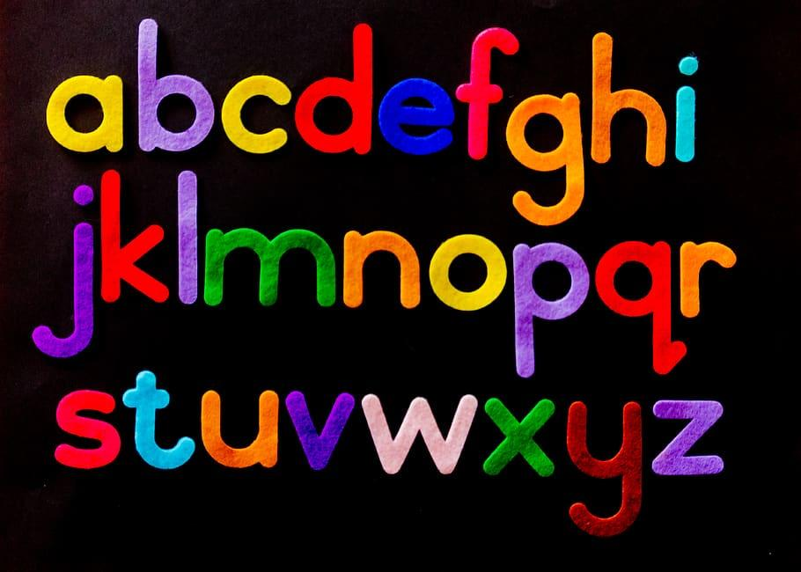
3.) Write Name

4.) Talk about Numbers

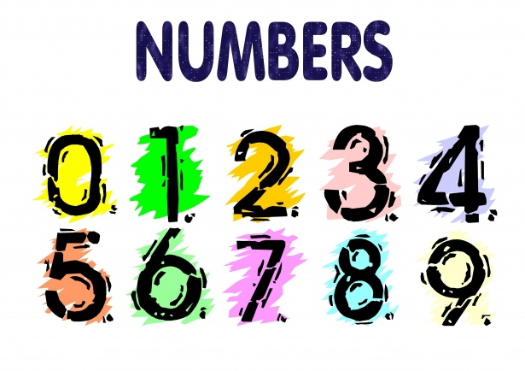
5.) Music and Movement

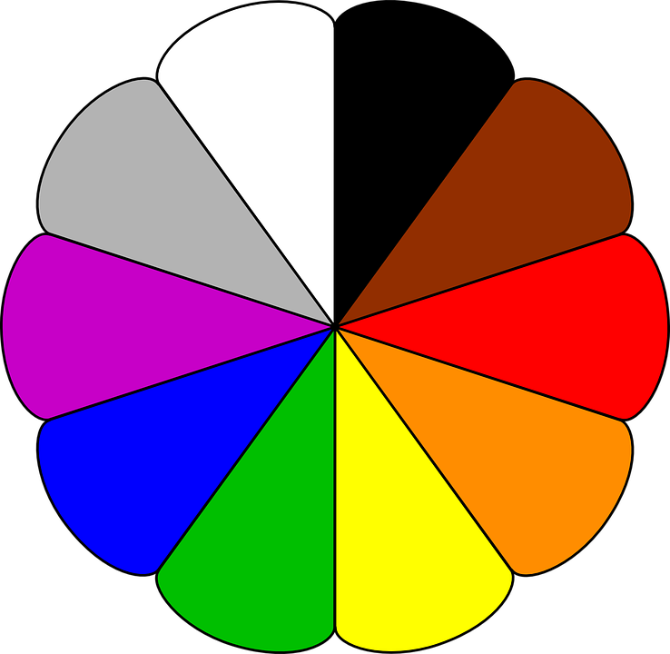
6.) Colors
7.) Tracing, Cutting, Playdough

8.) Circle Time: Nursery Rhymes
9.) Go Home.
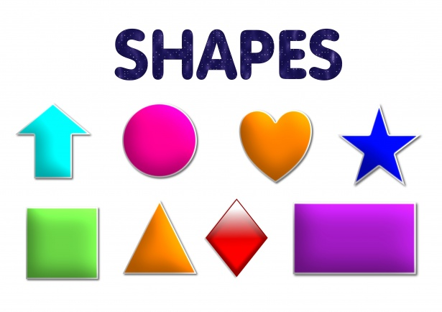
10.) Shapes

