Hands-on/Supplemental Teaching Ideas

**We understand that every child learns differently at different paces. Here are a few hands-on activities that will be engaging.
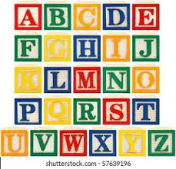
Letters in Name:
- Letter Blocks: Use letter blocks to build a child's name on every lesson.

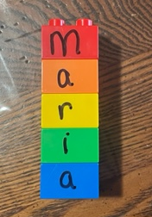

- Legos: with a black marker, write
the child’s name on each Lego.
Have the child connect the Legos.

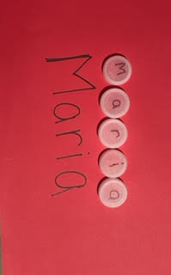
- Bottle Caps. Write letters of their name on water bottle caps with a permanent marker. Have the child place the letters in order.

- Popsicle Sticks. Write the letters of their name on popsicle sticks. Have the child place the letters in order.

Shapes:
- Playdough. Laminate or place the shape mats in a sheet protector. Build the shape using playdough using a scaffolding system.
  - First, you show the child
  - Then you do it together,
  - Finally the child does it independently.

***You can also do this with the letters in the child’s name. ***

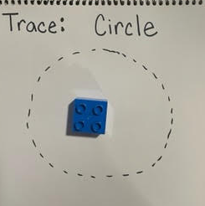
- Draw the shape on a piece of paper and have the child trace the shape or even draw the shape independently. Then, use the playdough to build the shape.

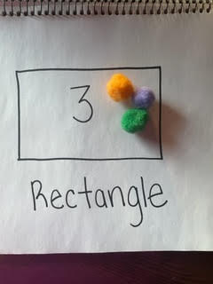

- Have the child place a specific quantity in a specific shape. For example, have the child place 3 objects in the rectangle.

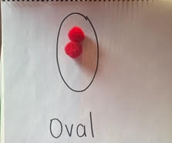

- Have the child place 2 colored objects in a specific shape.

****Child size toy tweezers are great for fine motor development. They can be used to pick up objects, especially pom-poms. .**
Numbers:
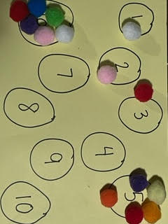

- Objects. Have the child place objects in the numbered circles. This can be toys, pom-poms, beans, beads, etc…

- Bottle Caps. Write the numbers 1-10 on water bottle caps with a permanent marker. Have the child place the numbers in order.

- Popsicle Sticks. Write the numbers 1-10 on popsicle sticks. Have the child place the numbers in order.
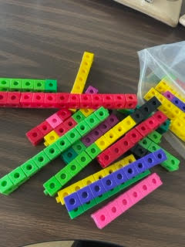

- Unifix cubes are great for counting and sorting.

***Helpful tip: (always touch count--meaning, touch the objects as you count)****

Other ideas..

Gross Motor Activity:
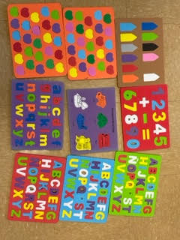
Jump 1 time, clap 1 time, stomp 1 time, roar 1 time (emphasis on number 1, etc…)

These are foam puzzles**

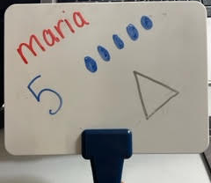

Dry erase whiteboards are also very engaging***

Dry Erase Pockets***

Magnetic Letters***
Transition Ideas
Either if you are working in a group or one-on-one, transitioning can be tricky. Our goal is to move from one activity to the next in a smooth way to help prevent negative behaviors by promoting self-regulation. Transition activities are those quick ideas you do during those "in-between" times and we usually have several of these each day.

Here are some opportunities to implement a transition activity:

- Separating from parents/guardians when arriving
- Moving from one activity to the next
- Sitting down at circle time (can be before/after Youtube Videos)
- Clean-up time
- Waiting for adults at pick-up time.

Here are some tips:
- Provide visuals. Include pictures to show the different activities.
- Establish routines.
- Create rituals.. For example, use certain songs for specific transitions (e.g., clean up song)
  - Teacher: “1-2-3, eyes on me” Children: “1-2, eyes on you.”
  - Teacher: “Look up. Look down. Turn around. Sit down.”
- Don’t be afraid to use concrete objects such as a timer or a bell.
- Praise, Praise, Praise!! Acknowledge behavior using their name.

