Verification Collection Report Instructions – School Nutrition Technology System (SNTS)
Verification Report must be completed by a School Food Authority (SFA) staff member with Application (AE) security rights in the SNTS. This report must be completed by ALL SFAs.
For ALL SFA Types except Special Milk:

Step 1: Log into the SN Technology System at https://schoolnutrition.dpi.nc.gov/snp/NcidLogin.aspx
Step 2: Select “School Nutrition Programs” Module
Step 3: Select “Application” tab.
Step 4: Select “Verification Report”. Step 5: Select “Modify”.
Step 6: Confirm “General Information” in questions 1-4 is correct. Make any changes necessary.
Step 7: Complete Section 1
1-1: For Traditional SFA, Non-public and Charter Schools students
(enter TOTAL number of schools in SFA and students in enrollment)
The total schools are the same as the number approved in the Application Packet.
1-2 and 1-2a: For RCCI with day students
1-2 and 1-2b: For RCCI without day students
Step 8: Complete Section 2
2-3: For SFAs operating Community Eligibility Provision (CEP) – enter the number of schools operating CEP and number of students enrolled in the CEP schools
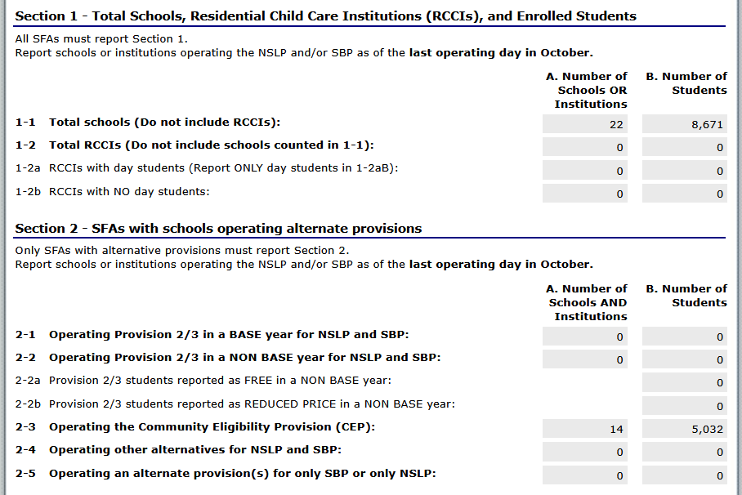

Step 9: Complete Section 3
3-1: For SFAs operating CEP district-wide (all sites) and RCCI without day students check box in question (Skip to Section 5)
3-2 and 3-3: For all other SFAs, complete these questions.
3-4: Question will be “0”.
Step 10: Complete Section 4
4-1, 4-2 and 4-3: Provide the number of applications in column A and number of students in column B, as applicable.
Software may offer reports with this information for you.
Helpful hint: The number of applications cannot exceed the number of students.
T-1 and T-2: Free and Reduced students are automatically generated by the numbers listed in 4-1, 4-2, and 4-3 above.
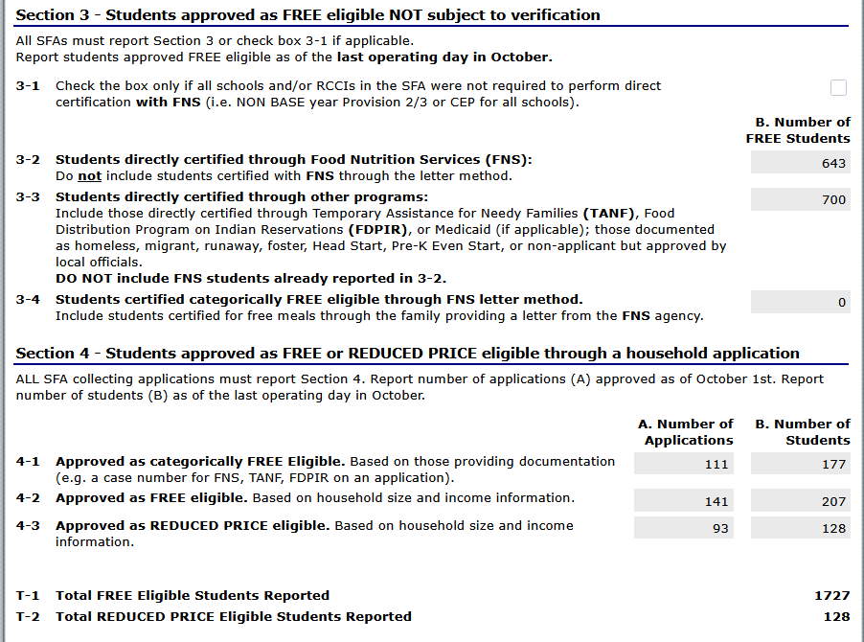

Step 11: Complete Section 5
5-1: For all SFAs offering CEP district-wide (all sites) and RCCI without day students check this box. Scroll to bottom and press “Save”. Verification report is complete.
5-1 through 5-7: Complete these questions based on the SFA.
5-5: List total number of applications in sample selection
5-6: Check this box if you did not conduct direct verification OR if you did not find any matches with direct verification.
5-7: Enter number of applications and students that were found in the direct verification match. (These students should also be listed in direct verification under Complete Direct Verification List.)

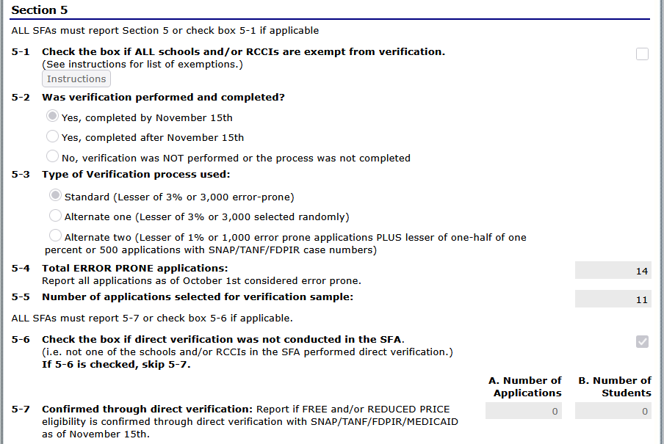

5-8 and VC-1: Enter the results of Verification in this section for both the number of applications and students. The number reported in 5-8 should include both the results of verification from verification process and the results from any application verified for cause reported in VC-1.
DO NOT include any Direct Verified students or applications in 5-8 results of verification.

VC-1: Enter the number of applications that are verified for cause. (If applicable or list NA.) These do not count towards the number of applications in 5-8.
Scroll to bottom and then press “Save”. Verification report is complete.
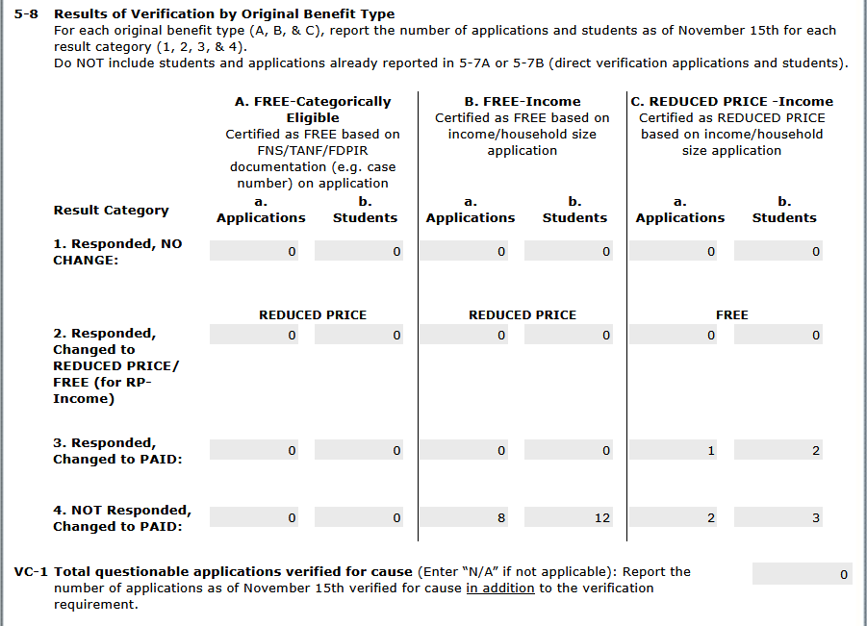

If the system indicates that the report is saved with “errors” double-check the information entered was correct and make changes to correct errors. You may also contact your Area Consultant or Dana Edwards, Program Analyst for assistance, dana.edwards@dpi.nc.gov or 984-236-2636.
If the SFA did not complete verification by November 15, over-verified, or under-verified, a Corrective Action Plan must be submitted to Dana Edwards, Program Analyst (dana.edwards@dpi.nc.gov). If the SFA did not complete Verification by November 15 but requested and received an extension from the State Agency, a Corrective Action Plan is not required.

