Instructions for Completing the Second Review of Application Report in the SN Technology System (SNTS)
PLEASE NOTE: Each year the Second Review of Applications Report must be completed by a School Food Authority (SFA) staff member with Application (AE) security rights in the SNTS. The due date is FEBRUARY 15.

- Click on Applications
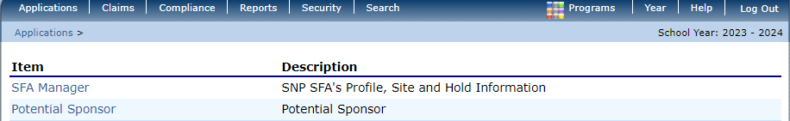

- Select Second Review of Applications
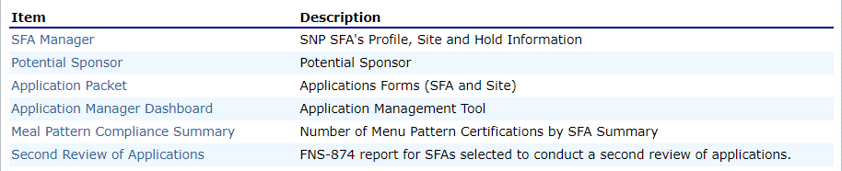

- Select Add
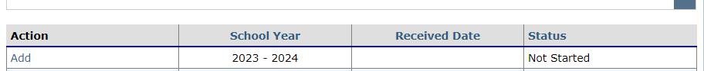
- 1-1: Total number of schools in the SFA. (This should be all sites approved to operate in the Application Packet.)
1-2: Total number of students enrolled at all schools.
1-3 & 1-4: Automatically calculated from 1-5 Results of Second Review
1-5: Enter application results into #1 for no change OR in each section of #2 & 3 under a, b, c, or d. This will calculate your totals for changes that occurred during the review of applications.

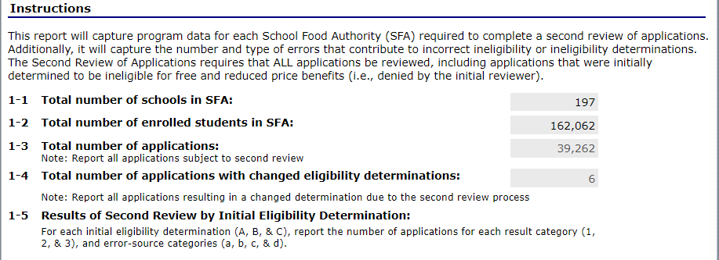
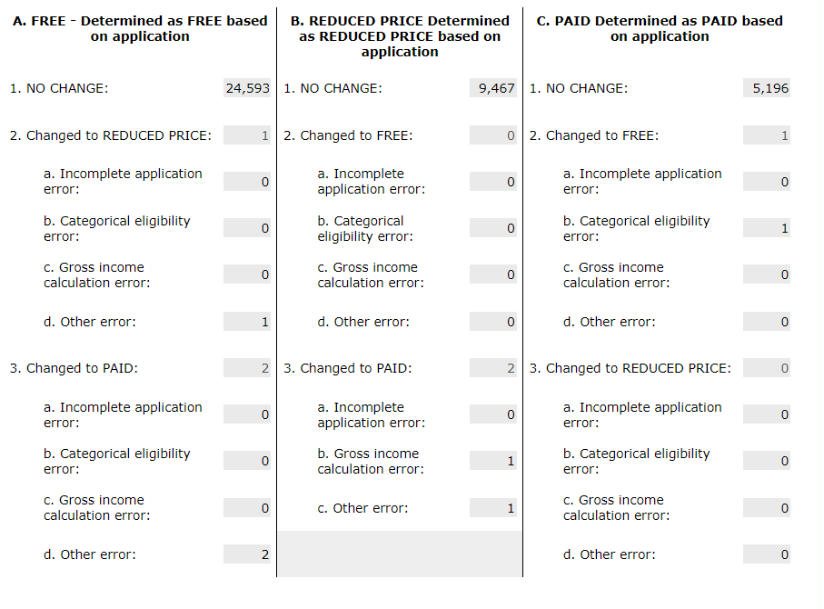
- Once completed, go to the bottom and SAVE.
Additional Instructions for Reporting FNS 874 are on the next page. If the system indicates that the report is saved with “errors” or you have questions, please contact Dana Edwards, Program Analyst at dana.edwards@dpi.nc.gov for assistance. The due date is FEBRUARY 15.

Additional Instructions for Reporting the FNS-874

For LEAs selected to conduct the second reviews of applications, enter the State agency name, either the LEA or SFA identification code (only one code needed), name of LEA or SFA, and the appropriate school year.

1-1: Total number of schools within LEA.
1-2: Total number of enrolled students in LEA.
1-3: The total number of reviewed applications (includes all applications, both those determined eligible and ineligible in the initial application review). Value should equal the sum of the categories (1-4 + 1-5A1 + 1-5B1 + 1-5C1).
1-4: The total number of applications in the LEA whose eligibility determinations changed as a result of the Second Review of applications. This includes the count of changes in eligibility determinations for all applications, both those determined eligible and ineligible in the initial application review. Value should equal the sum of the categories (1-5A2(a-d); 1-5A3(a-d); 1-5B2(a-d) 1-5B3(a-c); 1-5C2(a-d); & 1-5C3(a-d)).
1-5: This section captures information about the results from the second review of applications. All applications reported in 1-3 must be reported in this section (e.g. applications that were determined ELIGIBLE and INELIGIBLE during the INITIAL application review).
For each initial eligibility determination (A, B, & C), report the number of applications for each result category (1, 2, & 3). For applications with a changed initial eligibility determination, report the number of applications in each error source category that resulted in the eligibility determination change (only report in one error source category for each application). In some scenarios, one or more of the error sources may not be relevant. Error sources are as follows:
Incomplete application error examples include: lack of application signature, lack of SSN (last four digits), missing income value for household member(s), missing case numbers (i.e. SNAP), and other missing information that is necessary for an eligibility determination.
Categorical eligibility error examples include: invalid case numbers/identifiers, categorical eligibility claims known to be false, and invalid categorical standards.
Gross income calculation error examples include: incorrectly calculating household size, incorrectly determining the frequency of receipt of income, not converting multiple income sources to annual income, not counting the child in the list of household members or counting the child twice, incorrect arithmetic, misclassifying reportable income, and other income computation errors.
Other errors include: any errors that are not included in the other categories that caused a change in eligibility determination or benefit level during the second review of applications.
A1, B1, & C1: The total number of applications, by initial eligibility determination, that did not result in a change in eligibility determination or benefit level.
A2: The total number of applications Determined as FREE during the initial review of applications that changed to REDUCED PRICE due to the second review. Value should equal the sum of the error source categories under 1-5A2 (a, b, c, & d).
A2a-d: The number of applications with changes in eligibility determination by each error source.
A3: The total number of applications Determined as FREE during the initial review of applications that changed to PAID due to the second review. Value should equal the sum of the error source categories under 1-5A3 (a, b, c, & d).
A3a-d: The number of applications with changes in eligibility determination by each error source.
B2: The total number of applications Determined as REDUCED PRICE during the initial review of applications that changed to FREE due to the second review. Value should equal the sum of the error source categories under 1-5B2 (a, b, c, & d).
B2a-d: The number of applications with changes in eligibility determination by each error source.
B3: The total number of applications Determined as REDUCED PRICE during the initial review of applications that changed to PAID due to the second review. Value should equal the sum of the error source categories under 1-5B3 (a, b, & c).
B3a-c: The number of applications with changes in eligibility determination by each error source.
C2: The total number of applications Determined as PAID during the initial review of applications that changed to FREE due to the second review. Value should equal the sum of the error source categories under 1-5C2 (a, b, c, & d).
C2a-d: The number of applications with changes in eligibility determination by each error source.
C3: The total number of applications Determined as PAID during the initial review of applications that changed to REDUCED PRICE due to the second review. Value should equal the sum of the error source categories under 1-5C3 (a, b, c, & d).
C3a-d: The number of applications with changes in eligibility determination by each error source.

