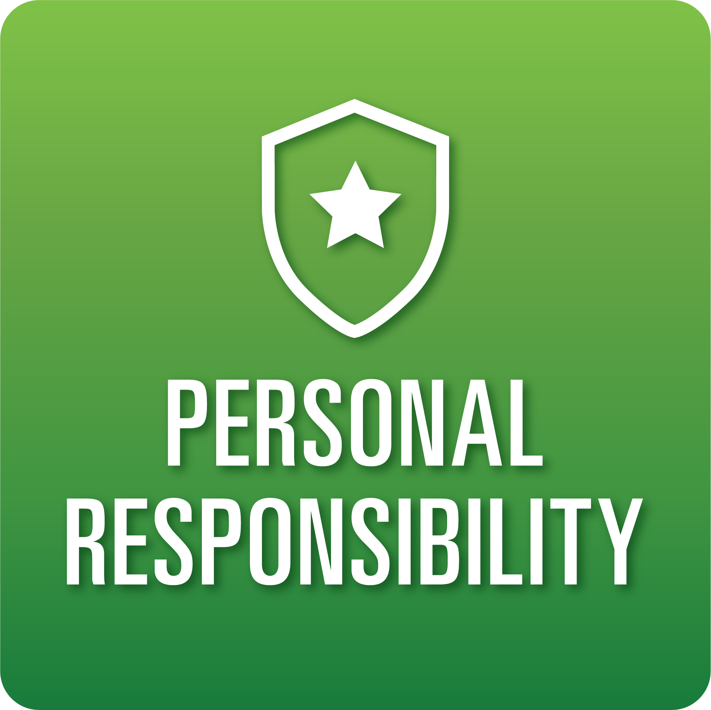
T-Chart for Improving Personal Responsibility Skills:
Grades 6-8
Select one of the following Personal Responsibility skills. Complete the T-Chart. Then, circle a “Look Like” and “Sound Like” behavior as your focus for improvement.

Task Initiation:
- I can recognize when to stop a task and begin a new task with minimal prompting.
- I can set a goal for the task at hand and prepare to engage in the necessary steps to complete the task.
- I can follow directions without prompting most of the time.
Planning/Prioritization:
- I can create a detailed plan to complete a task and follow through.
- I can remain on schedule and complete the outlined plan.
Persistence:
- I persist in getting tasks done accurately, with minimal assistance.
- I can set and complete goals on time with minimal assistance.
- I can recognize when I need help and ask for it.
Interpersonal Responsibility:
- I can show care and concern for others through actions and words.
- I understand the impact I have on others.
Intrapersonal Responsibility:
- I can self-regulate to work through a plan and correctly complete a task.
- I can exhibit self-discipline and/or self-motivation.
- I am aware of my thoughts, feelings, and intentions and their consequences.

When I _____________________________________________________________, it would…
Look like… (Be very specific) | Sound like… (Be very specific)
(To be completed at the end of a unit or performance task.)
Reflect: How did you improve your ability to demonstrate this skill?

