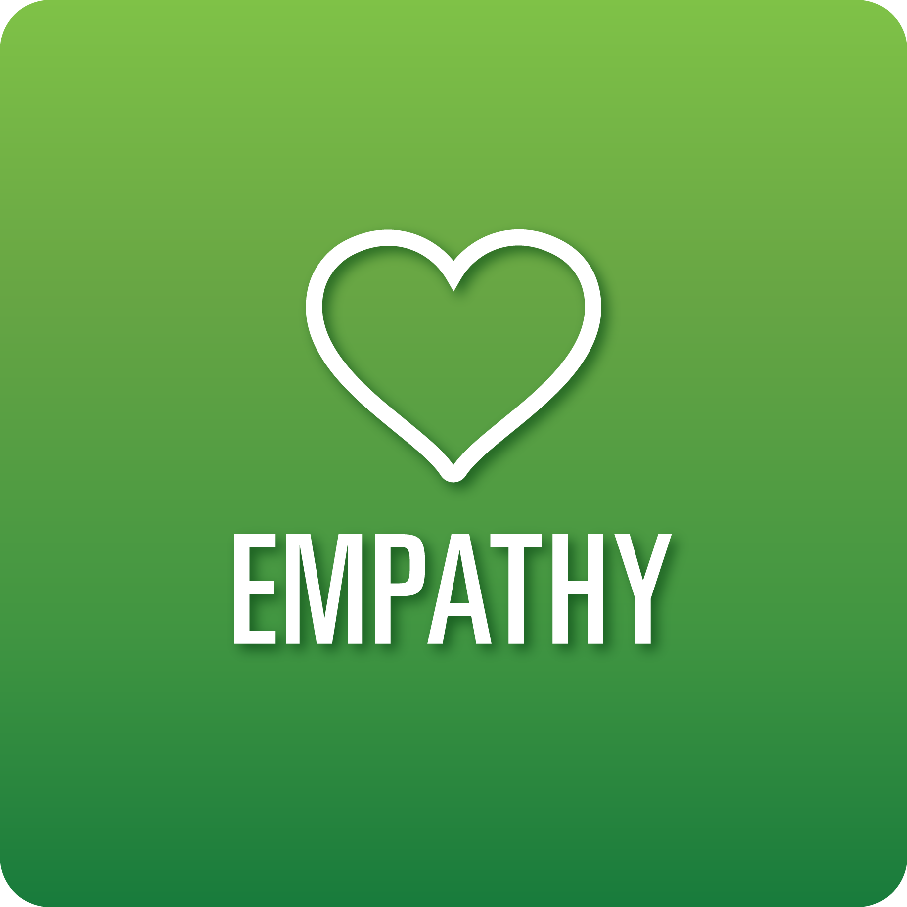
T-Chart for Improving Empathy Skills:
Grades 3-5
Select one of the following Empathy skills. Complete the T-Chart. Then, circle a “Look Like” and “Sound Like” behavior as your focus for improvement.

Perception of Self and Others:
- I can identify my feelings and viewpoints.
- I can identify the feelings and viewpoints of others based on their words, facial expressions, voice (tone), and body language.
Relationships:
- I can identify how choices about my words, actions, and behaviors affect others.
Diverse Perspectives:
- I understand and respect the viewpoints of others that are different from mine.
- I can explain how to respect the differences of others.
Effective Listening:
- I can allow others to share their ideas without interrupting.
- I can accurately paraphrase what others have shared to show I am listening.
- I can ask questions related to what the speaker is saying.

When I _____________________________________________________________, it would…
Look like… (Be very specific) | Sound like… (Be very specific)
(To be completed at the end of a unit or performance task.)
Reflect: How did you improve your ability to demonstrate this skill?

