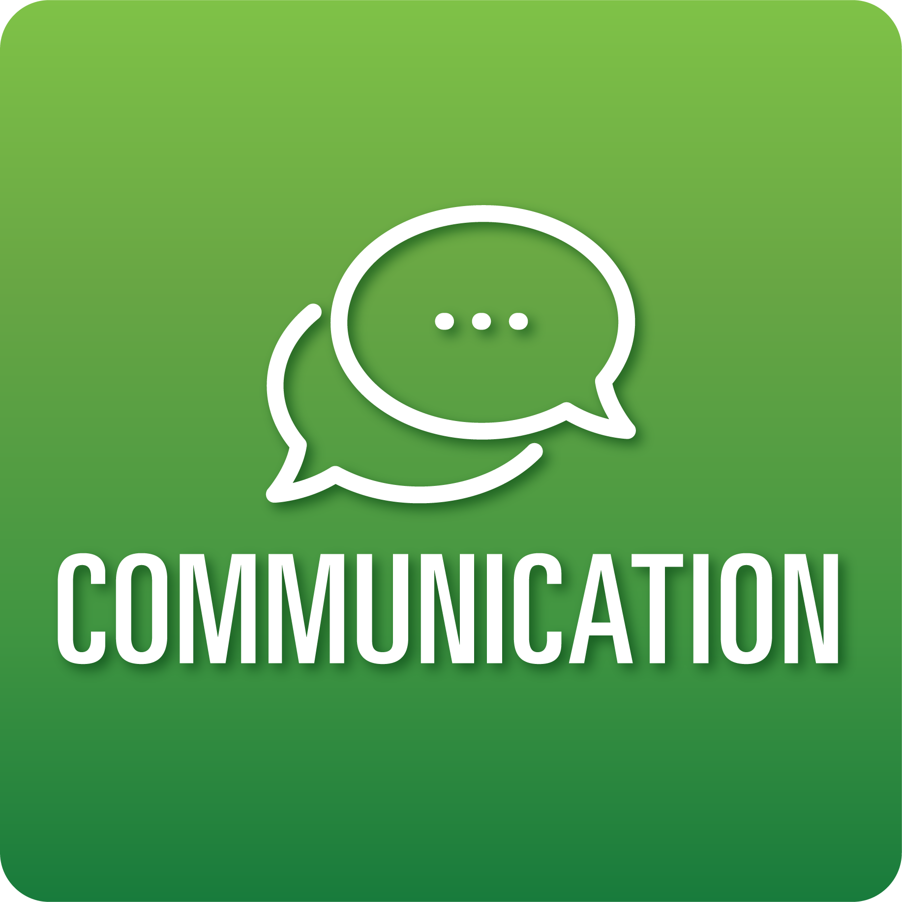
T-Chart for Improving Communication Skills:
Grades 6-8
Select one of the following Communication skills. Complete the T-Chart. Then, circle a “Look Like” and “Sound Like” behavior as your focus for improvement.

Engaging in Conversations:
- I can ask specific questions to check my understanding and deepen my knowledge during discussions.
- I can respond to others’ questions and comments with relevant connections and ideas.
- I can include evidence to support the views that I share during the discussion.
- I can accurately summarize information and perspectives shared during discussions.
Giving and Receiving Feedback:
- I can give specific, constructive feedback to my classmates about their work based on the success criteria provided.
- I can ask for specific feedback on my work.
- I can show acceptance for feedback.
- I can use feedback to improve my work.
Presenting Knowledge and Ideas:
- I can deliver a focused, coherent presentation using factual, relevant evidence, sound reasoning, and well-chosen details.
- I can speak clearly, at an understandable pace, using adequate volume.
- I can integrate visual displays or digital media to clarify information, strengthen claims, and add emphasis.
- I can answer questions to show my understanding.
When I _____________________________________________________________, it would…
Look like… (Be very specific) | Sound like… (Be very specific)
(To be completed at the end of a unit or performance task.)
Reflect: How did you improve your ability to demonstrate this skill?

