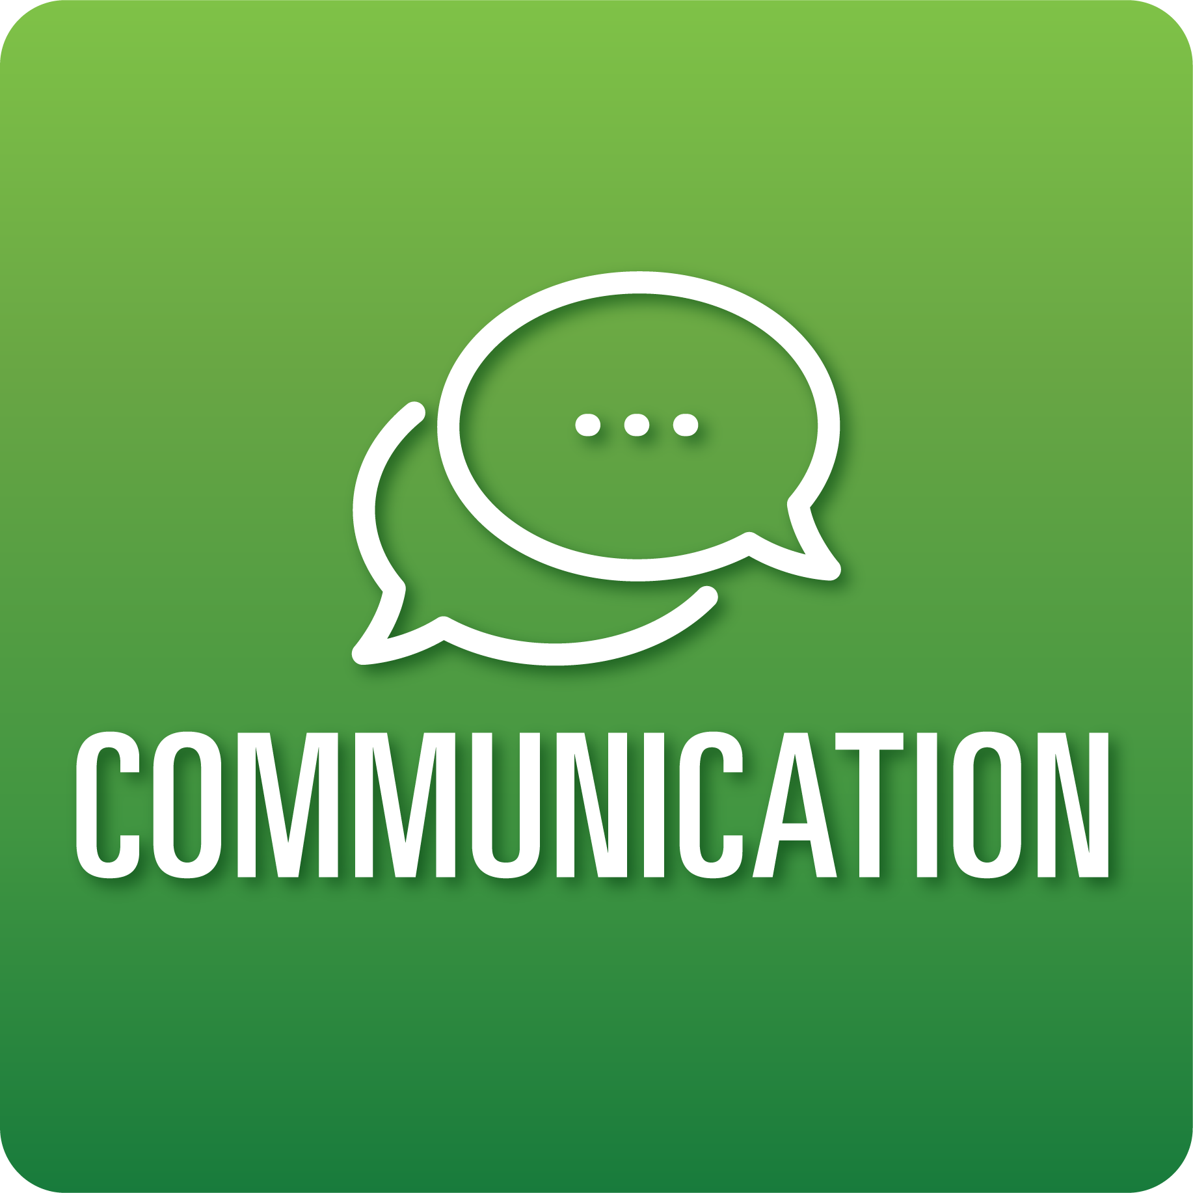
T-Chart for Improving Communication Skills:
Grades 3-5
Select one of the following Communication skills. Complete the T-Chart. Then, circle a “Look Like” and “Sound Like” behavior as your focus for improvement.

Engaging in Conversations:
- I can expand on others’ ideas during discussions.
- I can ask questions to better understand others’ comments.
- I can contribute to the discussion and connect my comments to what others say.
- I can summarize the main ideas made during a discussion.
Giving and Receiving Feedback:
- I can give constructive feedback to my classmates about their work.
- I can show acceptance for feedback.
- I can use feedback to improve my work with help from others.
Presenting Knowledge and Ideas:
- I can (tell a story, share my learning, etc.) using an appropriate amount of facts and details.
- I can speak clearly and at an understandable pace.
- I can use (props, drawings, visual displays, etc.) to support what I say and to emphasize important facts or ideas.
- I can answer questions to show my understanding.
When I _____________________________________________________________, it would…
Look like… (Be very specific) | Sound like… (Be very specific)
(To be completed at the end of a unit or performance task.)
Reflect: How did you improve your ability to demonstrate this skill?

