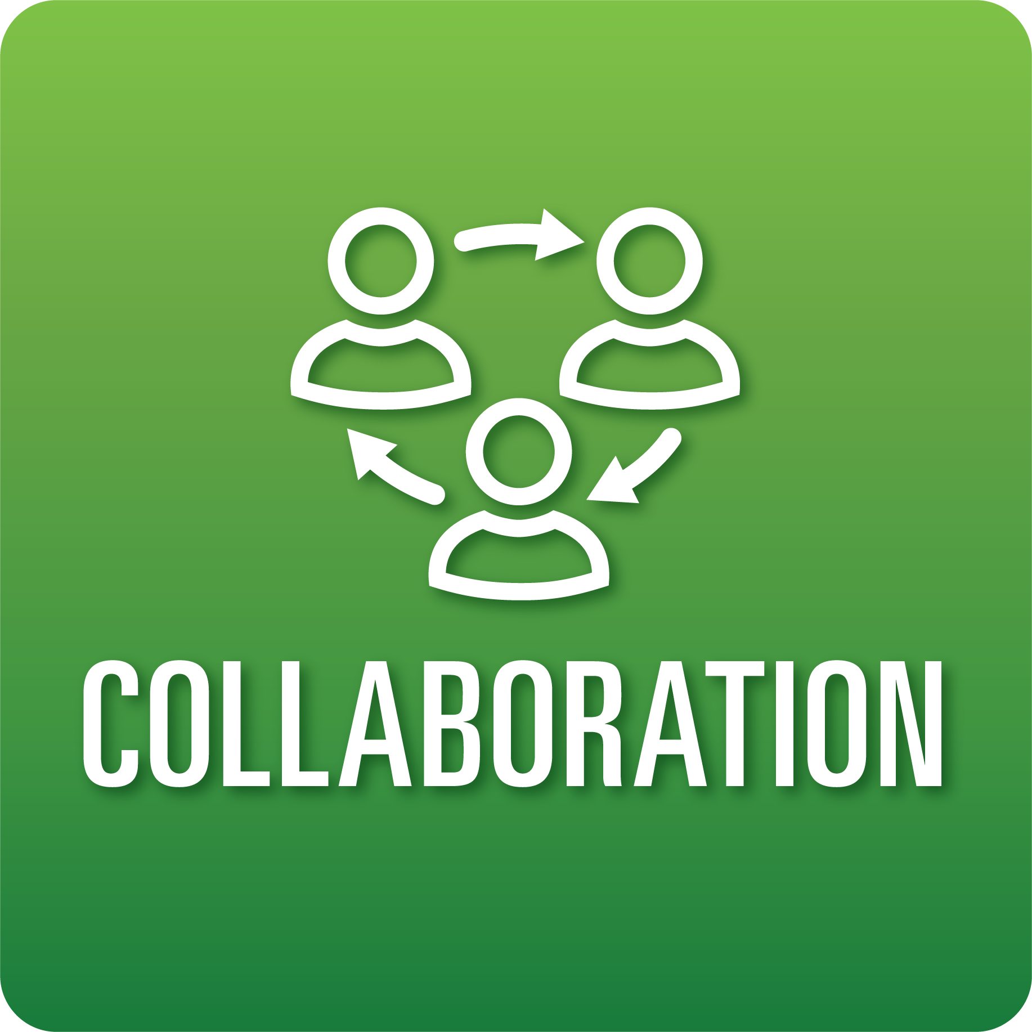
T-Chart for Improving Collaboration Skills:
Grades 9-12
Select one of the following Collaboration skills. Complete the T-Chart. Then, circle a “Look Like” and “Sound Like” behavior as your focus for improvement.

Roles:
- I can play a variety of roles and carry out different responsibilities that help my team meet goals.
- I can share the leadership responsibilities of my team.
- I can adjust to and respond to the needs of the group to achieve goals.
Cooperation:
- I can collaborate respectfully with my teammates in digital spaces.
- I can consistently follow our defined team norms and decision-making agreements.
- I can help my team solve problems or conflicts.
Productivity and Accountability:
- I can show that I am consistently prepared and ready to work with my team.
- I can prioritize and track individual and group progress toward established goals and deadlines.
- I can complete my tasks on time consistently.

When I _____________________________________________________________, it would…
Look like… (Be very specific) | Sound like… (Be very specific)
(To be completed at the end of a unit or performance task.)
Reflect: How did you improve your ability to demonstrate this skill?

