 Office of Exceptional Children

Request for Facilitated IEP Team Meeting
*Requests must be submitted at least (10) business days before a scheduled IEP Team meeting.
* Each section of this form must be completed. An incomplete form may result in a delay or denial of request.
*The assignment of a facilitator is based on both parties agreeing to engage in the FIEP process.
Request made by: Parent LEA Other
Contact Information for Parent/Guardian |  | Student Information
Name: |  | Student Name:
Address: |  | Area of  Exceptionality:
City/Zip: |  | Age & Grade:
County: |  | Name of School/Charter School:
Telephone: |  | Principal:
Email: |  | Birthdate:

Contact Information for LEA |  |  | Purpose of Request
Contact Person: Phone: Address: City/ZipEmail: | 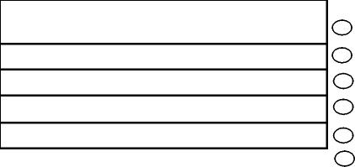 | Initial Referral, Evaluation, Eligibility
Contact Person: Phone: Address: City/ZipEmail: |  | Annual Review  IEP (review and revise, as appropriate)  Manifestation Determination Review  Re-evaluation Process  Other (explain):
*It is an expectation that one or more resolution options
have been attempted, please indicate below (with date):

Date: Early attempts at resolution: | Results of resolution attempts (required):
Parent-Teacher Conference
Parent-School Admin. Conference
IEP Team Meeting
Parent- EC Director Conference

If an IEP meeting has already been scheduled, what is the agreeable date between the parent and LEA:
***Please consider and sign the FERPA form regarding information sharing***
Name of Person Submitting this Request:
Name: _________________________________________ Date: ____________________________
(Please Print)
Signed: ___________________________________________ Date:
SEND SIGNED FORM VIA E-MAIL TO:
Facilitation Coordinator
NC DPI Exceptional Children Division
6356 Mail Service Center ~ Raleigh, NC 27699-6356
E-mail: Facilitation@dpi.nc.gov
FIEP -1
1.10.23

