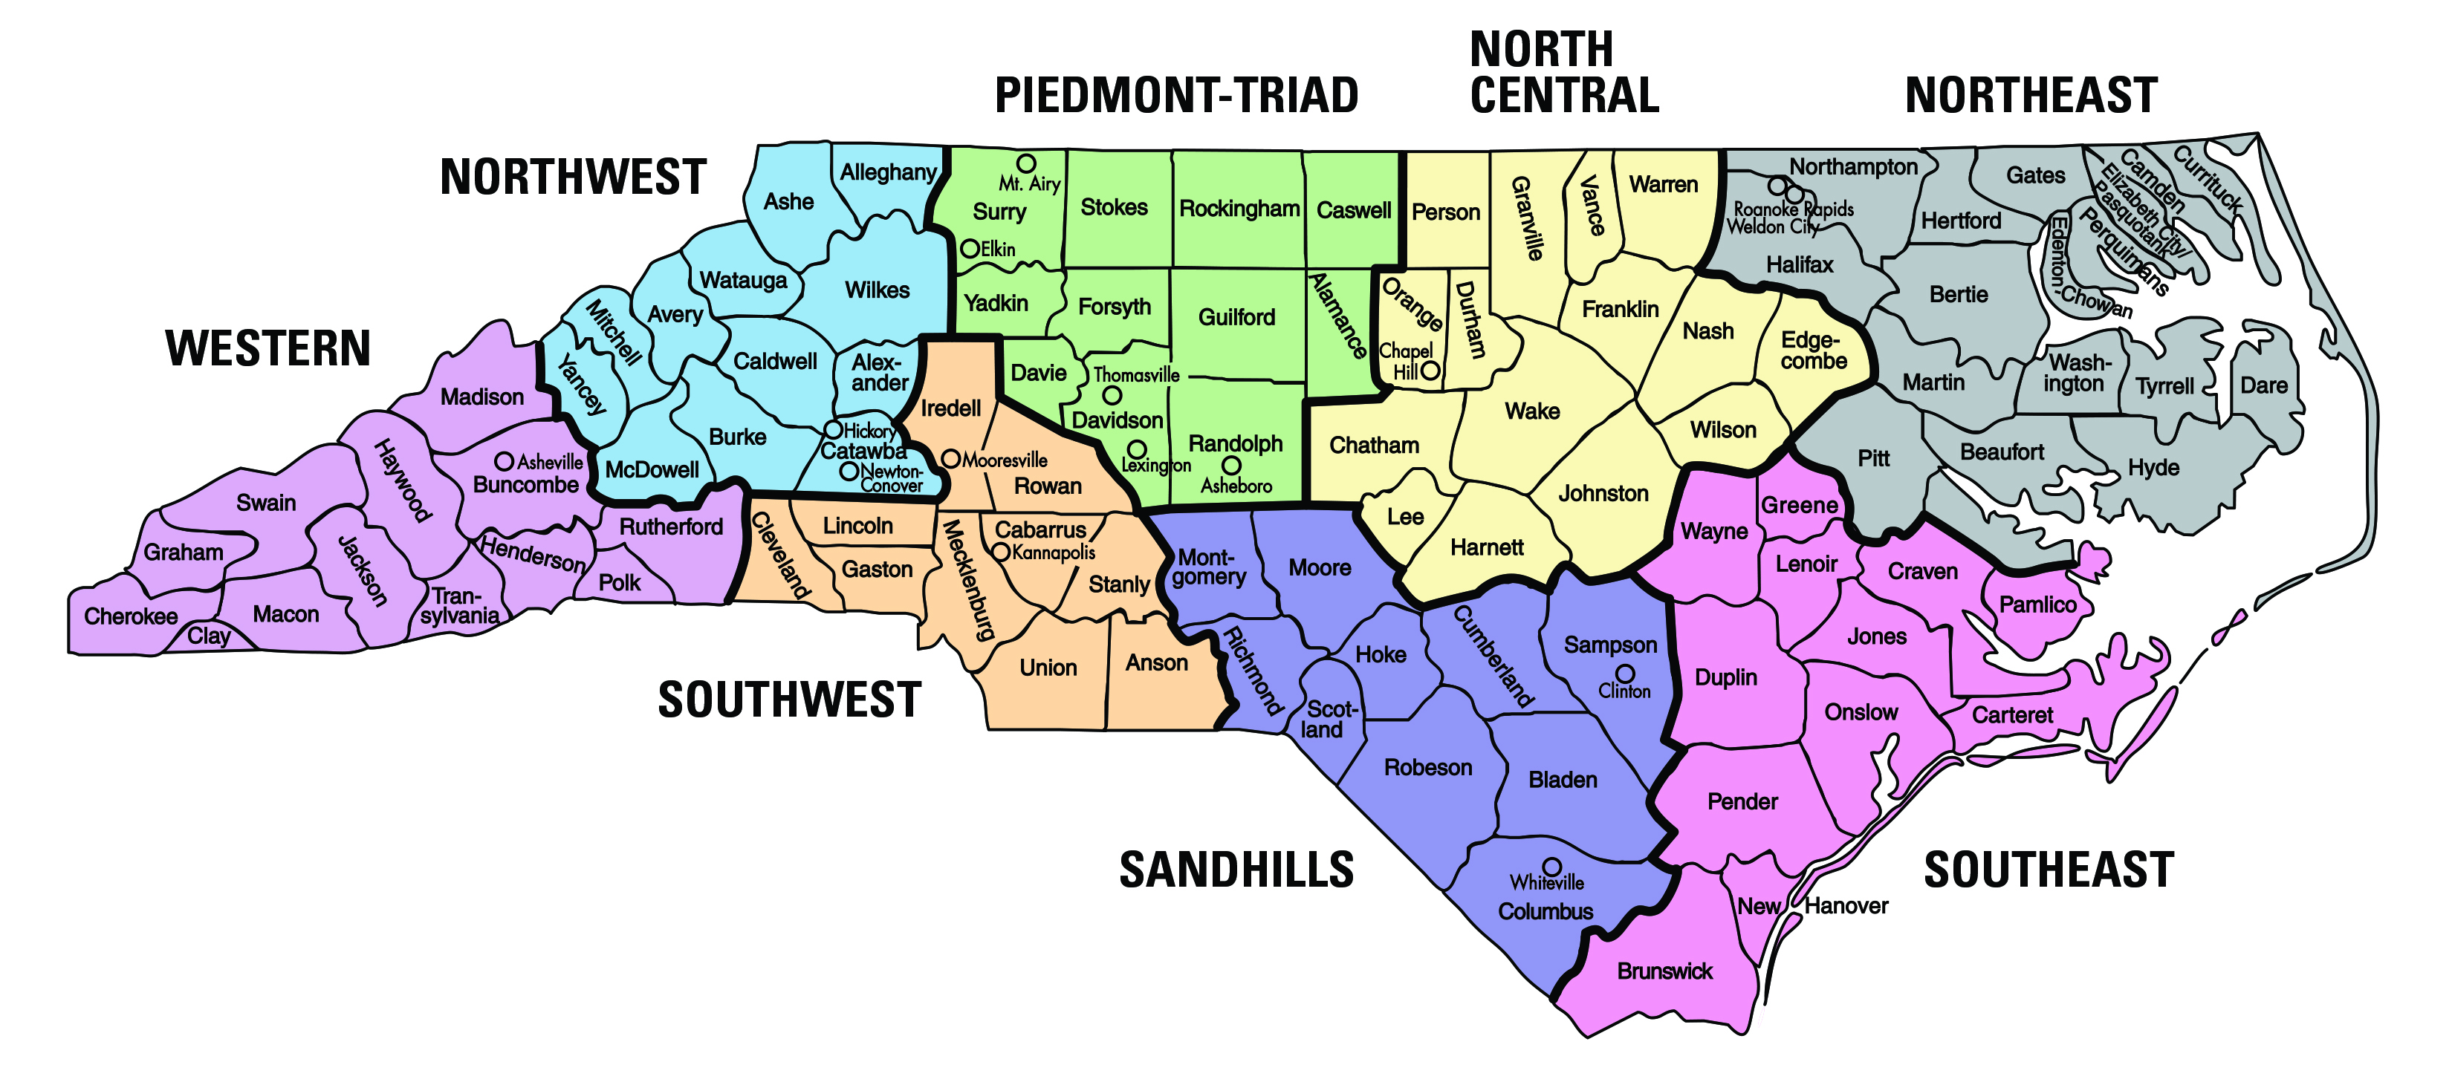
M. Sharpe-Literacy
C. Miller-Math
F. Goodgion-Behavior Support
C. Favasuli - Regional
R. McOuat-Regional Charters
E. Loring-Monitor
K. O’Farrow-Boulware-ECATS
C. Patrick-VI
G. Madorin-D/HH
A. Passmore-Autism
L. Blanton-IDEA 611
D. Meskil-IDEA 619
T. Queen-Literacy
VACANT-Math
F. Goodgion-Behavior Support
T. Royal-Regional
L. Metcalf-Regional Charters
P. Cox-Monitor/SOPs
K. O’Farrow-Boulware-ECATS
C. Patrick-VI
G. Madorin-D/HH
H. Carico-Autism
A. Parent-IDEA 611
D. Meskil-IDEA 619

B. Gilchrist-Literacy
C. Moffitt-Math
L. Taylor-Behavior Support
A. Betz-Regional
R. McOuat-Regional Charters
S. Stone-Monitor
VACANT-ECATS
A. Chase-VI
N. Woytowich-D/HH
N. Childress-Autism
E. Millen-IDEA 611
K. Walker-IDEA 619
B. Bilbro-Literacy
M. Towery-Math
L. Taylor-Behavior Support
A. Gray-Regional
M. Hamm-Regional Charters
K. Little-Monitor
VACANT-ECATS
A. Chase-VI
N. Woytowich-D/HH
M. Kaniuka-Autism
M. Martina-IDEA 611
K. Walker-IDEA 619
B. Bilbro-Literacy
M. Towery-Math
L. Taylor-Behavior Support
A. Gray-Regional
M. Hamm-Regional Charters
K. Little-Monitor
VACANT-ECATS
A. Chase-VI
N. Woytowich-D/HH
M. Kaniuka-Autism
M. Martina-IDEA 611
K. Walker-IDEA 619
B. Gilchrist-Literacy
C. Moffitt-Math
L. Taylor-Behavior Support
A. Betz-Regional
M. Hamm-Regional Charters
G. Hagins-Monitor/PRTFS
VACANT-ECATS
A. Chase-VI
N. Woytowich-D/HH
N. Childress-Autism
E. Millen-IDEA 611
K. Walker-IDEA 619

M. Sharpe-Literacy
C. Miller-Math
F. Goodgion-Behavior Support
C. Favasuli-Regional
L. Metcalf-Regional Charters
A. Monterosso-Monitor
T. Cestaro-Monitor
K. O’Farrow-Boulware-ECATS
C. Patrick-VI
G. Madorin-D/HH
A. Passmore-Autism
L. Blanton -IDEA 611
D. Meskil-IDEA 619
T. Queen-Literacy
VACANT-Math
F. Goodgion-Behavior Support
T. Royal-Regional
L. Metcalf-Regional Charters
P. Cox-Monitor/SOPs
K. O’Farrow-Boulware-ECATS
C. Patrick-VI
G. Madorin-D/HH
H. Carico-Autism
A. Parent-IDEA 611
D. Meskil-IDEA 619
Legend

ECATS: Every Child Accountability System

VI: Visual Impairment

D/HH: Deaf/Hard of Hearing

IDEA: Individuals with Disabilities Education Act

