Verification Collection Report Instructions – School Nutrition Technology System (SNTS)
Verification Report must be completed by a School Food Authority (SFA) staff member with Application (AE) security rights in the SNTS. This report must be completed by ALL SFAs.
For ALL SFA Types except Special Milk:

Step 1: Log into the SN Technology System at https://schoolnutrition.dpi.nc.gov/snp/NcidLogin.aspx
Step 2: Select “Application” tab.
Step 3: Select “Verification Report”. Step 4: Select “Modify”.
Step 5: Confirm “General Information” in questions 1-4 is correct. Make any changes necessary.
Step 6: Complete Section 1
1-1: For Traditional SFA, Non-public and Charter Schools students
(enter TOTAL number of schools in SFA and students in enrollment)
The total schools are the same as the number approved in the Application Packet.
1-2 and 1-2a: For RCCI with day students
1-2 and 1-2b: For RCCI without day students
Step 7: Complete Section 2
2-3: For SFAs operating Community Eligibility Provision (CEP) – enter the number of schools operating CEP and number of students enrolled in the CEP schools
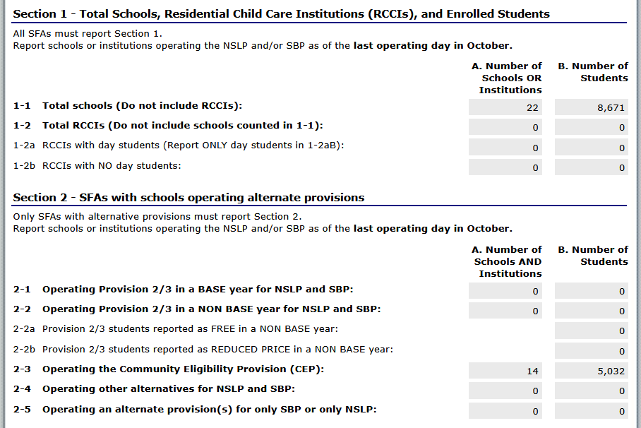
Step 8: Complete Section 3
3-1: For SFAs operating CEP district-wide (all sites) and RCCI without day students check box in question (Skip to Section 5)
3-2 and 3-3: For all other SFAs, complete these questions.
3-4: Question will be “0”.
Step 9: Complete Section 4
4-1, 4-2 and 4-3: Provide the number of applications in column A and number of students in column B, as applicable.
Software may offer reports with this information for you.
Helpful hint: The number of applications cannot exceed the number of students.
T-1 and T-2: Free and Reduced students are automatically generated by the numbers listed in 4-1, 4-2, and 4-3 above.

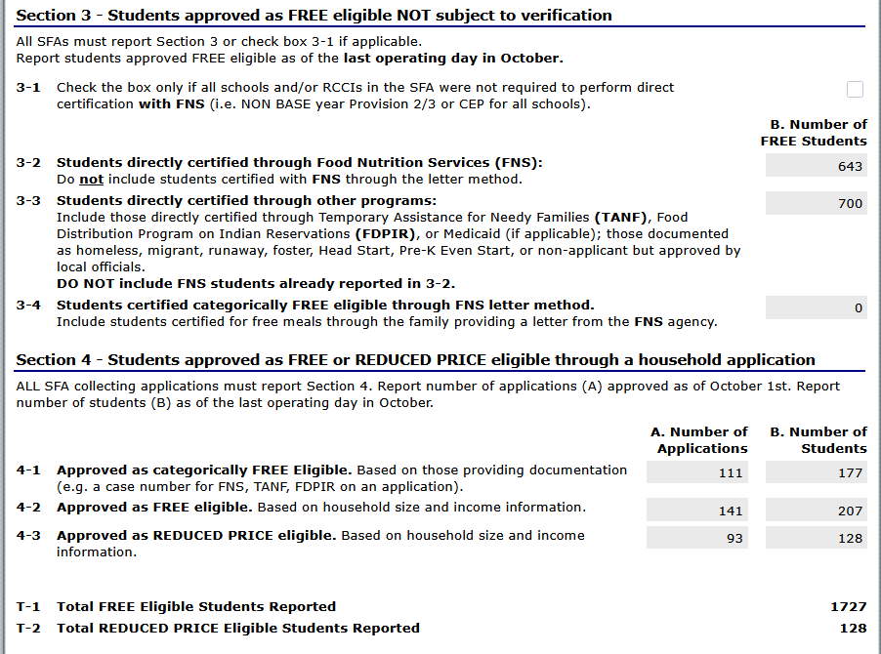

Step 10: Complete Section 5
5-1: For all SFAs offering CEP district-wide (all sites) and RCCI without day students check this box. Scroll to bottom and press “Save”. Verification report is complete.
5-1 through 5-7: Complete these questions based on the SFA.
5-5: List total number of applications in sample selection
5-6: Check this box if you did not conduct direct verification OR if you did not find any matches with direct verification.
5-7: Enter number of applications and students that were found in the direct verification match. (These students should also be listed in direct verification under Complete Direct Verification List.)
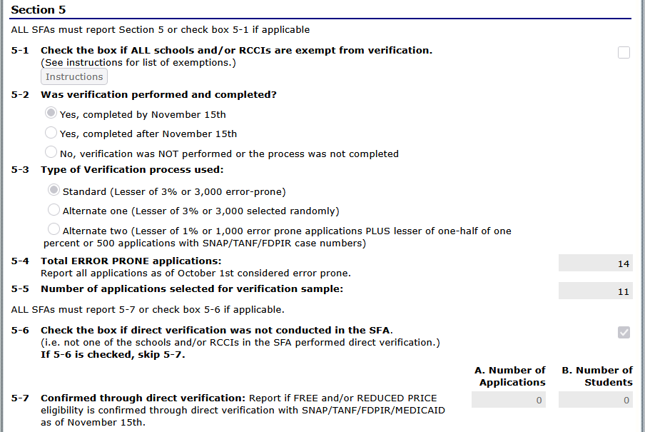

5-8 and VC-1: Enter the results of Verification in this section for both the number of applications and students. The number of applications should equal the number of applications selected for verification sample in 5-5.
VC-1: Enter the number of applications that are verified for cause. (If applicable or list NA.) These do not count towards the number of applications in 5-8.
Scroll to bottom and then press “Save”. Verification report is complete.
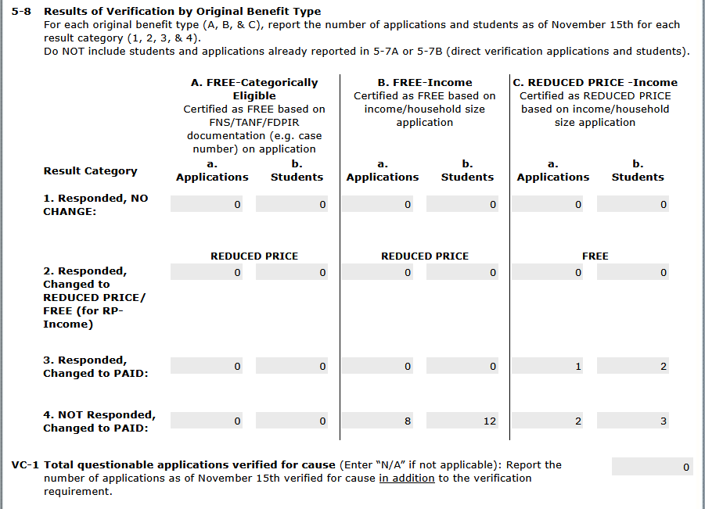

If the system indicates that the report is saved with “errors” double-check the information entered was correct and make changes to correct errors. You may also contact your Area Consultant or Dana Edwards, Program Analyst for assistance, dana.edwards@dpi.nc.gov or 984-236-2636.
If the SFA did not complete verification by November 15, over-verified, or under-verified, a Corrective Action Plan must be submitted to Dana Edwards, Program Analyst (dana.edwards@dpi.nc.gov). If the SFA did not complete Verification by November 15 but requested and received an extension from the State Agency, a Corrective Action Plan is not required.

