**NC Department of Public Instruction (NCDPI) – Office of School Nutrition**

**Special Milk Program (SMP)**

**What is the Special Milk Program?**



The Special Milk Program provides milk to children in schools, non-profit childcare and residential institutions that do not participate in other Federal School Nutrition meal service programs. The program reimburses institutions for the milk they serve; however, milk served to adults is **not** eligible for reimbursement. Schools in the National School Lunch (NSLP) or School Breakfast Programs may also participate in the SMP to provide milk to children in half-day pre-kindergarten and kindergarten programs where children do not have access to the school meal programs.

**What type of milk must be offered?**

Allowable milk options include pasteurized fluid types of fat-free (skim) or low-fat (1 percent fat or less) flavored and unflavored. Milk with higher fat content is not allowed unless otherwise stated by a Medical Statement. Low-fat or fat-free, lactose-free and reduced-lactose fluid milk may also be offered. All milk should contain vitamins A and D at levels specified by the Food and Drug Administration and be consistent with state and local standards for such milk. Fluid milk offered must meet the nutrition standards as specified by the NSLP or comply with the Fluid Milk Substitute rule requiring that nondairy beverages offered as fluid milk substitutes be nutritionally equivalent to fluid milk and provide specific levels of calcium, protein, vitamins A and D, magnesium, phosphorus, potassium, riboflavin, and vitamin B-12.

**What type of Special Milk Program can we operate?** The milk program must be open to all enrolled children. Milk may be either non-pricing or pricing. There are three options:

|  |  |
| --- | --- |
| **1. Pricing Program with Free Option** | Milk is free to eligible children and is sold to other children at a reduced price. A standard rate of reimbursement is provided for the milk sold to paying children, and an average of the actual price paid for the milk is reimbursed for the milk provided for non-paying children. This option requires eligibility documentation. |
| **2. Pricing Program without Free Option** | Milk is sold to all children at a reduced price, such as the actual price of milk minus the amount of the USDA reimbursement. This option does not require eligibility documentation. |
| **3. Nonpricing Program** | Milk is served free to all participating children. You are reimbursed a standard rate for each half-pint of milk served. This option does not require eligibility documentation. |

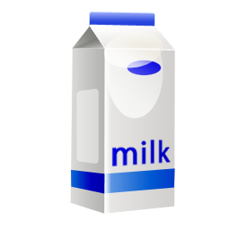

**Under the terms of the Annual Agreement, each SMP sponsor agrees to:**

* Complete the online agreement and submit the signature pages and other requested documentation in a timely manner.
* Operate a non-profit milk service.
* Provide milk to all children without regard to race, color, national origin, sex (including gender identity and sexual orientation), age or disability.
* Comply with financial requirements and provisions.
* Record the number of half-pints of milk when served each day by site and by category (free milk and purchased milk).
* Purchase milk through competitive bidding methods that ensure free and open competition.
* Ensure adequate quantities of milk are available. Milk may be purchased in bulk, but it is claimed in half pints. There is no limit on half pints per child per day. Therefore, you can serve milk in quantities suitable for the child’s age but only claim the number of half pints served total. Your milk count system must provide accurate counts of reimbursable milk served to eligible children.
* Keep in file all applications submitted by the households for free milk (if electing to provide the pricing program with free option).
* Maintain all records for a period of three years after the end of the fiscal year to which they pertain and comply with record keeping requirements.

**How Do We Get Reimbursed?**

The NCDPI Office of School Nutrition will reimburse you for milk that is served to eligible enrolled children in attendance. You may claim reimbursement for milk served beginning with the approval date of your Annual Agreement. At each milk service, make an actual count of the enrolled children who are present and the number of half-pints of milk served to them. Record the number of enrolled children who are present who are eligible for paid or free milk. This data determines the reimbursement that you will receive each month. The USDA issues new reimbursement rates each July. Reimbursement must not exceed the cost of the milk.

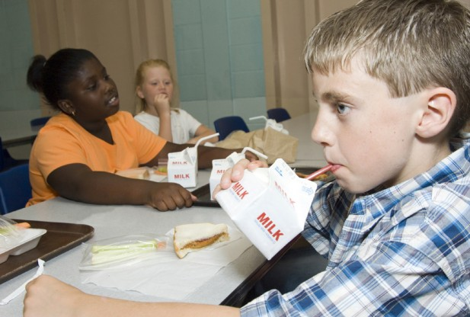

**Additional Resources:** If you would like further information about reimbursements, program regulations, menu planning, and more for the Special Milk Program, go to <http://www.fns.usda.gov/smp/special-milk-program> , <http://www.benefits.gov/benefits/benefit-details/1450> or <http://www.ecfr.gov/cgi-bin/text-idx?tpl=/ecfrbrowse/Title07/7cfr215_main_02.tpl>

You can also contact our Special Milk Program Consultant at the address below:

NC Department of Public Instruction

Office of School Nutrition

6324 Mail Service Center

Raleigh NC, 27699

984.236.2910

**USDA Nondiscrimination Statement**

In accordance with federal civil rights law and USDA civil rights regulations and policies, the USDA, its agencies, offices, employees, and institutions participating in or administering USDA programs are prohibited from discriminating based on race, color, national origin, religion, sex, disability, age, marital status, family/parental status, income derived from a public assistance program, political beliefs, or reprisal or retaliation for prior civil rights activity, in any program or activity conducted or funded by USDA (not all bases apply to all programs). Remedies and complaint filing deadlines vary by program or incident.

Persons with disabilities who require alternative means of communication for program information (e.g., Braille, large print, audiotape, American Sign Language, etc.) should contact the state or local agency that administers the program or contact USDA through the Telecommunications Relay Service at 711 (voice and TTY). Additionally, program information may be made available in languages other than English.

To file a program discrimination complaint, complete the USDA Program Discrimination Complaint Form, [AD-3027](https://www.usda.gov/sites/default/files/documents/ad-3027.pdf), found online at How to File a Program Discrimination Complaint and at any USDA office or write a letter addressed to USDA and provide in the letter all of the information requested in the form. To request a copy of the complaint form, call (866) 632-9992. Submit your completed form or letter to USDA by:

1. **Mail**: U.S. Department of Agriculture, Office of the Assistant Secretary for Civil Rights, 1400 Independence Avenue, SW, Mail Stop 9410, Washington, D.C. 20250-9410;
2. **Fax**: (202) 690-7442; or
3. **Email**: [program.intake@usda.gov](mailto:program.intake@usda.gov).

USDA is an equal opportunity provider, employer, and lender.