Page 1 |  |  | NC Department of Public Instruction  Office of School Nutrition  Special Milk Program Daily/Weekly Worksheet for Pricing Programs |  |  |  |  |  |  |  |  |  |  |  |  |  |  |  |  |  |  |  |  |  |  | Class/Teacher/Room #:  _ __
Dates of Service
 | Code | Sunday |  |  |  |  | Monday |  |  |  | Tuesday |  |  |  |  | Wednesday |  |  |  | Thursday |  |  |  |  | Friday |  |  |  |  | Saturday
Child’s Name |  | B |  | L | D | S | B | L | D | S | B | L | D |  | S | B | L | D | S | B | L | D | S |  | B |  | L | D | S | B | L | D | S
Daily Totals
Daily Adult Totals
# of ½ Pints of Milk Purchased
Cost of Milk
Weekly Summary
Free Category |  |  |  |  |  |  |  |  |  |  |  |  |  | Paid (Non-Free) Category
Breakfast: |  |  |  |  |  | Dinner/Supper: |  |  |  |  |  |  |  | Breakfast: |  |  |  |  |  |  |  |  |  | Dinner/Supper:
Lunch: |  |  |  |  |  | Snack: |  |  |  |  |  |  |  | Lunch: |  |  |  |  |  |  |  |  |  | Snack:
Name of Responsible Person for Daily Milk Count: __________________________________________________________
Page ____ |  |  | NC Department of Public Instruction  Office of School Nutrition  Special Milk Program Daily/Weekly Worksheet for Pricing Programs |  |  |  |  |  |  |  |  |  |  |  |  |  |  |  |  |  |  |  |  |  |  | Class/Teacher/Room #:  _ __
Dates of Service
 | Code | Sunday |  |  |  |  | Monday |  |  |  | Tuesday |  |  |  |  | Wednesday |  |  |  | Thursday |  |  |  |  | Friday |  |  |  |  | Saturday
Child’s Name |  | B |  | L | D | S | B | L | D | S | B | L | D |  | S | B | L | D | S | B | L | D | S |  | B |  | L | D | S | B | L | D | S

Special Milk Program Daily/Weekly Worksheet for Pricing Programs
Class/Teacher/Room #: Fill in the name of the class or teacher and or the number of the room when milk is served in multiple locations.

Dates of Service: Fill in the date for each day meals are served.

Child’s Name: Fill in each child’s name in alphabetical order.

Code:
Pricing Program with Free Option - Codes must be developed for children receiving free milk and children paying for milk and placed in the code column. Codes used should prevent overt identification of a student’s eligibility for benefits.
Pricing Program Without Free Option - Codes may be left blank (income eligibility household applications are not required).

The documentation for the above items can be typed in on each page; however, the documenting of point of service milk counting must be completed manually along with all the documentation for the items following.

Milk Counting: Record at the Point of Service (POS) under each meal type (B/L/D/S) that the child received a ½ pint of milk. B = Breakfast, L = Lunch, D = Dinner/Supper, S = Snack. If the child receives more than one ½ pint of milk at during a meal service put a check mark for each time a child is served a milk during the meal service. For example: if a child was served two ½ pints of milk during L, there should be 2 check marks in the L box.
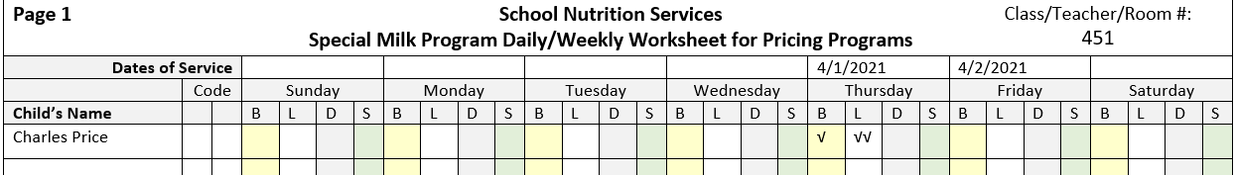

Daily Total: Total each column for milk served to children per meal type daily (from page 1 and any additional pages used) and document the compiled total daily count on page 1.

Daily Adult Total: Document the total daily count in each column for milk served to adults per meal type on page 1.

# of ½ Pints of Milk Purchased: Record the number of ½ pints of milk purchased daily. If no milk was purchased, put a zero for the day.
Cost of Milk: Record the cost of the milk purchased for each day. If zero milk was purchased on a day, put a zero for the cost of milk for that day.
Weekly Summary: Free Category - Record the weekly counts of milk served to children eligible for free milk. Paid (Non-Free) Category - Record the weekly counts of milk served to children not eligible for free milk. Milk counts are to be documented by meal types.
Record the name of person counting the milk. If multiple persons count milk daily during the week, record all names responsible for the milk counts.
Keep all records on file for three (3) years plus the current year.

