The Identified Student Percentage (ISP) is established as of April 1st in the School Year prior to implementing the Community Eligibility Provision (CEP).  **Documentation must be on file while operating under CEP and for three (3) years after the submission of the final claim for reimbursement for the last fiscal year of CEP.**

## **The following source documentation is mandatory to have on file:**

## Direct Certification list from SNTS in Excel form

## SN software report (if applicable)

## Extended Benefits (Software or Spreadsheet)

## Student Enrollment

**Step1: Student Enrollment**

* Confirm that the Student Information System (SIS) enrollment summary matches the Point of Sale (POS) enrollment summary for **each individual school** as of April 1st. A list of students in each site is not needed, just the summary
* Print or save a copy of enrollment summary for each individual school from SIS and the POS

**Step 2a:** **Direct Certification from SNTS (****SFAs with POS)**

* Import the SNTS Direct Certification (DC) into the POS following the software’s instruction
* Save file that was imported

*If there are students listed under an invalid school code, double check with your Student Information System Administrator. These usually are students that receive special services but are not counted in enrollment/membership as they don’t have access to meal services*

**Step 2b: Direct Certification from SNTS (SFAs without POS)**

* Download the SNTS Direct Certification (DC) list
* Remove “transfer” students and “Medicaid Reduced” from list
* Remove any duplicate students that may be listed
* Arrange by School Code
* Save file

**Step 3: School Nutrition Software (SFAs with POS)**

* Report for each School Site must have the following information
  + Student ID Number
  + Last Name
  + First Name
  + School Code
  + Grade
  + DC Type (Medicaid Reduced will need to be removed)

**Step 4: Extended Benefits**

Extended benefits are for students that were not counted in the DC system but qualify as Other Categorical due to living in a household where another student received SNAP, TANF, FDPIR; or they are considered migrant, homeless, foster, or runaway. **Student(s) can only be counted once and cannot be counted in multiple categories.** Double check for duplicates in any category. If a student is counted in Direct Certification and from other categorical , you will include the student count in the Direct Certification column. *Example: If a student is listed as a foster student but also listed as a direct certification student, then the student can only be counted once. You would remove the student from the foster list as they have been counted in the DC list.*

* Students that live in the same household with another student who is directly certified to receive **SNAP, TANF, FDPIR** must have documentation that includes the name of student who is eligible for extended benefits, name of qualifying student (directly certified or categorically eligible based on approved application), date SFA extended benefits to student, documentation of extended benefits student (name of household contact, telephone number for household, name of SFA staff making contact).
* **Runaway** students that have extended benefits must have documentation with signature from the Local Education Agency (LEA) liaison or designated official from Runaway services verifying student(s) name and effective dates.
* **Migrant** students that have extended benefits must have documentation with signature from the Local Education Agency (LEA) liaison or designated official from Migrant services verifying student(s) name and effective dates; or a letter from MEP official or LEA liaison confirming that the student currently meets the definition of migrant for non-automated local level data sharing.
* **Homeless** students that have extended benefits must have documentation with signature from the Local Education Agency (LEA) liaison, or designated official from Homeless services verifying student(s) name and effective date; or documentation verifying the student qualifies under the Runaway and Homeless Youth Act.
* **Foster** students that are extended benefits must have a letter, document, or list of children from the State, local welfare agency, or Court confirming the student's status as a foster child. **HOUSEHOLD APPLICATIONS STATING FOSTER CANNOT BE COUNTED.**
* **Head Start** or State funded pre-kindergarten must have a list of students enrolled or statement of student enrolled.
* **Non-applicant** students approved by local education officials, such as a principal, based on available information. *When exercising this option, the school official must complete an application on behalf of the student based on the best household size and income information or other source categorical eligibility status known to the official*
* Review Other Categorial student information and input the information in the NCDPI Extended Benefits spreadsheet or the SFA can use School Nutrition software if it provides the needed information
* Deduct any students in multiple categories, making sure that the student is only counted once.
* Keep all documentation

**Step 5: CEP Site Data Worksheet**

* For each site
  + Enter the number of students that are DC (SNAP, TANF, FNDR) and number of students that are DC Medicaid Free (MF) from Step 2.
  + Enter Other Categorical Identified Student Category information, for the extended benefits information from Step 3.
  + Enter the Student Information System enrollment from Step 4

**Step 6: Uploading Data into SNTS**

* Users with Application rights, log into SNTS
* Enter the number of identified students and enrollment into SNTS

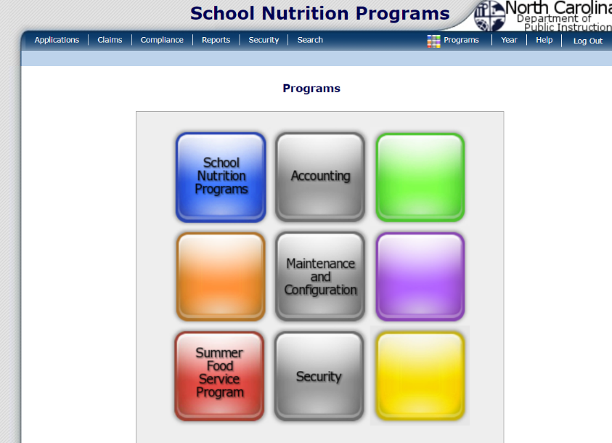**Select School Nutrition Program & Confirm 2024-2025 Year**

**Select Application tab on top bar**

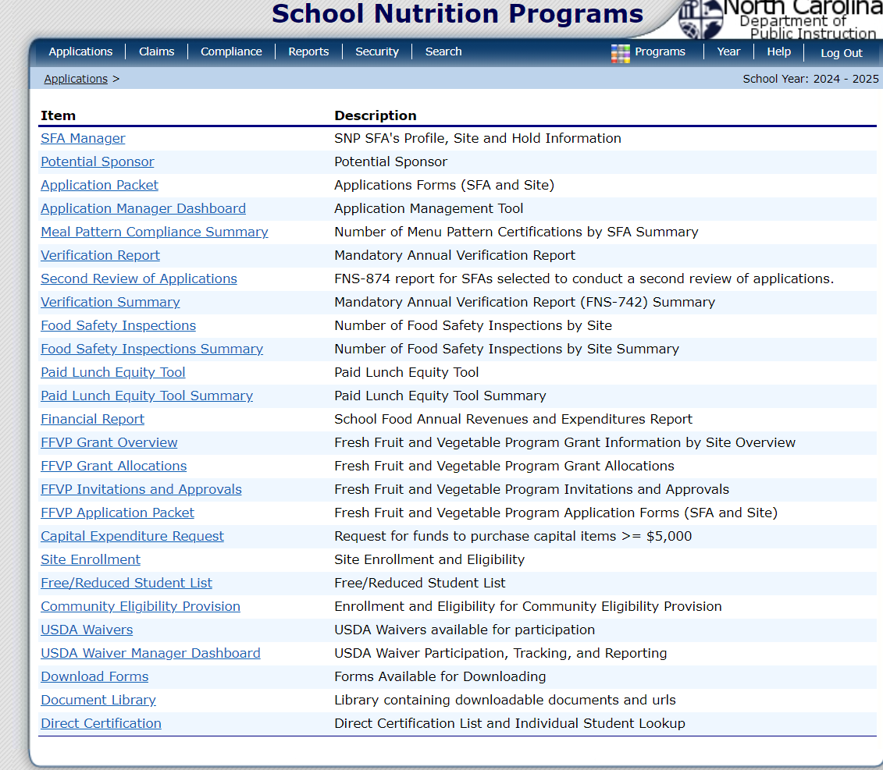**Select Community Eligibility Provision under Item list**

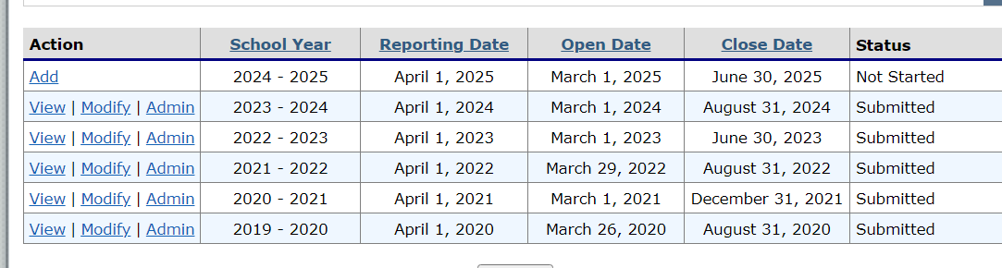**Select “Add” under Action for 2024-2025 School Year**

**Enter Number of Identified Students & Enrollment from above checklist items**

**Select “Save”**

