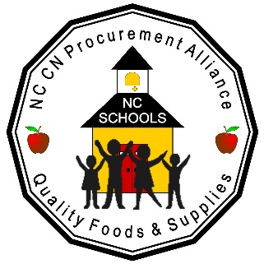

OVERVIEW OF MANUFACTURER PROCEDURES FOR OBTAINING PRODUCT PRE-APPROVAL FOR PRODUCTS THAT DO NOT MATCH AN EXISTING PRODUCT ON THE NCPA BID
Beginning December 1, 2020, the NCPA Board of Directors will accept Requests for Product Approval throughout the year for Products that would be new to the bid and have no matching Current NCPA specifications. The deadline for New Food Product Approval requests is March 30th for the next Direct to Manufacturer and Commodity Processing (DTM) bid and for the next Distributor Bid. Requests may be made for New Supply products through June 30th. Brokers and Manufacturers should review the current NCPA Distributor Bid spreadsheets by Product Category to determine if the product would be New to the bid and that it does not match an existing bid specification.

- NEW FOOD PRODUCT WITH NO MATCHING CURRENT BID SPECIFICATION
- To be considered NEW, the food product does not match a description and specification on the current bid.
- The Broker/Manufacturer must have a NCPA Member District willing to “Sponsor” and test the product in order to submit a request for NEW product approval.
- The Board of Directors reviews and makes final approval for additional testing by a non-sponsor district.
- The Manufacturer submitting products for approval agrees to provide samples for student testing in school districts at no charge.
- Evaluation scores of 85% or higher (75% for Fish or Beans) will allow the product to be reviewed by the Board of Directors for inclusion in the NCPA New Product Food Show held in November each year.
- The NCPA Board of Directors reviews and makes final decisions about products that will be accepted for the Food Show. Total products shown are limited to approximately 20 items each year.
- Members evaluate products during the show and commit to an estimated usage for the next bid year.
- Specifications for products with the highest usage, indicated by members, are prepared and those products will be added to an upcoming bid. Approximately 10 new products are added to the bid each year.

- NEW SUPPLY PRODUCT WITH NO MATCHING CURRENT BID SPECIFICATION
- To be considered NEW, the supply product does not match a description and specification on the current bid.
- The Broker/Manufacturer must submit the Request for Product Approval
- The Board of Directors reviews and makes final approval for testing.
- The Manufacturer/Broker will receive email notification for delivery of test samples.
- The Manufacturer submitting products for approval agrees to provide samples for NCPA testing at no charge.
- The NCPA Board of Directors reviews approved products and makes final decisions about products that will be accepted for the Product Showcase held in March.
- Members evaluate products during the show and commit to an estimated usage for the next bid year.
- Specifications for products with adequate usage, indicated by members, are prepared and those products will be added to the upcoming Distributor bid.
- Approved products are added to the NCPA Distributor bid spreadsheets for solicitation in the next bid contract periods.
Note: There is a process for providing PASS/FAIL information with rationale to all manufacturers/brokers for each product submitted. Also, manufacturers/brokers of products accepted for Student Testing will receive all directions as to how to provide samples, etc. in the testing assignment letter.
Questions: Contact Leann Seelman at leann.seelman@dpi.nc.gov

