Veggies!
Fresh Vegetable
Menu Suggestions for FFVP
Note: this list includes a wide variety of options, however, may not include all fresh vegetable snack possibilities.

Artichokes
Asparagus…any variety (green, purple, white, other)

Beets…should be cooked before serving (red, purple, or yellow)
Bok Choy
Broccoli
Broccolini
Broccoflower
Brussel Sprouts…should be cooked before serving

Cabbage…any variety (green or red/purple)
Carrots…any variety (baby, orange, purple, red, white, other)
Cauliflower…any variety (white, orange, purple)
Celery
Collards…should be cooked before serving
Corn
Cucumbers

Eggplant…must be cooked before serving

Green beans…may be served uncooked

Jicama…may be served uncooked or cooked
This institution is an equal opportunity provider.

Kohlrabi…should be cooked before serving

Leeks…must be cooked before serving
Lima Beans…must be cooked before serving

Onions…should be served with another vegetable

Parsnips
Peppers…any variety (Bell: green, orange, red, yellow, or other, if not too hot)
Potatoes…any variety (Fingerlings, Red, Russet, Yukon Gold, other)
Pumpkin…technically a “fruit”…menued as a vegetable…must be cooked before serving

Radishes
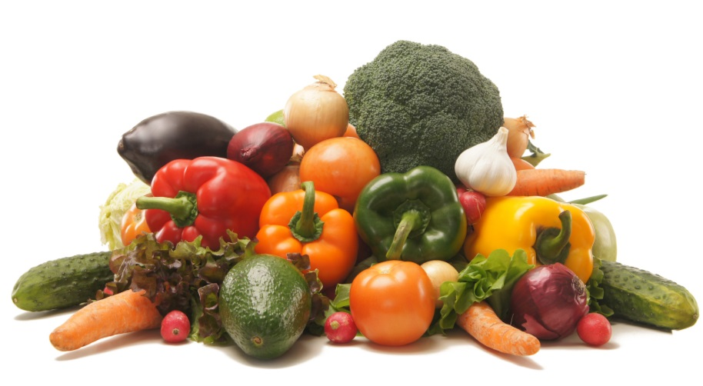
Rhubarb…must be cooked before serving
Rutabagas…should be cooked before serving

Salad (Dark, Leafy Greens)…Endive, Kale, Green/Red Leaf Lettuce, Radicchio, Romaine, Watercress, other
Snow Peas…may be eaten uncooked
Spinach…may be served cooked or uncooked
Squash…any variety (Acorn, Crookneck/Yellow, Chayote, Spaghetti, Summer, Zucchini)
Note: the many varieties of “winter squash” should be cooked before serving
Sugar Snap Peas…may be eaten uncooked
Sweet Potatoes…may be eaten uncooked
Swiss Chard

Tomatoes…technically a “fruit”...menued as vegetable; cherry, grape, slicing, red, orange, yellow
Turnip Greens/Turnips…both should be cooked before serving

