Veggies!
Fresh Vegetable
Menu Suggestions for FF&VP
Note: this list includes a wide variety of options, however, may not include all fresh vegetable snack possibilities.

Artichoke
Asparagus…any variety (green, purple, white, other)

Beet…should be cooked before serving (red, purple, or yellow)
Bok Choy
Broccoli
Broccolini
Broccoflower
Brussel Sprout…best to cook before serving

Cabbage…any variety (green or red/purple)
Carrot…any variety (baby, orange, purple, red, white, other)
Cauliflower…any variety (white, orange, purple)
Celery
Collards…best to cook before serving
Corn
Cucumber

Eggplant…must be cooked before serving

Green bean…may be served uncooked or cooked

Jicama…may be served uncooked or cooked
USDA is an equal opportunity provider.
Kohlrabi…should be cooked before serving

Leek…must be cooked before serving
Lima Bean…must be cooked before serving

Onion…should be served with another vegetable

Parsnip
Pepper…any variety (Bell: green, orange, red, yellow, or other, if not too hot)
Potato…any variety (Fingerlings, Red, Russet, Yukon Gold, other), best to cook before serving
Pumpkin…technically a “fruit”…menued as a vegetable…must be cooked before serving

Radish
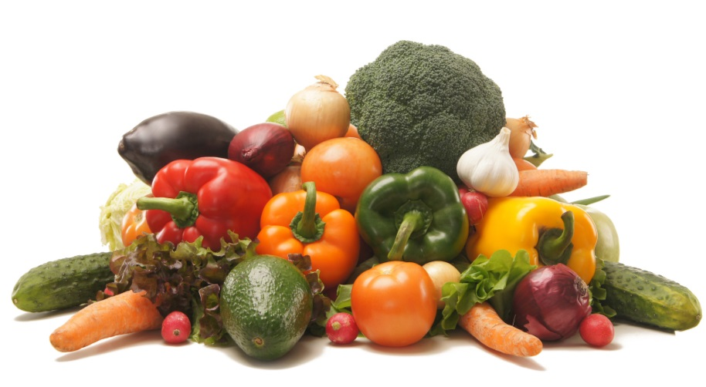
Rhubarb…must be cooked before serving
Rutabaga…should be cooked before serving

Salad (Dark, Leafy Greens)…Endive, Kale, Green/Red Leaf Lettuce, Radicchio, Romaine, Watercress, other
Snow Pea…may be eaten uncooked
Spinach…may be served cooked or uncooked
Squash…any variety (Acorn, Crookneck/Yellow, Chayote, Spaghetti, Summer, Zucchini)
Note: the many varieties of “winter squash” should be cooked before serving
Sugar Snap Pea…may be eaten uncooked
Sweet Potato…may be eaten uncooked
Swiss Chard

Tomato…technically a “fruit”...menued as vegetable; cherry, grape, slicing, red, orange, yellow
Turnip Greens/Turnip…both should be cooked before serving

