Fresh Fruit
Menu Suggestions for FF&VP

Apples…any variety (Gala, Gold/Red Del, Gr Smith, Jazz, Jonagold, McIntosh, Pink Lady, Rome, other)

Apricots Avocados

Honeydew Kiwi
Kumquats
Note: this list includes a wide variety of options, however, may not include all fresh fruit snack possibilities.

Raspberries…any variety (Red, Golden, other)

Strawberries Tangerines

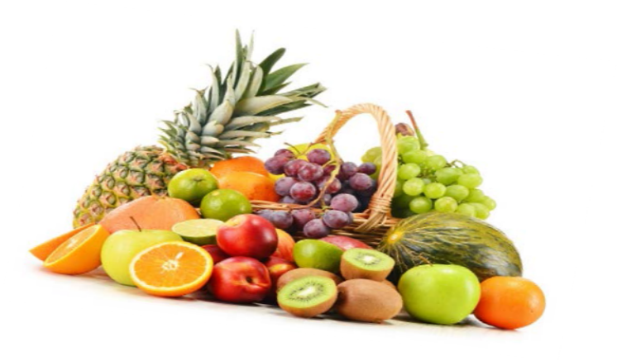
Bananas or “Petite Bananas” Blackberries
Blueberries

Cantaloupes Carambola (Star Fruit)
Cherries…any variety (Bing, Rainier, other)

Cherimoya
Clementines Cranberries
Currants (remember, “fresh” not dried)

Dates (remember, “fresh” not dried)

Dragon Fruit

Grapefruit…any variety (Indian River, Pink, Pummelos, Rio Red, Ruby Red, White, other) Grapes…any variety (Black, Green, Red, seedless, with seed, other)

Guava

Figs (remember, “fresh” not dried)
Lemons & Limes…permissible (best if served
with other fruit)

Mangoes Nectarines
Oranges…any variety (Blood, Mandarins, Minneolas, Navels, Tangeloes, Satsumas, Valencias, other)

Papaya Passion Fruit Peaches
Pears…any variety (Asian, Bartlett, Bosc, Brown, D’Anjou, Red, other)

Persimmons Pineapples Plums
Pluots (recently referred to as “Apriums”)

Pomegranates
USDA is an equal opportunity provider and employer.
Ugli Fruit

Watermelon…any variety (seedless, with seeds, “Personal” or “Bambino” Melon)

