Fresh Fruit
Fruits!
Menu Suggestions for FF&VP

Note: this list includes a wide variety of options, however, may not include all fresh fruit snack possibilities.

Apple…any variety (Gala, Gold/Red Del, Gr Smith, Jazz, Jonagold, McIntosh, Pink Lady, Rome, other)
Apricot
Avocado

Banana or Petite Banana
Blackberry
Blueberry

Cantaloupe
Carambola or Star Fruit
Cherry…any variety (Bing, Rainier), “fresh” not dried
Cherimoya
Clementine
Cranberry …“fresh” not dried
Currant…”fresh” not dried

Date…“fresh” not dried
Dragon Fruit

Grapefruit…any variety (Indian River, Pink, Pummelos, Rio Red, Ruby Red, White, other)
Grape…any variety (Black, Green, Red, seedless, with seeds, other)
Guava

Fig …“fresh” not dried

Honeydew

USDA is an equal opportunity provider.

Kiwi
Kumquat

Lemon & Lime…best if served with other fruit and only occasionally

Mango

Nectarine

Orange…any variety (Blood, Mandarins, Minneolas, Navels, Tangeloes, Satsumas, Valencias, other)

Papaya
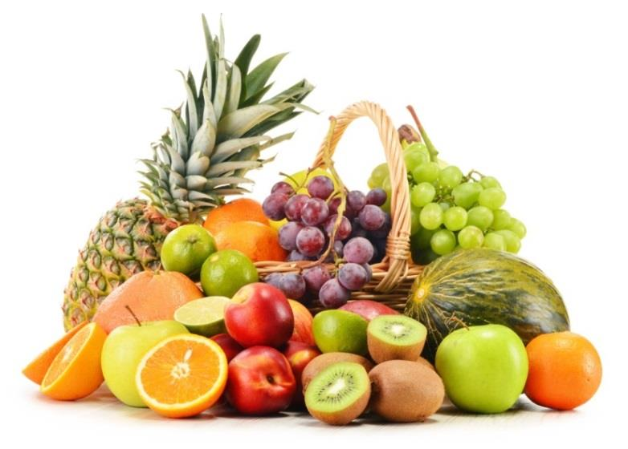
Passion Fruit
Peach
Pear…any variety (Asian, Bartlett, Bosc, Brown, D’Anjou, Red, other)
Persimmon
Pineapple
Plum
Pluot…also referred to as an “Aprium”
Pomegranate

Raspberry…any variety (Red, Golden, other)

Strawberry

Tangerine

Ugli Fruit

Watermelon…any variety (seedless, with seeds, “Personal” or “Bambino” Melon)

