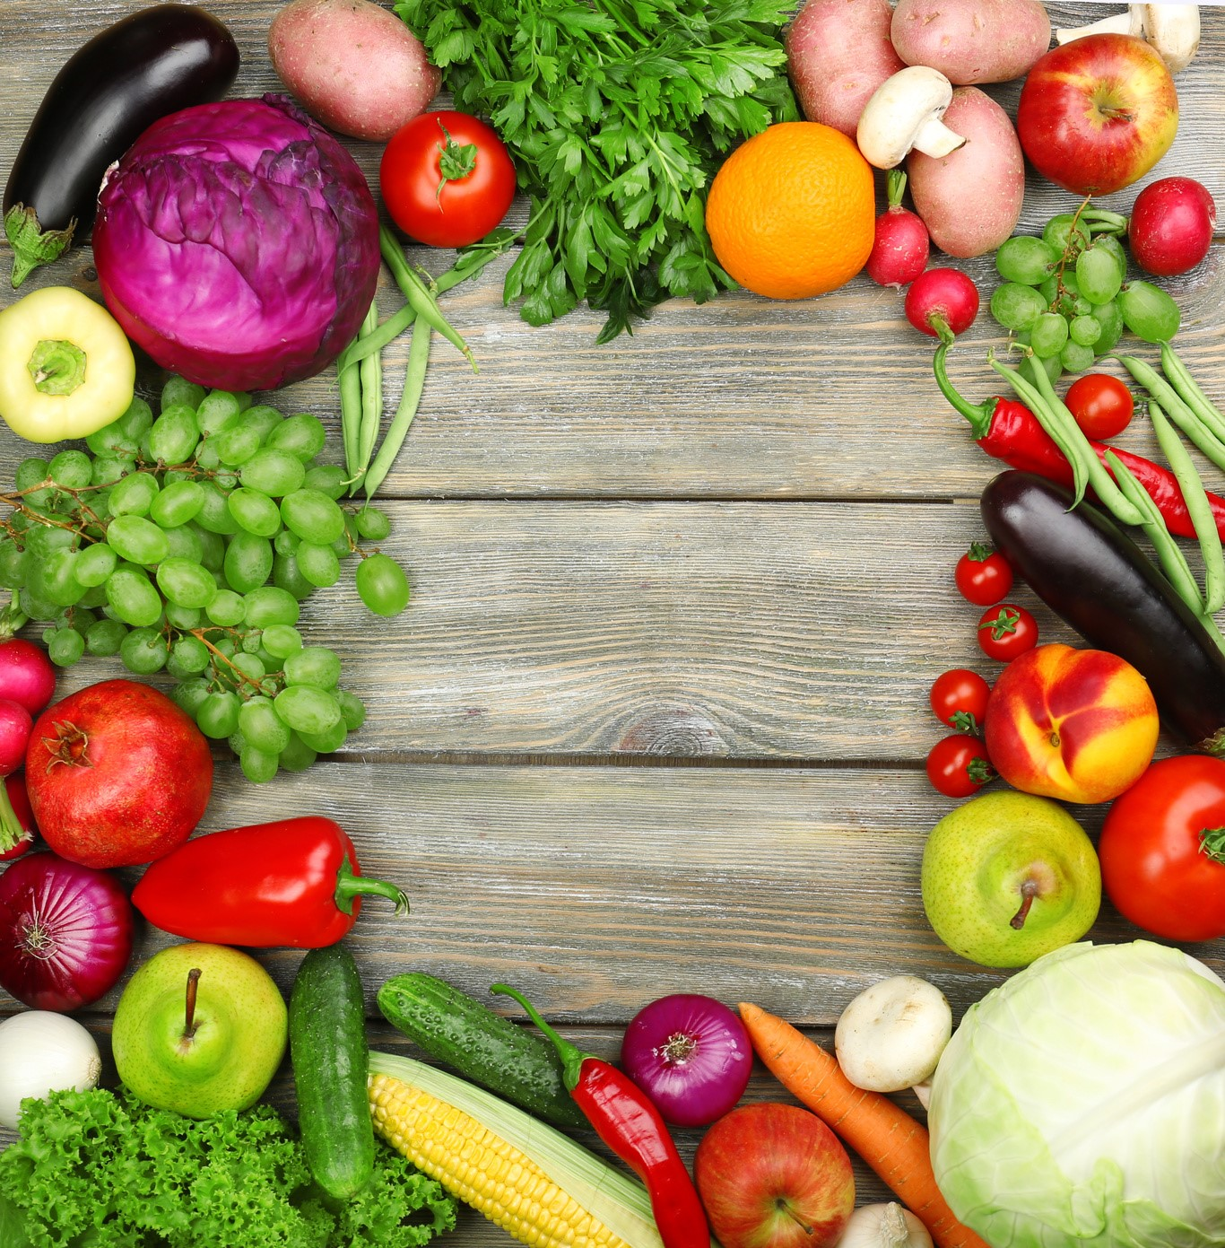

To successfully file the monthly FFVP claim in the School Nutrition Technology System, it is a

requirement to type information in the “SFA Comments” section on the claim. What type of information

should be included in this section?

The explanation of:

**a recent nutrition education lesson/activity, (school wide or classroom)**

*Note: feedback from students regarding likes and dislikes is not considered nutrition education.)*

*(*

**seasonal fresh fruit and/or vegetable promotions**

**locally grown produce menued/showcased**

**special circumstances for why fresh fruits and/or vegetables were *not* claimed**

**issues regarding small supplies/small wares purchased**

**issues regarding large equipment purchased**

**issues regarding FFVP Operational and/or Administrative labor claimed**

**any information that helps explain any item claimed for reimbursement**

Each FFVP claim should be self-explanatory. With information submitted in the “SFA Comments” section,

anyone viewing the FFVP claim (USDA, NCDPI, NC State Board of Education, or other) should be able to

understand what was

understand what was purchased for use in the FFVP.

It is imperative to provide this type of information to expedite the review, approval, and reimbursement

of the FFVP claim. Otherwise, NCDPI School Nutrition Division staff need to call requesting further explanation

and revisions to the claim may be required, all taking *additional* time causing a delay in reimbursement.

**Zoe McKay-Tucker | School Nutrition Consultant for Special Programs**

**zoe.mckaytucker@dpi.nc.gov**

**| 984-236-2636**



FFVP Claims - SFA Comments Checklist