Instructions for Completing a Claim for Reimbursement

**Step 1: Log in to the School Nutrition Technology System at** https://schoolnutrition.dpi.nc.gov/snp/

**Step 2: Select the “Claims” tab**



**Step 3: Select the “Claim – FFVP”**

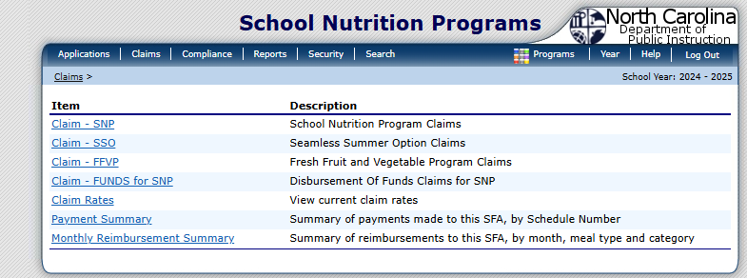

**Step 4: Select the Claim Month**

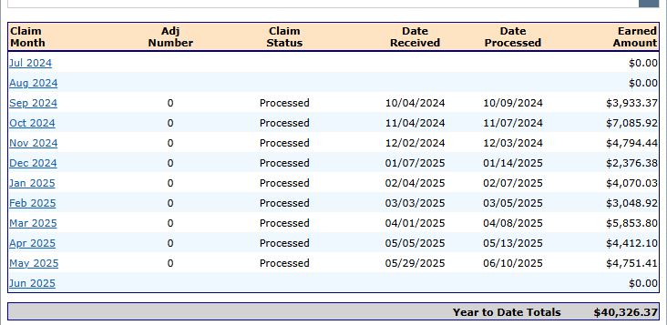

**Step 5: Select “Add Original Claim”**

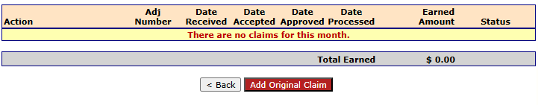

**Step 6: Complete “Product Description Information”**

Complete Fresh Fruit – Product Description

Enter Name of Fresh Fruit

* + - * + Size/Weight of Shipping Unit
        + Number of Units
        + Cost Per Unit
        + Total Unit Cost

Enter Name of Fresh Vegetable

* + - * + Size/Weight of Shipping Unit
        + Number of Units
        + Cost Per Unit
        + Total Unit Cost

**Step 7: Complete Operational Costs Items**

Enter Personnel Costs – Preparation and Service, if applicable

Enter Small Supplies/Other Operational Costs, if applicable

**Step 8: Complete Administrative Costs**

Enter Personnel Costs – Preparation and Service, if applicable

Enter Durable Supplies/Equipment Purchases, if applicable

**Step 9: Enter SFA Comments**



**Step 10: Press Save**

**Step 8: The following screen appears once the “Save” button is pressed, the following information appears. Review the information entered for accuracy and then check the “Certification” box and press “Submit for Payment”.**