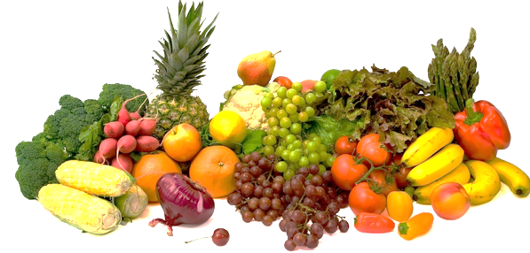
Fresh Fruit and Vegetable Program
Application & Selection Process Timeline: 2023 – 2024 SY

March 1, 2023 | Fresh Fruit and Vegetable Program (FFVP) application season for the 2023-2024 School Year (SY) opens on March 1, 2023. For assistance with the FFVP application, contact Zoe McKay-Tucker, NC’s FFVP Coordinator at zoe.mckaytucker@dpi.nc.gov or 919-961-0608.
March 24, 2023  11:59 PM | Absolute deadline for completing FFVP online application for the 2020-2021 SY in the School Nutrition Technology System (SNTS) is: 11:59 PM on March 24, 2023. At this time, the FFVP application component in the SNTS closes and no more applications can be opened, and revisions can no longer be made. School Nutrition administrators with “Application Entry” access in the SNTS are responsible for entering any information not pre-populated for the School Profile as well as entering/modifying responses to the Proposal School questions. Note: there is no tab to click to “Submit” the FFVP online application. Once the information is entered, remember to “Save” so all is stored in the SNTS.
March 31, 2023  11:59 PM | Deadline for the “Signature Pages” and “Number of Days the FFVP Operates Weekly” form with required original signatures in blue ink to be submitted electronically. Scan/E-mail both forms to zoe.mckaytucker@dpi.nc.gov to complete the FFVP application. A Signature Page is due for each applying school. One “Number of Days FFVP Operates Weekly” form per Public School Unit will suffice. These are the only two documents that are required to be submitted to NCDPI for the FFVP application process.
April 2023 | NC’s FFVP applications will be reviewed and categorized in descending order from highest to lowest F/R percentage or ISP. As referenced in the USDA FF&VP Handbook for Schools and in accordance with Federal policy, schools with the highest F/R percentage or ISP will be selected to participate. Once USDA notifies NCDPI of NC’s FFVP grant allocation for the 2023-2024 SY (the timing varies each year), schools will be selected in preparation of the NC State Board of Education (SBE) to review and vote to approve.
May 2023,  June 2023,  or July 2023 | NC SBE will review and vote to approve the list of NC elementary schools selected for the FFVP for the 2023-2024 SY accordingly. Applying schools will be notified by the NCDPI Office of School Nutrition if selected, or not selected, for the coming school year. School Nutrition administrators will be notified of their district’s FFVP allocation for the 2023-2024 SY upon their successful completion of the FFVP required annual continuing education.
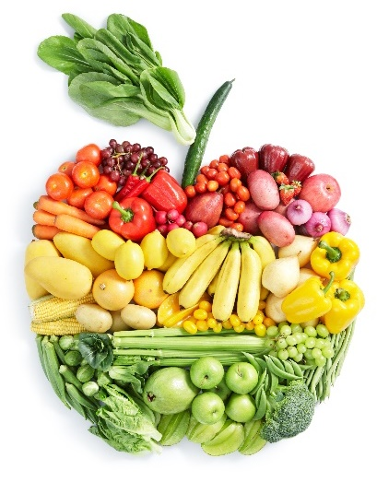
REQUIRED INSTRUCTION It is a requirement that a minimum of one School Nutrition administrator from the School Food Authority with a school or schools selected for the 2023-2024 FFVP participate in both Part 1 and Part 2 FFVP webinars before the respective FFVP funds will be released to the selected FFVP school. Webinar registration information will be included in the written notification from NCDPI to the selected schools.

Date and Time  to be announced | FFVP required webinar, Part 1 – Program Requirements
Date and Time  to be announced | FFVP required webinar, Part 2 - Financial Guidance

