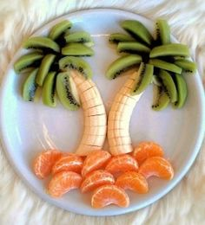
2022-2023 FFVP Required Annual Continuing Education

Part 1: Program Requirements and Operation

August 9, 2022

Webinar Agenda

- Welcome & Congratulations!
- FFVP Addendum for 2022-2023 SY (e-mailed to SN administrators)
- FFVP Allocations for 2022-2023 SY (e-mailed to SN administrators)
- USDA Fresh Fruit and Vegetable Program: A Handbook for Schools (link to access posted on NCDPI SN website)
- Program Objectives
- Establishing Partnerships
- Advertising and Marketing
- Competitively Procuring
- Program Requirements
- Allowable/Unallowable FFVP Purchases (guidance posted on NCDPI SN website)

- Operating Procedures
- FFVP Snacks No Cost to Students (menu suggestions posted on NCDPI website)
- Leftover FFVP Snacks
- FFVP Labor
- Monthly FFVP Claims
- Civil Rights
- Special Dietary Needs
- Food Safety/Sanitation
- Nutrition Education (resources posted on NCDPI SN website)
- Best Practices
- FFVP Technical Assistance/Reviews

The NCDPI Office of School Nutrition appreciates your participation in the
FFVP required annual continuing education for the 2022-2023 school year.

