NC Office of School Nutrition

How to Submit a Site Based Claim for Reimbursement

for CEP School Food Authorities (SFAs)

The following information is now required for EACH site submitting the monthly claim for reimbursement in the School Nutrition Technology System (SNTS).

The claim is divided into **four** sections for each site and includes the following:

* General Information
* National School Lunch Information
* School Breakfast Information
* After School Snack Program Information (if applicable)

Section 1: General Information

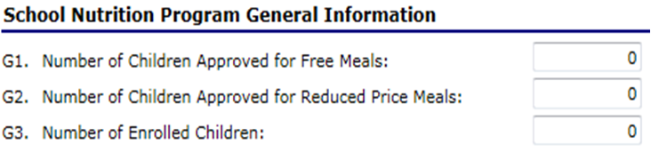

* **G1.** Enter the number of students that have been approved for free meal benefits at the school.
* **G2.** Enter the number of students that have been approved for reduced price meal benefits at the school.
* **G3.** Enter the number of students enrolled in the school.   
   *NOTE: Please use the highest enrollment during the month. The system will use this number to calculate the number of paid students at the school*.

Section 2: National School Lunch Claim Entry

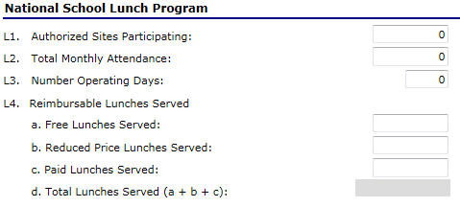

* **L1.** Enter the number of sites participating in the National School Lunch Program.   
   *NOTE: The number will be* ***“1”*** *since we are requiring a site-based claim.*
* **L2.** Enter the Total Monthly Attendance for the school.   
   *NOTE: This number will be the total (sum) for the entire month.*
* **L3.** Enter the number of days lunch meals were served during the month.
* **L4.** Enter the number of lunch meals served during the month in each category.

1. Free, b. Reduced, c. Paid)

*NOTE:* d. Total Lunches Served (a + b + c): *The system will automatically calculate and display the total in this field.*

Section 3: School Breakfast Claim Entry

**\*\*IMPORTANT\*\*** The information displayed for the School Breakfast Program is determined by whether the school qualifies for Regular or Severe-Need Reimbursement. Only the appropriate screen will display.

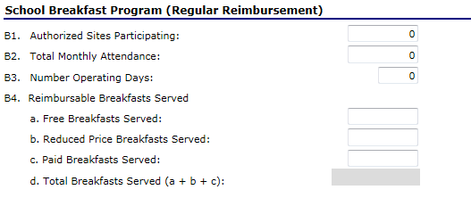

# Regular Reimbursement

# screen

* **B1.** Enter the number of sites participating in the School Breakfast Program.   
   *NOTE: The number will be* ***“1”*** *since we are requiring a site-based claim.*
* **B2.** Enter the Total Monthly Attendance for the school.   
   *NOTE: This number will be the total (sum) for the entire month.*
* **B3.** Enter the number of days breakfast meals were served during the month.
* **B4.** Enter the number of breakfast meals served during the month in each category. (Free/Reduced/Paid)  
   *NOTE: B4. d. Total Breakfasts Served (a + b + c) – The system will automatically calculate and display the total in this field.*

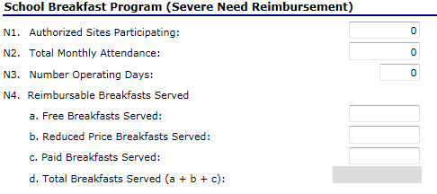

# Severe Need

# Reimbursement

# screen

* **N2** Enter the number of sites participating in the School Breakfast Program.   
   *NOTE: The number will be* ***“1”*** *since we are requiring a site-based claim.*
* **N2.** Enter the Total Monthly Attendance for the school.   
   *NOTE: This number will be the total (sum) for the entire month.*
* **N3.** Enter the number of days breakfast meals were served during the month.
* **N4.** Enter the number of breakfast meals served during the month by category (Free/Reduced/Paid).

*NOTE: N4. d. Total Breakfasts Served (a + b + c) – The system will automatically calculate this number and display the total in this field.*

Section 4: After School Snack Program Claim Entry

The information displayed for the After School Snack Program is determined by whether the school is Area Eligible or NonArea Eligible.

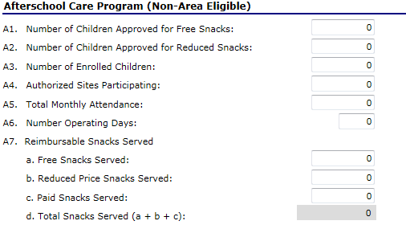

# ASSP NonArea Eligible

# screen

* **A1.** Enter the number of students enrolled in the After School Snack Program(s) that are approved for FREE meal benefits.
* **A2.** Enter the number of students enrolled in the After School Snack Program(s) that are approved for REDUCED price meal benefits.
* **A3.** Enter the TOTAL number of students enrolled in the After School Snack Program(s).   
   *NOTE: Please use the highest enrollment during the month. The system will use this number to calculate the number of PAID students at the school.*
* **A4.** Enter the number of sites participating in the After School Snack Program.   
   *NOTE: The number will be* ***“1”*** *since we are requiring a site-based claim.*
* **A5.** Enter the Total Monthly Attendance for the school.   
   *NOTE: This number will be the total (sum) for the entire month.*
* **A6.** Enter the number of days snacks were served during the month.
* **A7.** Enter the number of snacks served during the month by category (Free/Reduced/Paid).

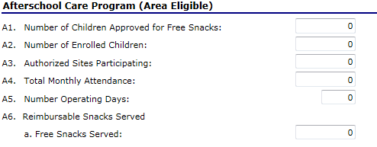

# ASSP

# Area Eligible screen

* **A1.** Enter the number of students enrolled in the After School Snack Program(s) that are approved for free meal benefits.
* **A2.** Enter the total number of students enrolled in the After School Snack Program(s).  *NOTE: Please use the highest enrollment during the month*
* **A3.** Enter the number of sites participating in the After School Snack Program.   
   *NOTE: The number will be one* ***“1”*** *since we are requiring a site-based claim.*
* **A4.** Enter the Total Monthly Attendance for the school.   
   *NOTE: This number will be the total (sum) for the entire month.*
* **A5.** Enter the number of days snacks were served during the month.
* **A6.** Enter the number of snacks served during the month.