NCDPI | NC Office of School Nutrition

How to Submit a Site Based Claim for Reimbursement

for NonCEP School Food Authorities (SFAs)

The following information is now required for EACH site submitting the monthly claim for reimbursement in the School Nutrition Technology System (SNTS).

The claim is divided into **four** sections for each site and includes the following:

* General Information
* National School Lunch Information
* School Breakfast Information
* After School Snack Program Information (if applicable)

Section 1: General Information

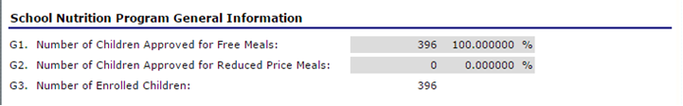

* **G1.** The number of students that have been approved for free meal benefits at the school. *NOTE: Calculated based on ISP*
* **G2.** The number of students that have been approved for reduced price meal benefits at the school.   
   *NOTE: Always “****0”*** *and will not be accessible for data* 
  + **G3.** The number of students enrolled in the school.  *NOTE: The system will use this number to calculate the number of students at the school.*

Section 2: National School Lunch Claim Entry

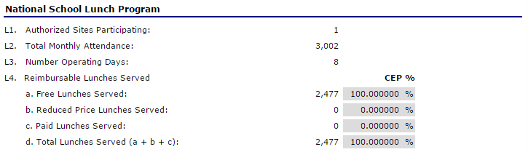

* **L1.** Enter the number of sites participating in the National School Lunch Program.  
   *NOTE: The number will be one (1) since we are requiring a site-based claim.*
* **L2.** Enter the Total Monthly Attendance for the school.   
   *NOTE: This number will be the total (sum) for the entire month.*
* **L3.** Enter the number of days lunch meals were served during the month.
* **L4(d).** Enter the total number of lunch meals served during the month.   
   *NOTE: The system will calculate the appropriate number (Free/Paid based on ISP).*

Section 3: School Breakfast Claim Entry

**\*\*IMPORTANT\*\*** The information displayed for the School Breakfast Program is determined by whether the school qualifies for Regular or Severe-Need Reimbursement. Only the appropriate screen will display.

# SEVERE NEED REIMBURSEMENT

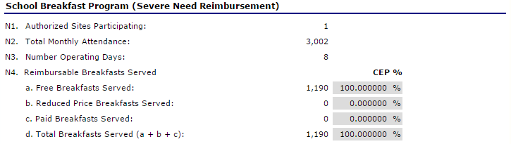

* **N1.** Enter the number of sites participating in the School Breakfast Program.   
   *The number will be one (1) since we are requiring a site-based claim.*
* **N2.** Enter the Total Monthly Attendance for the school.   
   *NOTE: This number will be the total (sum) for the entire month.*
* **N3.** Enter the number of days breakfast meals were served during the month.
* **N4(d).** Enter the total number of breakfast meals served during the month.   
   *NOTE: The system will calculate the appropriate number (Free/Paid based on ISP).*

# REGULAR REIMBURSEMENT

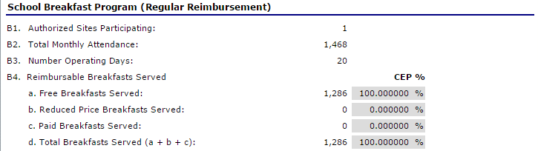

* **B1**. Enter the number of sites participating in the School Breakfast Program.   
   *NOTE: The number will be one (1) since we are requiring a site-based claim****.***
* **B2.** Enter the Total Monthly Attendance for the school.   
   *NOTE: This number will be the total (sum) for the entire month.*
* **B3.** Enter the number of days breakfast meals were served during the month.
* **B4(d).** Enter the total number of breakfast meals served during the month.   
   *NOTE: The system will calculate the appropriate number (Free/Paid based on ISP).*

Section 4: After School Snack Claim Entry (if applicable)

**\*IMPORTANT\*** The information displayed for the After School Snack Program is determined by whether the school is **Area Eligible** or **Non-Area Eligible.**

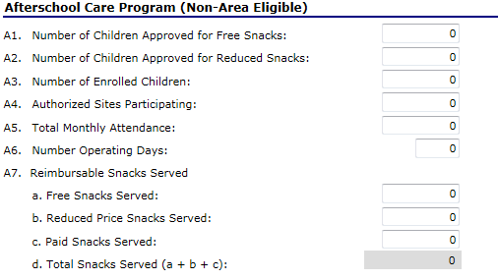

# ASSP Non-Area Eligible screen

* **A1.** Enter the number of students enrolled in the After School Snack Program(s) that are approved for free meal benefits.
* **A2.** Enter the number of students enrolled in the After School Snack Program(s) that are approved for reduced price meal benefits.
* **A3.** Enter the total number of students enrolled in the After School Snack Program(s).  *NOTE: Please use the highest enrollment during the month). The system will use this number to calculate the number of paid students at the school.*
* **A4.** Enter the number of sites participating in the After School Snack Program.   
   *NOTE:* *The number will be one (1) since we are requiring a site-based claim.*
* **A5.** Enter the Total Monthly Attendance for the school.   
   *NOTE: This number will be the total (sum) for the entire month.*
* **A6.** Enter the number of days snacks were served during the month.
* **A7.** Enter the number of snacks served during the month by category (Free/Reduced/Paid).

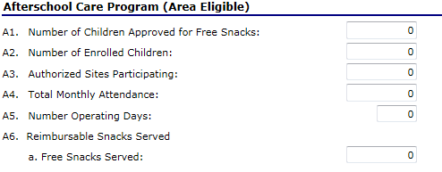

# ASSP Area Eligible screen

* **A1.** Enter the number of students enrolled in the After School Snack Program(s) that are approved for free meal benefits.
* **A2.** Enter the total number of students enrolled in the After School Snack Program(s).  *NOTE: Please use the highest enrollment during the month)*
* **A3.** Enter the number of sites participating in the After School Snack Program. *NOTE:* *The number will be one (1) since we are requiring a site-based claim.*
* **A4.** Enter the Total Monthly Attendance for the school.   
   *NOTE:* *This number will be the total (sum) for the entire month.*
* **A5.** Enter the number of days snacks were served during the month.
* **A6.** Enter the number of snacks served during the month.