**Instructions for Completing the Fresh Fruit and Vegetable Program**

**Online Application**

**STEP 1:** **Login to the SN Technology System at:** <https://schoolnutrition.dpi.nc.gov/snp/NcidLogin.aspx>

**STEP 2:** **Select “Application” Tab**

**STEP 3:** **Select “FFVP Application Packet”**

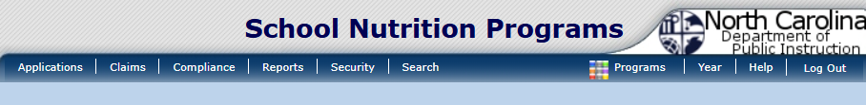



**STEP 4: Select “Detail” for 2025-2026 School Year**

2025-2026

**STEP 5: Select “Add/Modify” to complete the “Fresh Fruit and Vegetable Program” Sponsor**

**Application**

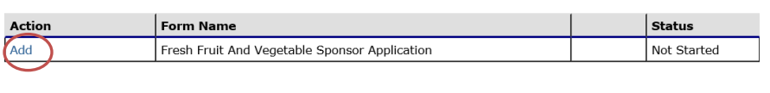

**STEP 6: Select “Add/Modify” to complete the “Fresh Fruit and Vegetable Program” Site Application**

**Please note the system will display eligible sites (elementary schools only) based**

**on information the State Agency has on file.**

***ONLY* add the sites to be considered for participation in the Fresh Fruit and**

**Vegetable Program for the School Year 2025-2026. Thank you.**