North Carolina Department of Public Instruction | Office of School Nutrition

Service Area Map & School Food Authorities Served

**Senior Director:** [Rachel Findley](mailto:rachel.findley@dpi.nc.gov)

**Mailing Address:** 6324 Mail Service Center, Raleigh, NC 27699-6324 **Main Number:** 984.236.2910  
**Website:** <https://www.dpi.nc.gov/districts-schools/district-operations/school-nutrition>

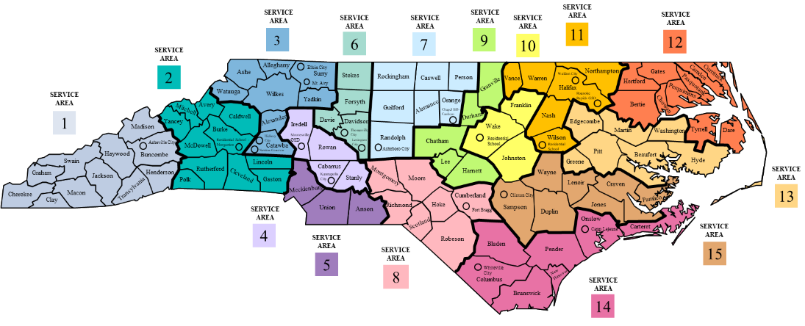

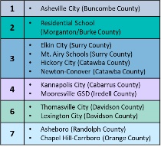

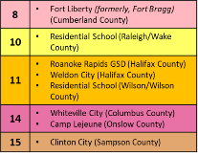

**Victoria Homick, Section Chief |** [**victoria.homick@dpi.nc.gov**](mailto:victoria.homick@dpi.nc.gov) **| 984.236.2631**

|  |  |  |  |  |
| --- | --- | --- | --- | --- |
|  | **Counties/Traditional PSUs Served** | **Charter Schools** | **Residential Child Care Institutions (RCCI)** | **NonPublic Schools** |
| **AREA 1**  Jennifer Brown [jennifer.brown@dpi.nc.gov](mailto:jennifer.brown@dpi.nc.gov) 828.736.1474 | 110 Buncombe County  111 Asheville City  200 Cherokee County  220 Clay County  380 Graham County  440 Haywood County  450 Henderson County  500 Jackson County  560 Macon County  570 Madison County  870 Swain County  880 Transylvania County | ***(Avery)***  06B Marjorie Williams Academy  ***(Buncombe)***  11A Evergreen Community Charter School | ***(Avery)***  1132 Crossnore School, Inc.  [SITE] Crossnore Communities for Children – Winston-Salem |  |
| **AREA 2**  Sheryl Harris  [sheryl.harris@dpi.nc.gov](mailto:sheryl.harris@dpi.nc.gov) 828.674.2215 | 298-204 NC Sch for the Deaf *(Morganton)*  060 Avery County  120 Burke County  140 Caldwell County  230 Cleveland County  360 Gaston County  550 Lincoln County  590 McDowell County  610 Mitchell County  750 Polk County  810 Rutherford County  995 Yancey County | ***(Gaston)***  36C Mountain Island Charter  ***(Lincoln)***  55B West Lake Preparatory Academy |  |  |
| **AREA 3**  Trip Warren  [trip.warren@dpi.nc.gov](mailto:trip.warren@dpi.nc.gov)  828.230.4586 | 020 Alexander County  030 Alleghany County  050 Ashe County  180 Catawba County  181 Hickory City *(Catawba)*  182 Newton-Conover *(Catawba)*  860 Surry County  861 Elkin City Schools *(Surry)*  862 Mt. Airy City *(Surry)*  950 Watauga County  970 Wilkes County  990 Yadkin County |  | ***(Wilkes)***  1142-009  Eckerd Youth Alternatives  [SITE] Boomer  ***(Alexander)***  1154-4  NCDPS, Div of Juvenile Justice  [SITE] Alexander | ***(Guilford)***  1099  Greensboro Islamic Academy  1167  Guilford County Juvenile Detention Center |

|  |  |  |  |  |
| --- | --- | --- | --- | --- |
|  | **Counties/Traditional PSUs Served** | **Charter Schools** | **Residential Child Care Institutions (RCCI)** | **NonPublic Schools** |
| **AREA 4**  Kimberly McCall  [kimberly.mccall@dpi.nc.gov](mailto:kimberly.mccall@dpi.nc.gov)  704.425.8191 | 130 Cabarrus County  132 Kannapolis City *(Cabarrus)*  490 Iredell/Statesville  491 Mooresville GSD *(Iredell)*  800 Rowan-Salisbury  840 Stanly County | *Charter USA Main Contact*  ***(Cabarrus)***  13B Valor Preparatory Academy  13C A.C.E. Academy  13D Concord Lake STEAM Academy  ***(Iredell)***  49B American Renaissance Middle School  49D Success Institute  49F Langtree Charter Academy  49G Iredell Charter Academy of Arts & Science | ***(Cabarrus)***  1154-5  NCDPS, Div of Juvenile Justice  [SITE] Cabarrus Youth Development Center  1154-16  NCDPS, Div of Juvenile Justice  [SITE] Cabarrus Regional Juvenile Detention Center |  |
| **AREA 5**  Kristen Bealler  [kristen.bealler@dpi.nc.gov](mailto:kristen.bealler@dpi.nc.gov)  636.795.7483 | 040 Anson County  600 Charlotte/Mecklenburg  900 Union County | ***(Mecklenburg)***  60B Sugar Creek Charter  60G Queen’s Grant Comm.  60L KIPP Charlotte  60N American Leadership Academy  61M Charlotte LAB School  61N The Math/Science Academy of Charlotte  61Q Mallard Creek STEM Academy  61R Matthew’s Charter Academy  61T Movement Charter School  61V Bonnie Cone Classical Academy  61Y Steel Creek Prep Academy  62J SW Charlotte STEM Academy  62K Movement School Eastland  62L Telra Institute  62M Bonnie Cone Leadership Academy  62P Movement School Southwest  62R Movement School Northwest  ***(Union)***  90C Union Preparatory |  |  |

|  |  |  |  |  |
| --- | --- | --- | --- | --- |
|  | **Counties/Traditional PSUs Served** | **Charter Schools** | **Residential Child Care Institutions (RCCI)** | **NonPublic Schools** |
| **AREA 6**  Flo Smith  [florestine.smith@dpi.nc.gov](mailto:florestine.smith@dpi.nc.gov) 336.681.6045 | 290 Davidson County  291 Lexington City *(Davidson)*  292 Thomasville City *(Davidson)*  300 Davie County  340 WS/Forsyth County  850 Stokes County | ***(Forsyth)***  34B Quality Education Academy  34D Carter G. Woodson School  34F Forsyth Academy | ***(Mecklenburg)***  1124 Thompson Child and Family Focus  1148 Alexander Youth Network  ***(Gaston)***  1120 Holy Angels  1162 With Friends, Inc. |  |
| **AREA 7**  Choncy Holman [choncy.holman@dpi.nc.gov](mailto:choncy.holman@dpi.nc.gov) 704.219.1051 | 010 Alamance-Burlington  170 Caswell County  410 Guilford County  760 Randolph County  761 Asheboro City *(Randolph)*  790 Rockingham County  680 Orange County  681 Chapel Hill/Carrboro *(Orange)*  730 Person County | ***(Guilford)***  41C Guilford Preparatory  41F Triad Math & Science Academy  41H College Prep and Leadership Academy of High Point  41J Summerfield Academy  41L Gate City Academy  41M Next Generation Academy  41N Experiential School of Greensboro  41R Summit Creek Academy  ***(Person)***  73A Bethel Hill Charter |  |  |
| **AREA 8**  Jennifer Ozkurt  [jennifer.ozkurt@dpi.nc.gov](mailto:jennifer.ozkurt@dpi.nc.gov)  919.854.9755 | 260 Cumberland County  470 Hoke County  620 Montgomery County  630 Moore County  770 Richmond County  780 Robeson County  830 Scotland County  1007 Fort Liberty [Bragg] *(Cumberland)* | ***(Cumberland)***  26B Alpha Academy  26C Capitol Encore Academy  ***(Robeson)***  78A CIS Academy  78C Old Main STREAM Academy | *Eckerd Youth Alternatives, Inc. Main Contact*  ***(Cumberland)***  1125 Falcon Children's Home  ***(Cumberland)***  1154-8 NCDPS, Div of Juvenile Justice  [SITE] Cumberland County  ***(Montgomery)***  1142-8 Eckerd Youth Alternatives, Inc. [SITE] Candor | ***(Cumberland)***  1095 Trinity Christian |

|  |  |  |  |  |
| --- | --- | --- | --- | --- |
|  | **Counties/Traditional PSUs Served** | **Charter Schools** | **Residential Child Care Institutions (RCCI)** | **NonPublic Schools** |
| **AREA 9**  Jamie Narron  [jamie.narron@dpi.nc.gov](mailto:jamie.narron@dpi.nc.gov)  919.520.3632 | 190 Chatham County  320 Durham Public  390 Granville County  430 Harnett County  530 Lee County | ***(Chatham)***  19A Chatham Charter School  ***(Durham)***  32A Maureen Joy Charter  32B Durham Charter School  32C Community School of Digital and Visual Arts (CSDVA)  32D Kestrel Heights Charter School  32H Research Triangle Charter  32K Central Park School for Children  32L Voyager Academy  32M Global Scholars Academy  32S KIPP Durham College Preparatory  ***(Lee)***  53C MINA Charter School of Lee County  53D Central Carolina Academy | ***(Durham)***  1154-1 NCDPS, Div of Juvenile Justice  [SITE] C.A. Dillon  ***(Chatham)***  1154-13 NCDPS, Div of Juvenile Justice  [SITE] Chatham Youth Development Center |  |
| **AREA 10**  Dana Edwards  [dana.edwards@dpi.nc.gov](mailto:dana.edwards@dpi.nc.gov)  919.412.6773 | 298-203 Residential School *(Raleigh)*  350 Franklin County  510 Johnston County  920 Wake County | *\*Main Contact for National Heritage Academy Schools\**  ***(Johnston)***  51B Johnston Charter Academy  51C American Leadership Academy  ***(Wake)***  35C Wake Preparatory Academy  92M PreEminent Charter  92V Wake Forest Charter  92W Cardinal Charter Academy  93J RISE Southeast Raleigh  93M Peak Charter Academy  93P Rolesville Charter Academy  93T Cardinal Charter Academy at Wendell Falls  93V Doral Academy of North Carolina | ***(Wake)***  1154-12 NCDPS, Div of Juvenile Justice [SITE] Wake Regional Juvenile |  |

|  |  |  |  |  |
| --- | --- | --- | --- | --- |
|  | **Counties/Traditional PSUs Served** | **Charter Schools** | **Residential Child Care Institutions (RCCI)** | **NonPublic Schools** |
| **AREA 11**  Cathie Masters  [catherine.masters@dpi.nc.gov](mailto:catherine.masters@dpi.nc.gov) 919.247.2853 | 298-202 Eastern NC Sch for the Deaf  420 Halifax County  421 Roanoke Rapids GSD *(Halifax)*  422 Weldon City *(Halifax)*  640 Nash County  660 Northampton County  910 Vance County  930 Warren County  980 Wilson County | *\*Main contact for KIPP Schools\**  ***(Halifax)***  42A KIPP Halifax College Preparatory  ***(Nash)***  64A Rocky Mount Preparatory  ***(Northampton)***  66A Gaston College Preparatory  ***(Vance)***  91B Henderson Collegiate  ***(Warren)***  93A Haliwa Saponi Tribal School  ***(Wilson)***  98A Sallie B Howard  98B Wilson Preparatory | ***(Warren)***  1142-010 Eckerd Youth Alternatives, Inc.  [SITE] Girls Academy at   Kerr Lake |  |
| **AREA 12**  Leslie Otts  [leslie.otts@dpi.nc.gov](mailto:leslie.otts@dpi.nc.gov)  252.330.7944 | 080 Bertie County  150 Camden County  210 Edenton-Chowan  270 Currituck County  280 Dare County  370 Gates County  460 Hertford County  700 Elizabeth City/Pasquotank County  720 Perquimans County  890 Tyrrell County | ***(Pasquotank)***  70A Northeast Academy for Aerospace and Advanced Technologies | ***(Durham)***  1156 Durham County Youth Home  ***(Granville)***  1110 Murdoch Developmental |  |

|  |  |  |  |  |
| --- | --- | --- | --- | --- |
|  | **Counties/Traditional PSUs Served** | **Charter Schools** | **Residential Child Care Institutions (RCCI)** | **NonPublic Schools** |
| **AREA 13**  Katie Exum  Katie.exum@dpi.nc.gov  252.330.7944 | 070 Beaufort County  330 Edgecombe County  400 Greene County  480 Hyde County  580 Martin County  740 Pitt County  940 Washington County | ***(Edgecombe)***  33A North East Carolina Preparatory  ***(Pitt)***  74C Winterville Academy | *NC Department of Public Safety, Div of Juvenile Justice Main Contact*  ***(Edgecombe)***  1154-14 NCDPS, Div of Juvenile Justice  [SITE] Edgecombe Youth Development Center  ***(Pitt)***  1154-15 NCDPS, Div of Juvenile Justice  [SITE] Pitt Regional Juvenile Detention Center | ***(Sampson)***  1026 Tarheel Challenge Academy  ***(Stanly)***  1027 Tarheel Challenge Academy – New London |
| **AREA 14**  Laura Chase  [laura.chase@dpi.nc.gov](mailto:laura.chase@dpi.nc.gov)  252.725.3945 | 090 Bladen County  100 Brunswick County  160 Carteret County  240 Columbus County  241 Whiteville City *(Columbus)*  650 New Hanover County  670 Onslow County  710 Pender County  1002 Camp Lejeune *(Onslow)* | ***(Bladen)***  09A Paul R Brown Leadership  ***(Columbus)***  24N Classical Charter School of   Whiteville  ***(New Hanover)***  65C Classical Charter Schools of Wilmington  65G Girls Leadership Academy of Wilmington  65H Wilmington School of the Arts  ***(Onslow)***  67B Z.E.C.A. School of Art and Technology | ***(New Hanover)***  1154-9 NCDPS, Div of Juvenile Justice  [SITE] New Hanover |  |
| **AREA 15**  Pamela Sheets  [pamela.sheets@dpi.nc.gov](mailto:pamela.sheets@dpi.nc.gov)  919.649.7819 | 250 Craven County  310 Duplin County  520 Jones County  540 Lenoir County  690 Pamlico County  820 Sampson County  821 Clinton City *(Sampson)*  960 Wayne County | ***(Pamlico)***  69A Arapahoe Charter School  ***(Wayne)***  96C Dillard Academy  96G Wayne STEM Academy | ***(Lenoir)***  1154-17 NCDPS, Div of Juvenile Justice  [SITE] Lenoir Youth Development Center |  |