2021-22 Extended Learning & Integrated Student Supports (ELISS) Competitive Grant Program

Application Planning Worksheet

NC Department of Public Instruction
Federal Program Monitoring and Support Division
2021-2022 Grant Competition

GENERAL INFORMATION

For the Extended Learning and Integrated Student Supports (ELISS) Grant Competition, all applications must be completed on the web-based grants management system, the North Carolina Comprehensive Continuous Improvement Plan (CCIP) by 12:00 p.m. (NOON) EDT August 11, 2021. Only applications submitted through CCIP as ‘Draft Completed’ will be reviewed and evaluated.
The Application Planning Worksheet is provided solely to assist organizations with proposal development prior to submitting the application through the web-based system. This worksheet is NOT what you will be submitting.

FUNDING APPLICATION COMPONENTS

BUDGET SECTION

Data entry into the Budget Section Page will be manual.

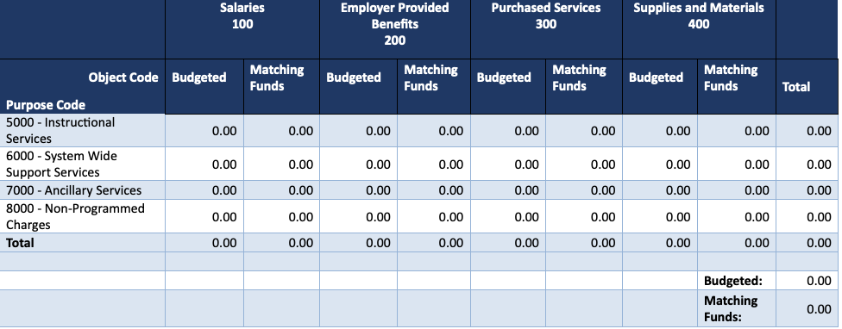

GRANT DETAILS SECTION

NOTE: An entry of ‘N/A’ in a narrative box will yield a score of zero (0) points for that item.

Total Amount Requested for 2021-2022: Total amount requested may not exceed $500,000.

Matching Funds Year for 2021-2022

1. Organization Type: Indicate the organization type that is submitting the application. Check one box only.

Nonprofit corporation
Nonprofit corporation working in collaboration with local education agency (LEA) (must submit Partnership Agreement in the “Related Documents” section signed by the local superintendent)

Non-Profit Working in Collaboration with Local Education Agency (LEA): Enter the name and code for the LEA that will serve as the collaboration partner.

NOTE: The text box below is limited to 1,500 characters including spaces.

2. Program Type: Indicate the type of program activities proposed. Check all boxes that apply.

Extended Learning:
Proposed number of students to be served in afterschool program during the school year:
Proposed number of students to be served via summer programming:

Integrated Student Supports:
Proposed number of students to be served during the school day (e.g. case-managed or Tier 2 and/or Tier 3 students):

3. Absolute Priority: Programs must serve one or more of the following groups of at-risk students whose learning has been negatively affected by COVID-19 impacts:
(i) at-risk students not performing at grade level as demonstrated by statewide assessments or not on track to meet year-end expectations, as demonstrated by existing indicators, including teacher identification, and/or
(ii) students at-risk of dropout, and/or
(iii) students at-risk of school displacement due to suspension or expulsion as a result of antisocial behaviors.

Indicate the students that will be served by the program. Applicants must check at least one of the groups to meet the Absolute Priority. Check all that are addressed by proposed program.

At-risk students not performing at grade level as demonstrated by statewide assessments, or not on track to meet year-end expectations, as demonstrated by existing indicators, including teacher identification, and/or,
Students at-risk of dropout, and/or
Students at-risk of school displacement due to suspension or expulsion as a result of antisocial behaviors

4. Competitive Priorities: Indicate which of the competitive priorities will be met through the proposed program. Check all that apply.

Academic content focusing on:

Science, Technology, Engineering, and Mathematics (STEM) learning opportunities, and/or
Academic content focusing on reading development and proficiency instruction

Models that focus services and programs in schools that are identified as State low performing (pursuant to G.S. 115C 105.37); at least 51% of schools proposed to be served are State low performing.

Non-profit corporation working in partnership with LEAs resulting in a match utilizing federal funds under Title I, Part A of the Elementary and Secondary Education Act or Title IV of the Higher Education Act to supplement the ELISS program.

5. Program Abstract: Provide a concise description of the proposed program that communicates the program mission and vision, clearly frames the intent of the proposed project, and describes how the proposed project will meet the needs of at-risk students whose learning has been negatively affected by COVID-19 impacts.

NOTE: The text box below is limited to 8,000 characters including spaces.

6. Collaborative Focus on At-Risk Students:
Describe: a) the types of targeted at-risk students (at-risk factor(s), grade level, etc.), including those students whose learning has been negatively affected by COVID-19 impacts, as well as, schools (including low-performing) and district(s) to be served;
b) the specific needs of at-risk students, including those students whose learning has been negatively affected by COVID-19 impacts;
c) the gaps collaborating school(s) and district(s) have in meeting the needs of targeted at-risk students; and
d) collaboration with proposed partnering school principal(s), including roles and responsibilities.

NOTE: The text box below is limited to 15,000 characters including spaces.

- 7. Articulation of Program Model:
Describe: a) the program model, its key components, including strategies to mitigate the negative effects of COVID-19 impacts on learning and alignment to the needs of targeted students;
b) the organization’s past experience in implementing the model described in “a.” and what was learned from past experience about how to implement the model for at-risk students;
c) how proposed students to be served will be invited to participate in the program, and how proposed activities/services support targeted students’ success in their regular academic program;
d) how the program will facilitate meaningful family and community engagement in supporting targeted students’ academic behaviors and achievement; and
e) how the program model proposed is likely to benefit (including mitigating negative effects of COVID-19 impacts on learning) the targeted students.

NOTE: The text box below is limited to 18,000 characters including spaces.

8. Check any implementation features below that apply to your proposed program.

Prioritizes integration of clear academic content, in particular STEM learning opportunities or reading development and proficiency instruction
Aligns activities with State performance measures, student academic goals, and/or the North Carolina Standard Course of Study
Minimizes student class size when providing instruction, instructional supports, or interventions
Deploys multiple tiered supports in a school setting to address student barriers to achievement such as strategies to improve chronic absenteeism, anti-social behaviors, academic growth, and enhancement of parent and family engagement
Expands student access to high quality learning activities and academic support that strengthens student engagement
Leverages community-based resources which may include mentoring or private-sector employer involvement
Uses digital content or resources to expand learning time
Other
NOTE: The text box below is limited to 1,000 characters including spaces.

9. Operational Capacity:
Describe: a) organizational history and prior funding sources for programs serving at-risk students;
b) key leaders’ experience and proposed staffing;
c) agreement with school(s) and district(s) on commitment of resources for program (e.g., extended learning time facilities, space/time in the school day for Integrated Student Support meetings with students, technology in place for student use);
d) how community-based resources have been identified and will be leveraged to expand student access to learning activities and, academic and behavioral supports; and
e) how collaborations and partnerships with other organizations will lead to sustaining the program (i.e., secure funding, shared resources, long-term partnerships) to support the needs of at-risk students beyond the grant period.

- NOTE: The text box below is limited to 18,000 characters including spaces.

- 10. Evaluation Capacity:
- Describe: a) key student outcomes and associated performance measures that align with the proposed program model;
- b) the organizational plan for collecting, analyzing, and reporting participation and outcome data on students served (including assurances that the organization has access to the data described); and
- c) organizational capacity (internal or external) for completing the required outcome reporting, as well as, using data for continuous program improvement.

NOTE: The text box below is limited to 12,000 characters including spaces.

11. Budget Narrative and Alignment: Identify the number of at-risk students to be served and provide cost per student estimates.
Describe: a) how costs align to proposed program components, reflecting the necessity and reasonableness of costs; and
b) any cost-sharing or resource-sharing arrangements between partnering districts/schools and applicant organization(s).

Complete and upload the ELISS Budget Worksheet in “Required Documents” – do not upload worksheet here. This section is for narrative only.

NOTE: The text box below is limited to 9,000 characters including spaces.

12. Potential for Replication: Describe: a) the extent of prior implementation of the proposed program model in your county or in the state and what is known about its impact on at-risk students; and b) the extent to which the proposed program model has future potential for replication in other locations.

NOTE: The text box below is limited to 6,000 characters including spaces.

13. Applicant must respond to the following questions related to recent and/or existing funding (Responding “Yes” to any of the questions below does not exclude applicant from eligibility for consideration for funding.)

- Does applicant have a current 21st CCLC grant?
Yes
No

If yes, describe how the proposed ELISS program will be different in scope from the currently operated 21st CCLC program.

NOTE: The text box below is limited to 6,000 characters including spaces.

- Has applicant received federal or state funds to support students in low-performing schools in the past five (5) years?
Yes
No

If yes, indicate for each: 1) the funding source, 2) the funding period, 3) the total amount of funds received across the funding period, and 4) the total number of students served.

NOTE: The text box below is limited to 6,000 characters including spaces.

RELATED DOCUMENTS
Required Documents (template can be found on the CCIP Homepage in the NCDPI Resources section at: https://ccip.schools.nc.gov/DocumentLibrary)
- Basic Organization Information (Primary Organization Contact, Fiscal Agent Contact, etc.)
- Articles of Incorporation and Registered Agent
- Statement of Assurances
- Debarment Certification
- Budget Worksheet & Total Cost Certification Form (must include matching contributions that demonstrate required match)
- Data Integrity and Confidentiality Certification (indicates communication with school(s) to ensure that students served meet the Absolute Priority)
- Proposed Feeder Schools and Low-Performing Status
- SAM Registration Confirmation

Optional Documents
- Partnership Agreement with LEAs (only for nonprofits working in collaboration with LEAs - template provided)
- Other Collaborative Agreement(s) (no template provided)

