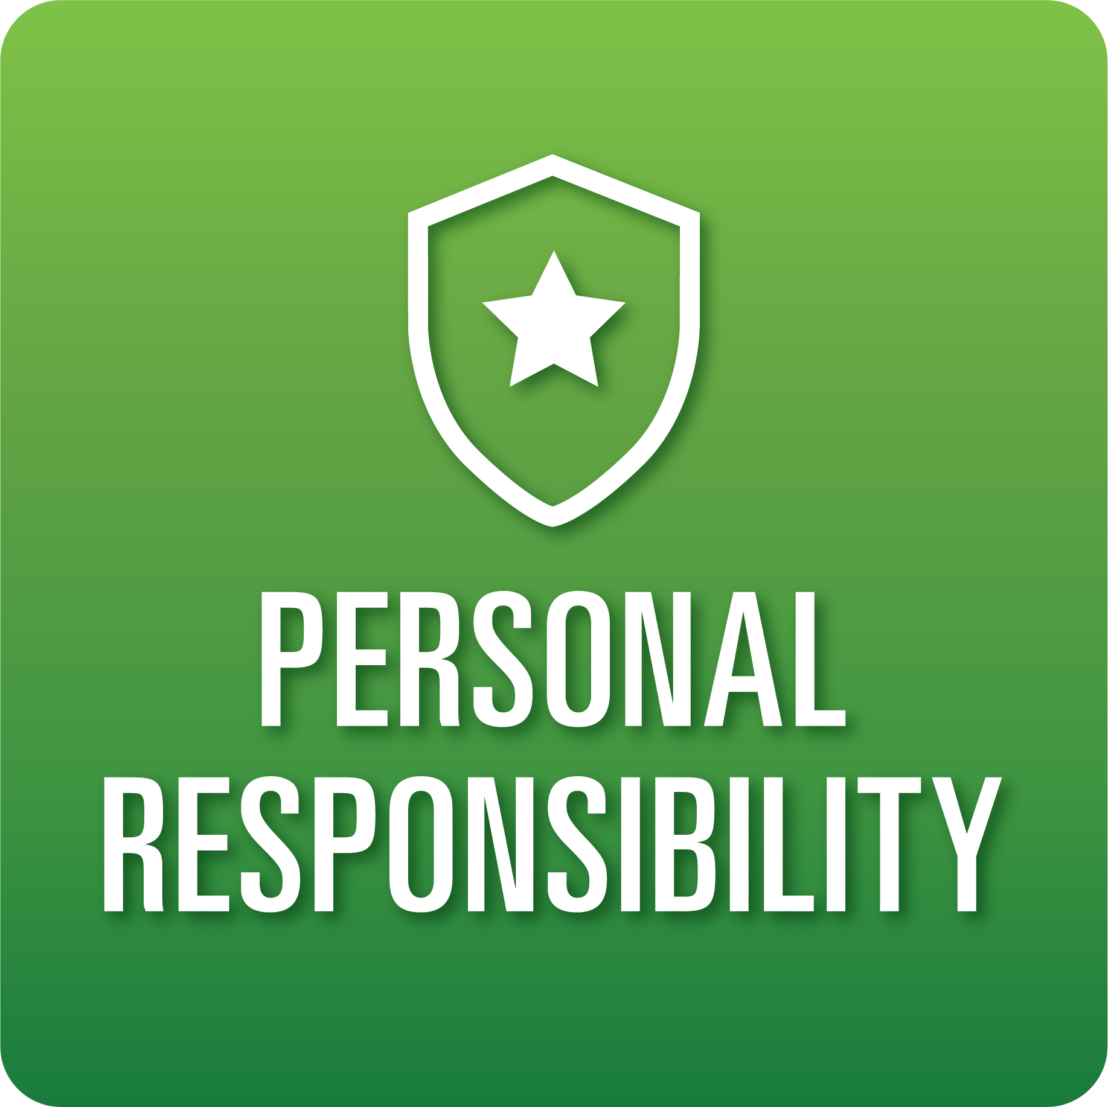

**T-Chart for Improving Personal Responsibility Skills:**

**Grades 9-12**

Select one of the following Personal Responsibility skills. Complete the T-Chart. Then, circle a “Look Like” and “Sound Like” behavior as your focus for improvement.

**Task Initiation:**

* I can recognize a task and take action, moving from step to step without prompting from others.
* I can set a goal for the task and engage in the necessary steps to complete the task.
* I can follow directions without prompting.

**Planning/Prioritization:**

* I can create a plan to complete a task and follow through successfully.
* I can successfully remain on schedule and complete a plan.

**Persistence:**

* I can persist in getting tasks done accurately and independently.
* I can set and complete goals on time, asking for help if needed.
* I can utilize a variety of resources and choose the most relevant resource(s) as needed.

***Inter*personal Responsibility:**

* I can choose words and actions that have a positive influence/impact on others.

***Intra*personal Responsibility:**

* I can self-regulate and take individual responsibility to achieve the final goal.

**When I _____________________________________________________________, it would…**

| **Look like… (Be very specific)** | **Sound like… (Be very specific)** |
| --- | --- |
|  |  |

(To be completed at the end of a unit or performance task.)

| **Reflect: How did you improve your ability to demonstrate this skill?** |
| --- |
|  |