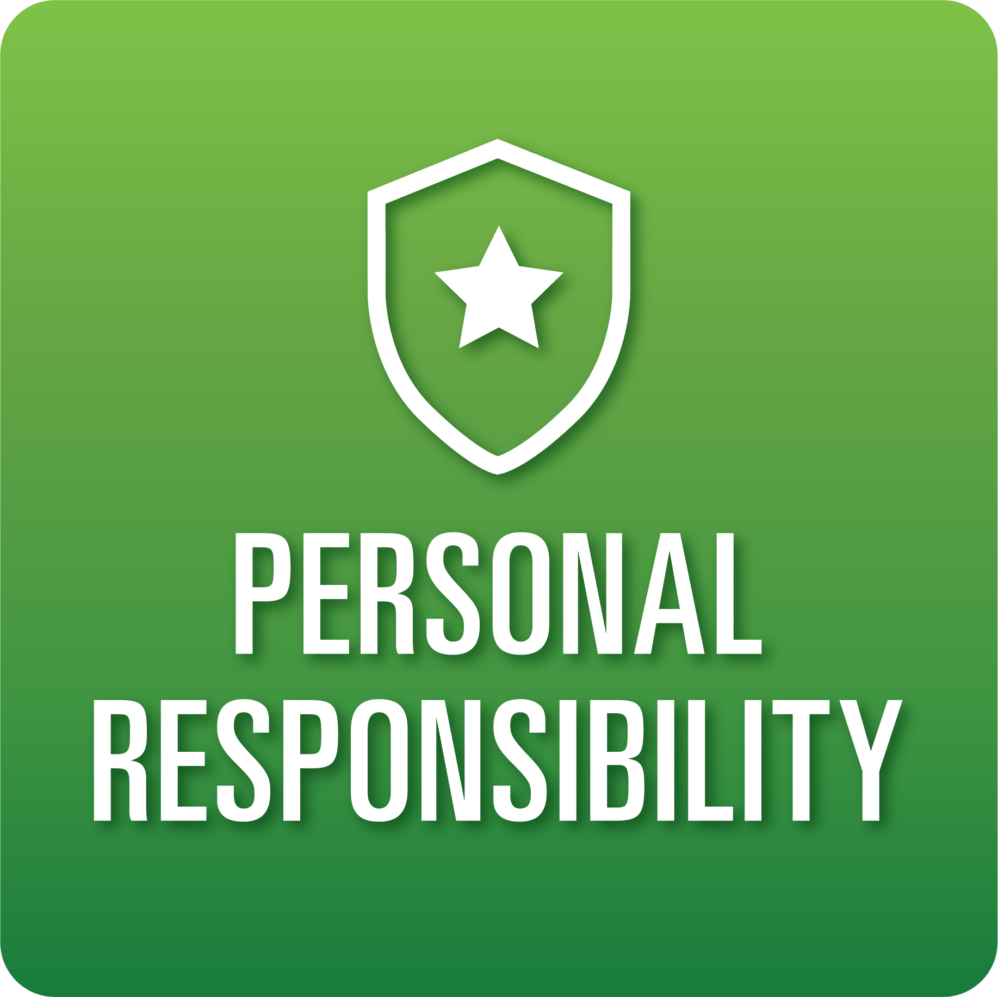

**T-Chart for Improving Personal Responsibility Skills:**

**Grades 6-8**

Select one of the following Personal Responsibility skills. Complete the T-Chart. Then, circle a “Look Like” and “Sound Like” behavior as your focus for improvement.

**Task Initiation:**

* I can recognize when to stop a task and begin a new task with minimal prompting.
* I can set a goal for the task at hand and prepare to engage in the necessary steps to complete the task.
* I can follow directions without prompting most of the time.

**Planning/Prioritization:**

* I can create a detailed plan to complete a task and follow through.
* I can remain on schedule and complete the outlined plan.

**Persistence:**

* I persist in getting tasks done accurately, with minimal assistance.
* I can set and complete goals on time with minimal assistance.
* I can recognize when I need help and ask for it.

***Inter*personal Responsibility:**

* I can show care and concern for others through actions and words.
* I understand the impact I have on others.

***Intra*personal Responsibility:**

* I can self-regulate to work through a plan and correctly complete a task.
* I can exhibit self-discipline and/or self-motivation.
* I am aware of my thoughts, feelings, and intentions and their consequences.

**When I _____________________________________________________________, it would…**

| **Look like… (Be very specific)** | **Sound like… (Be very specific)** |
| --- | --- |
|  |  |

(To be completed at the end of a unit or performance task.)

| **Reflect: How did you improve your ability to demonstrate this skill?** |
| --- |
|  |