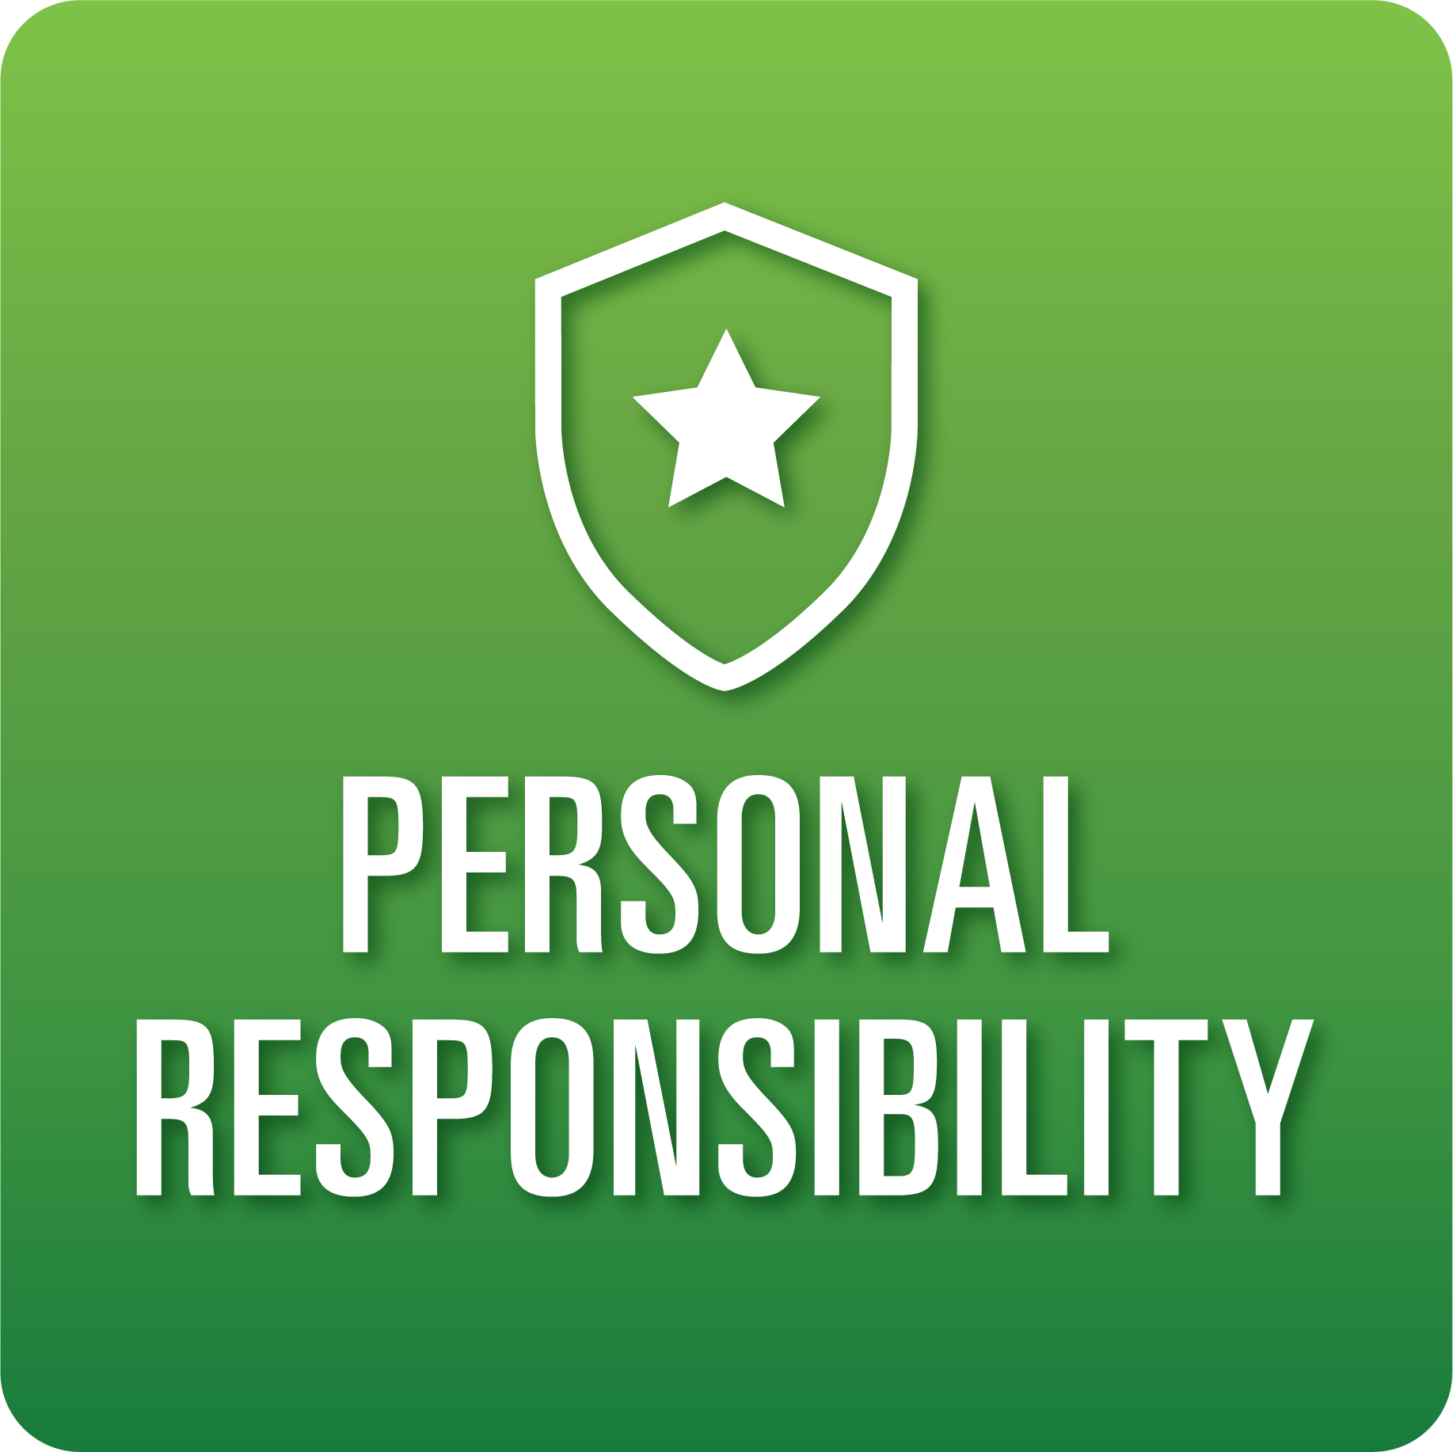

**T-Chart for Improving Personal Responsibility Skills:**

**Grades 3-5**

Select one of the following Personal Responsibility skills. Complete the T-Chart. Then, circle a “Look Like” and “Sound Like” behavior as your focus for improvement.

**Task Initiation:**

* I can stop a previous task and begin a new task when necessary.
* I can set goals and identify a starting place for assignments/projects.
* I can follow directions without prompting most of the time.

**Planning/Prioritization:**

* I can develop a plan to complete a task and follow through.
* I can usually remain on schedule as outlined in my plan.

**Persistence:**

* I can persist in completing goals or tasks on time.
* I ask for help or clarification when needed.

***Inter*personal Responsibility:**

* I can choose words and actions that have a positive influence/impact on others.
* I can communicate care for others through words and actions.

***Intra*personal Responsibility:**

* I can usually self-regulate to meet goals/deadlines.
* I can exhibit self-discipline and/or self-motivation.

**When I _____________________________________________________________, it would…**

| **Look like… (Be very specific)** | **Sound like… (Be very specific)** |
| --- | --- |
|  |  |

(To be completed at the end of a unit or performance task.)

| **Reflect: How did you improve your ability to demonstrate this skill?** |
| --- |
|  |