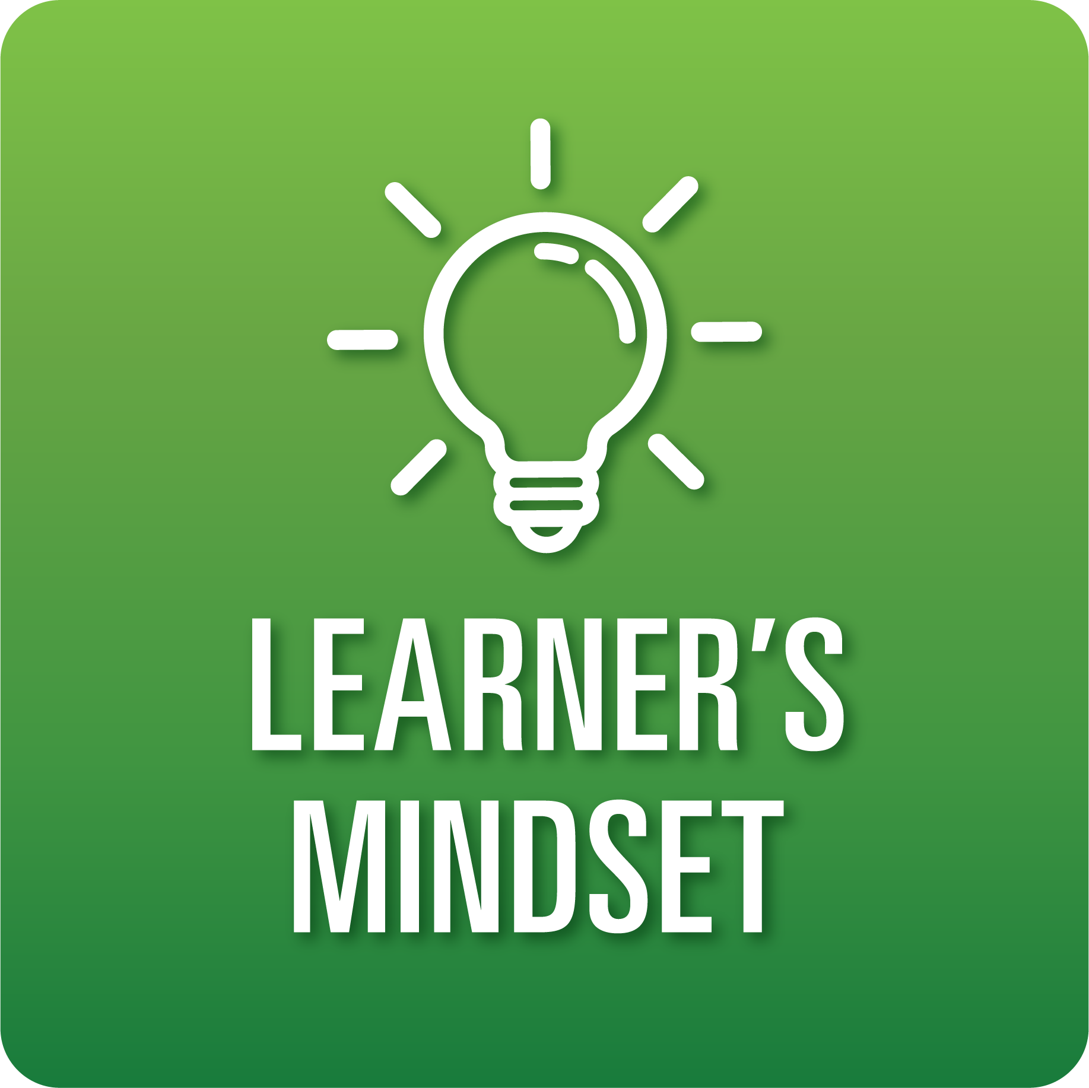

**T-Chart for Improving Learner’s Mindset Skills:**

**Grades 9-12**

Select one of the following Learner’s Mindset skills. Complete the T-Chart. Then, circle a “Look Like” and “Sound Like” behavior as your focus for improvement.

**Curiosity:**

* I can engage in inquiry that reflects my unique learning process and interests.
* I can use inquiry to examine new perspectives and ideas that challenge my assumptions and help me to extend my thinking.

**Persistence:**

* I can use resources to find ways to keep working when faced with challenges and obstacles.

**Innovation:**

* I can find unique solutions to problems by drawing on many different types of knowledge, experiences, and ideas.

**Beliefs About Learning:**

* I can articulate the meaning and value of new learning experiences.
* I can use strategies to overcome challenges and obstacles to my learning.
* I can integrate feedback from others to improve my learning.

**When I _____________________________________________________________, it would…**

| **Look like… (Be very specific)** | **Sound like… (Be very specific)** |
| --- | --- |
|  |  |

(To be completed at the end of a unit or performance task.)

| **Reflect: How did you improve your ability to demonstrate this skill?** |
| --- |
|  |