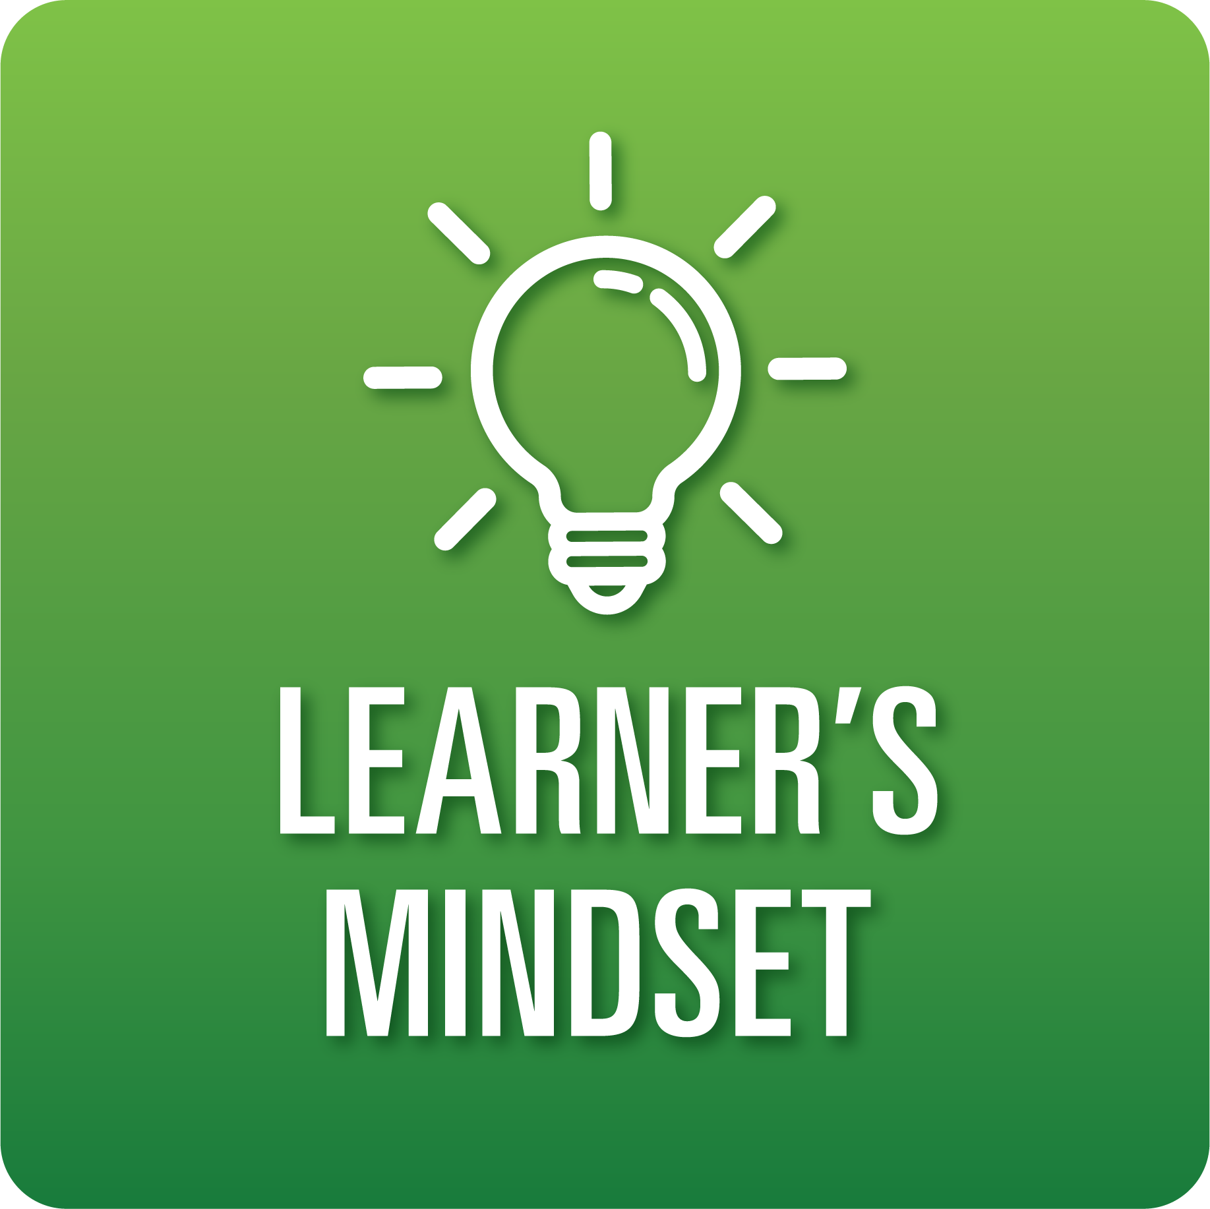

**T-Chart for Improving Learner’s Mindset Skills:**

**Grades 6-8**

Select one of the following Learner’s Mindset skills. Complete the T-Chart. Then, circle a “Look Like” and “Sound Like” behavior as your focus for improvement.

**Curiosity:**

* I can use a defined inquiry process to explore ideas and find solutions.

**Persistence:**

* I can use resources to find ways to keep working when faced with challenges and obstacles.

**Innovation:**

* I can create new approaches and solutions by using research and building on my prior learning and experiences.

**Beliefs About Learning:**

* I can use new strategies to increase my learning.
* I can seek feedback from others to help me revise my ideas and products.

**When I _____________________________________________________________, it would…**

| **Look like… (Be very specific)** | **Sound like… (Be very specific)** |
| --- | --- |
|  |  |

(To be completed at the end of a unit or performance task.)

| **Reflect: How did you improve your ability to demonstrate this skill?** |
| --- |
|  |