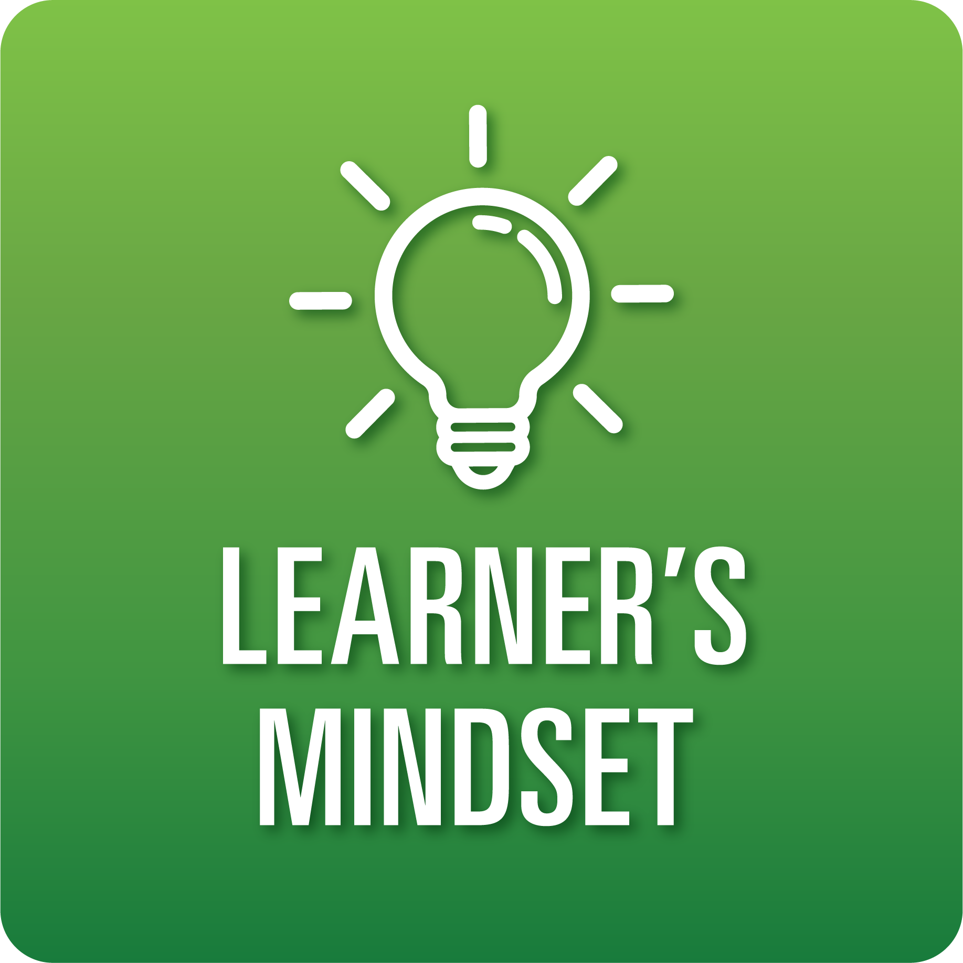

**T-Chart for Improving Learner’s Mindset Skills:**

**Grades 3-5**

Select one of the following Learner’s Mindset skills. Complete the T-Chart. Then, circle a “Look Like” and “Sound Like” behavior as your focus for improvement.

**Curiosity:**

* I can ask questions to deepen my knowledge and understanding.
* I can find answers to my questions in a variety of ways.

**Persistence:**

* I can identify resources (peers, adults, visuals, etc.) to help me move past challenges or obstacles.

**Innovation:**

* I can use my knowledge, along with supporting research, to generate new ideas, products, or ways of doing things.

**Beliefs About Learning:**

* I can explain why it is important to explore new knowledge on topics both captivating and unappealing.

**When I _____________________________________________________________, it would…**

| **Look like… (Be very specific)** | **Sound like… (Be very specific)** |
| --- | --- |
|  |  |

(To be completed at the end of a unit or performance task.)

| **Reflect: How did you improve your ability to demonstrate this skill?** |
| --- |
|  |