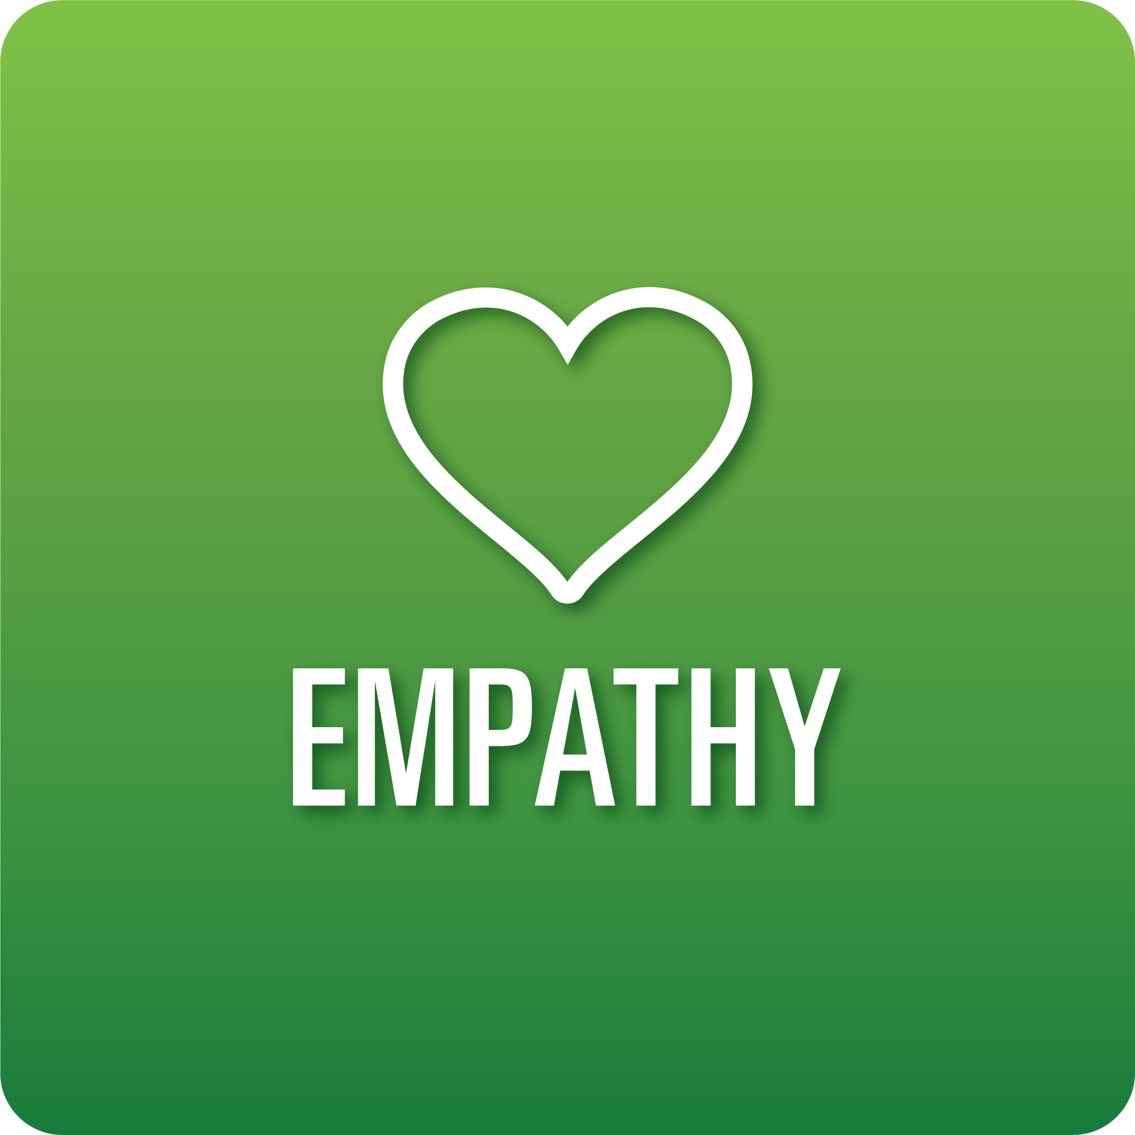

**T-Chart for Improving Empathy Skills:**

**Grades 9-12**

Select one of the following Empathy skills. Complete the T-Chart. Then, circle a “Look Like” and “Sound Like” behavior as your focus for improvement.

**Perception of Self and Others:**

* I can seek and consider feelings, perspectives, and experiences when interacting with others virtually and in person.
* I can demonstrate the value that the feelings, perspectives, and experiences of others bring to a variety of situations.

**Relationships:**

* I can create positive and supportive relationships with others.
* I can appreciate and respect the feelings, perspectives, and experiences of others.
* I can advocate for myself and others when necessary.

**Diverse Perspectives:**

* I can ask questions to help me better understand the viewpoints of others.

**Effective Listening:**

* I can identify the feelings and ideas behind the speaker’s message that may not be spoken in words.
* I can deepen my understanding of the speaker’s message by considering the words that are said as well as those that are not.
* I can reflect on the speaker’s message and attempt to understand it from their point of view.

**When I _____________________________________________________________, it would…**

| **Look like… (Be very specific)** | **Sound like… (Be very specific)** |
| --- | --- |
|  |  |

(To be completed at the end of a unit or performance task.)

| **Reflect: How did you improve your ability to demonstrate this skill?** |
| --- |
|  |