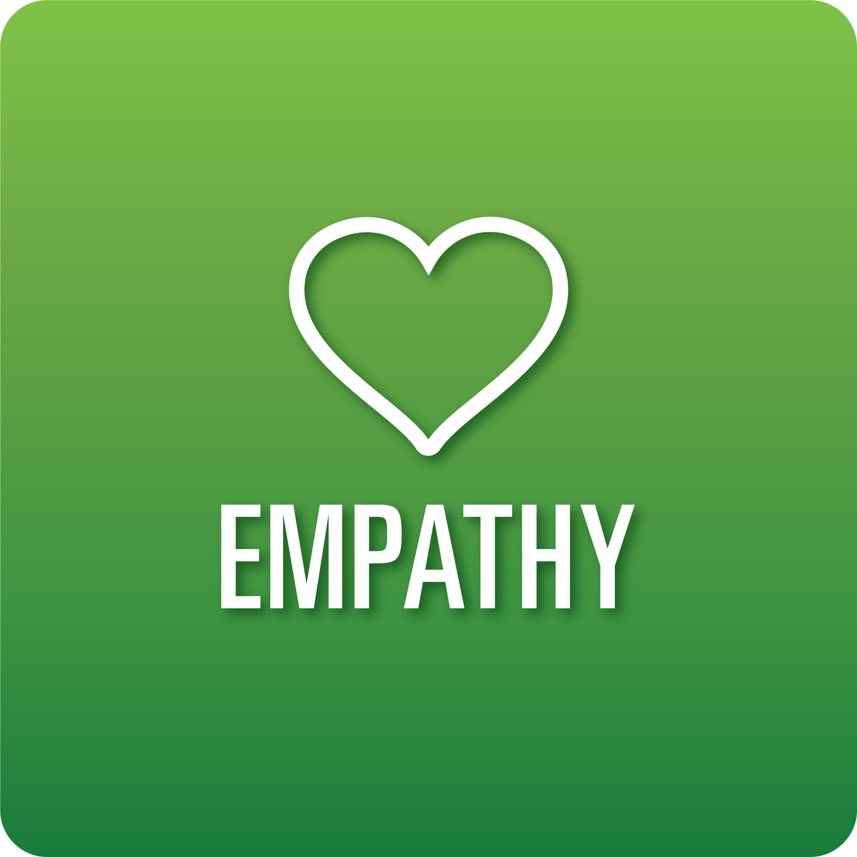

**T-Chart for Improving Empathy Skills:**

**Grades 6-8**

Select one of the following Empathy skills. Complete the T-Chart. Then, circle a “Look Like” and “Sound Like” behavior as your focus for improvement.

**Perception of Self and Others:**

* I can understand the feelings, perspectives, and experiences of myself and others when interacting virtually and in person.

**Relationships:**

* I can create positive and supportive relationships with others.
* I can appreciate and respect the feelings, perspectives, and experiences of others.

**Diverse Perspectives:**

* I can ask questions to help me better understand the viewpoints of others.

**Effective Listening:**

* I can show others that I am listening by taking notes, asking thoughtful questions, summarizing, and being mindful of my expressions and behaviors.
* I can ask questions that encourage the speaker to share more information.

**When I _____________________________________________________________, it would…**

| **Look like… (Be very specific)** | **Sound like… (Be very specific)** |
| --- | --- |
|  |  |

(To be completed at the end of a unit or performance task.)

| **Reflect: How did you improve your ability to demonstrate this skill?** |
| --- |
|  |