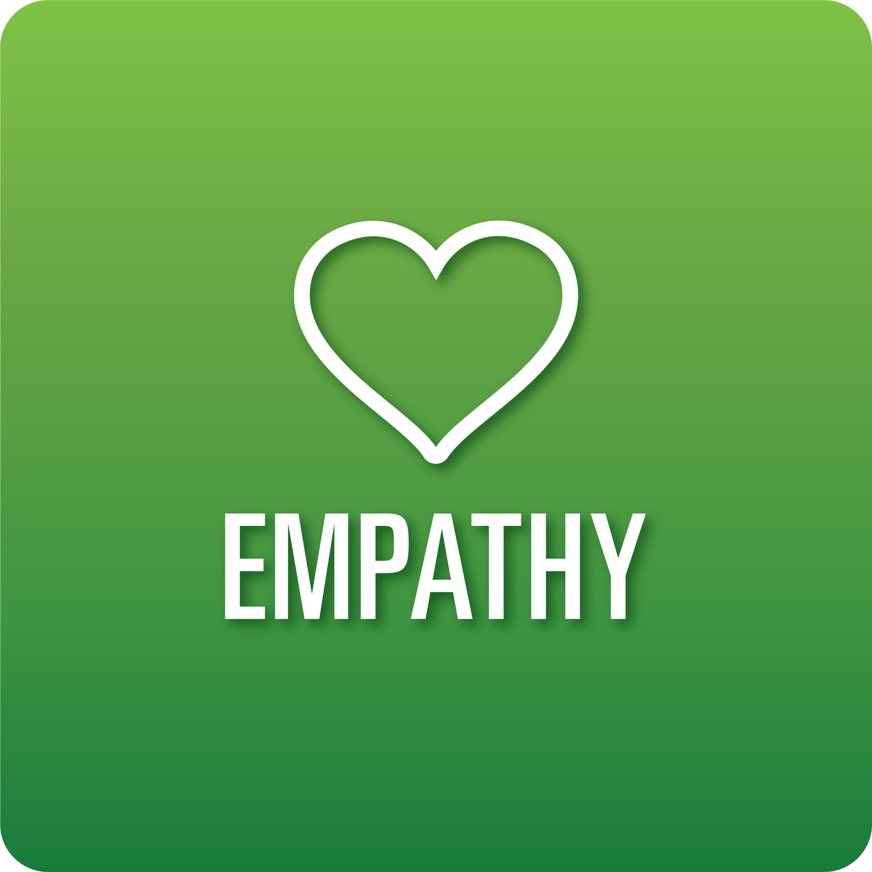

**T-Chart for Improving Empathy Skills:**

**Grades 3-5**

Select one of the following Empathy skills. Complete the T-Chart. Then, circle a “Look Like” and “Sound Like” behavior as your focus for improvement.

**Perception of Self and Others:**

* I can identify my feelings and viewpoints.
* I can identify the feelings and viewpoints of others based on their words, facial expressions, voice (tone), and body language.

**Relationships:**

* I can identify how choices about my words, actions, and behaviors affect others.

**Diverse Perspectives:**

* I understand and respect the viewpoints of others that are different from mine.
* I can explain how to respect the differences of others.

**Effective Listening:**

* I can allow others to share their ideas without interrupting.
* I can accurately paraphrase what others have shared to show I am listening.
* I can ask questions related to what the speaker is saying.

**When I _____________________________________________________________, it would…**

| **Look like… (Be very specific)** | **Sound like… (Be very specific)** |
| --- | --- |
|  |  |

(To be completed at the end of a unit or performance task.)

| **Reflect: How did you improve your ability to demonstrate this skill?** |
| --- |
|  |