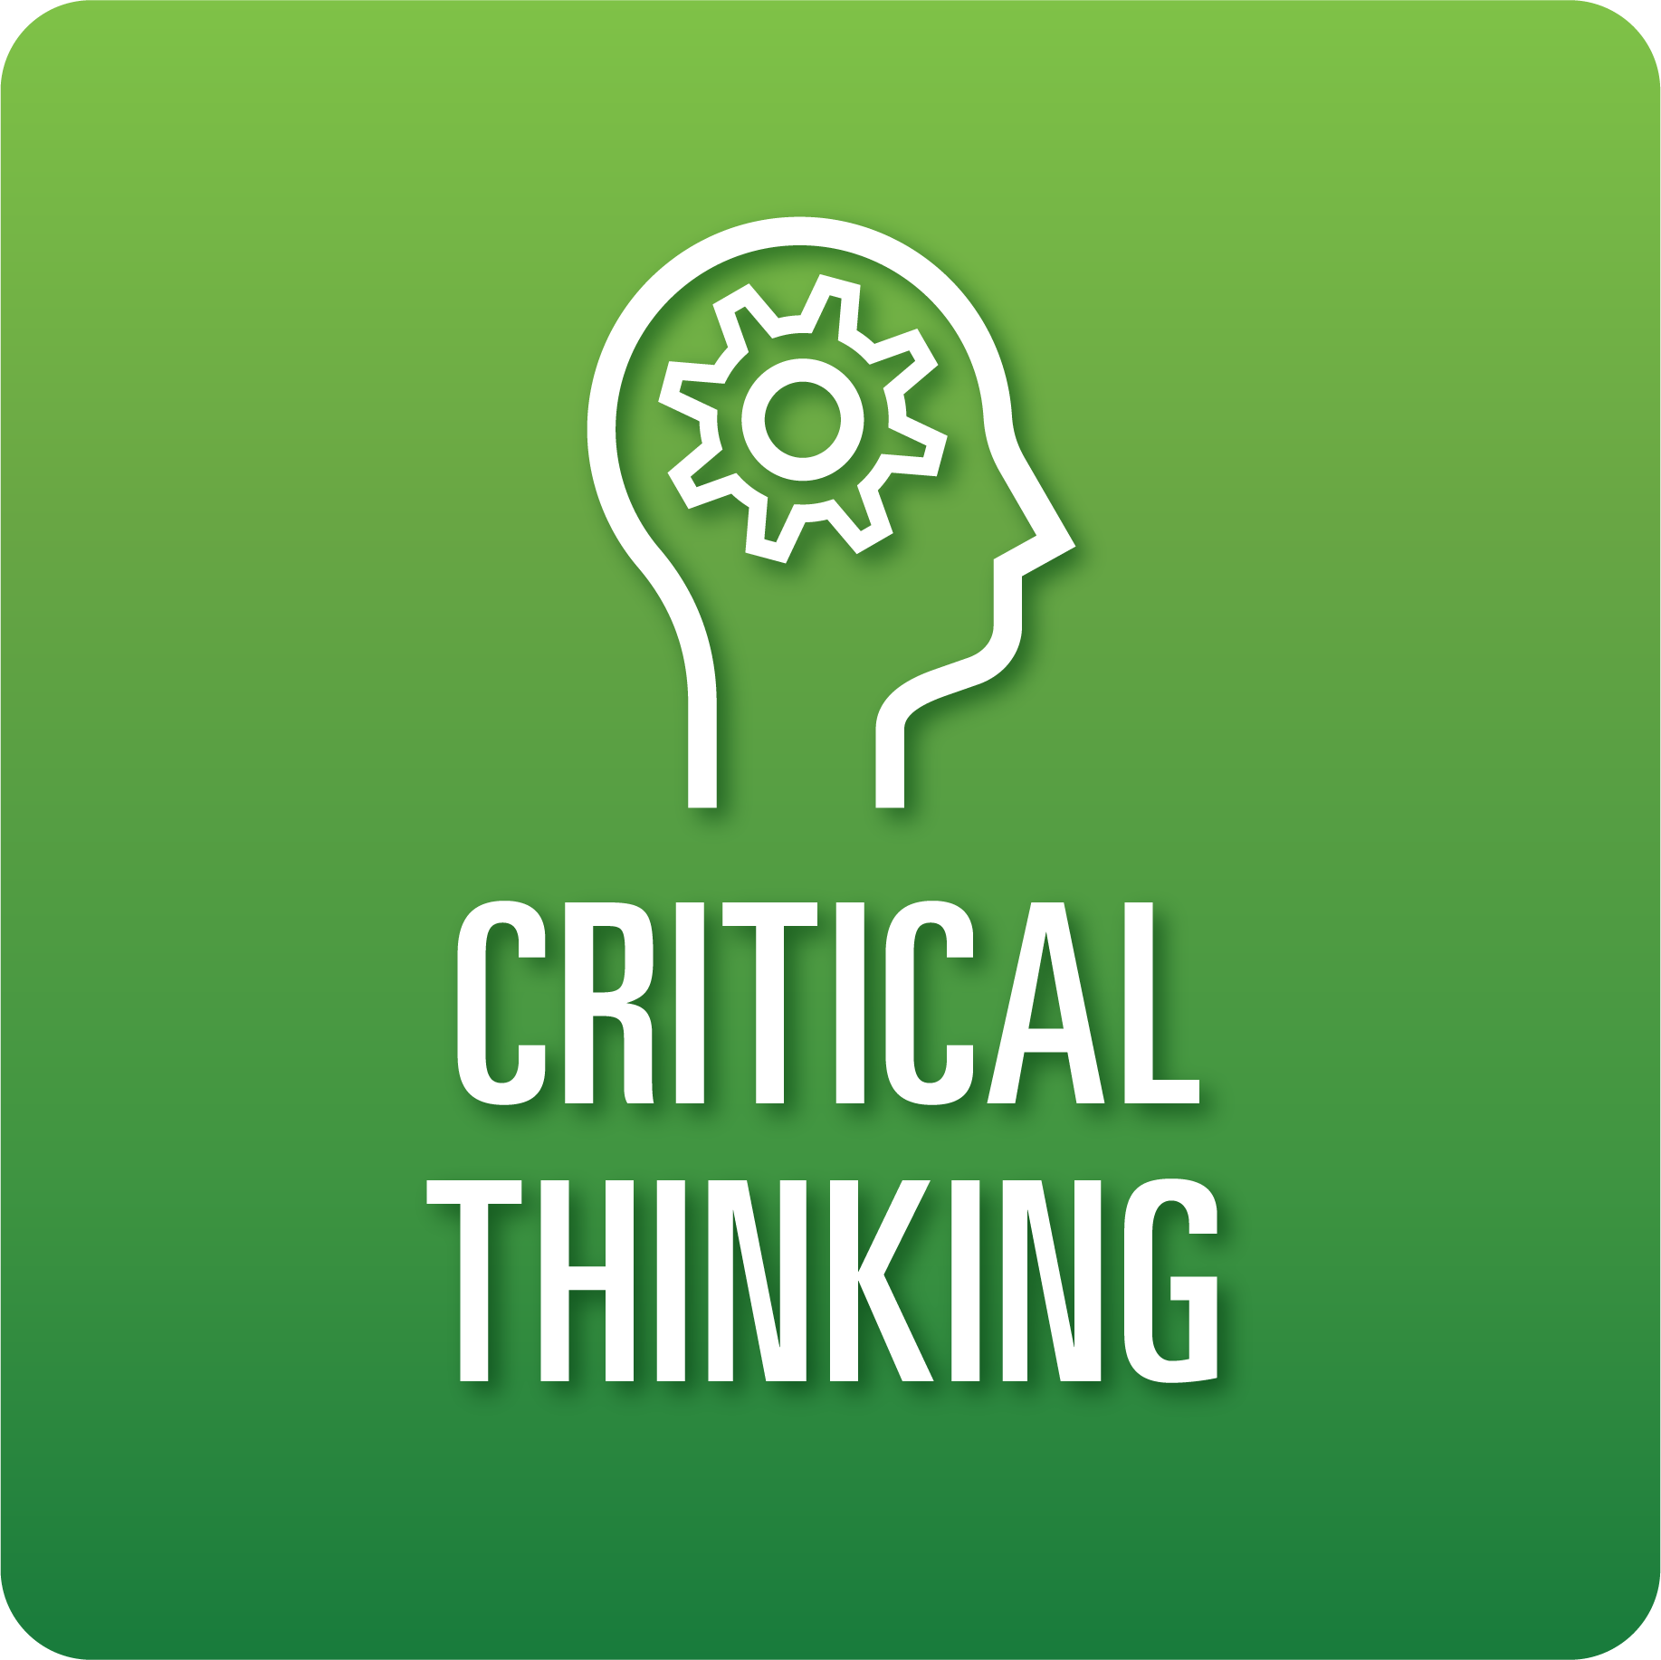

**T-Chart for Improving Critical Thinking Skills:**

**Grades 9-12**

Select one of the following Critical Thinking skills. Complete the T-Chart. Then, circle a “Look Like” and “Sound Like” behavior as your focus for improvement.

**Information, Discovery, and Research:**

* I can develop an initial set of questions related to the topic, polish the questions, and identify a key question or prioritized set of questions that provide a foundation for my investigation.
* I can find appropriate, high-quality, and diverse information sources relevant to my questions.
* I can compare information across sources to determine credibility and accuracy.

**Reasoning, Analysis, and Interpretation:**

* I can organize my notes/data and identify similarities, differences, and/or patterns.
* I can draw logical conclusions from my notes, observations, and inferences.
* I can cite specific details upon which my conclusions were drawn and explain any shifts in thinking about the problem/issue.

**Solution Finding:**

* I can create relevant criteria to evaluate my approach to solving a problem.
* I can evaluate my solution ideas and select an effective solution that meets all criteria.
* I can design a process to test my proposed solution.
* I can analyze, with precision and accuracy, the relative effectiveness of my proposed solution and clearly explain what I need to improve.

**Justification:**

* I can provide a clear, knowledgeable claim about the problem or issue and distinguish it from opposing claims.
* I can thoroughly support my claim with logical reasoning and relevant evidence.
* I can clearly and convincingly address counter arguments.

**When I _____________________________________________________________, it would…**

| **Look like… (Be very specific)** | **Sound like… (Be very specific)** |
| --- | --- |
|  |  |

(To be completed at the end of a unit or performance task.)

| **Reflect: How did you improve your ability to demonstrate this skill?** |
| --- |
|  |