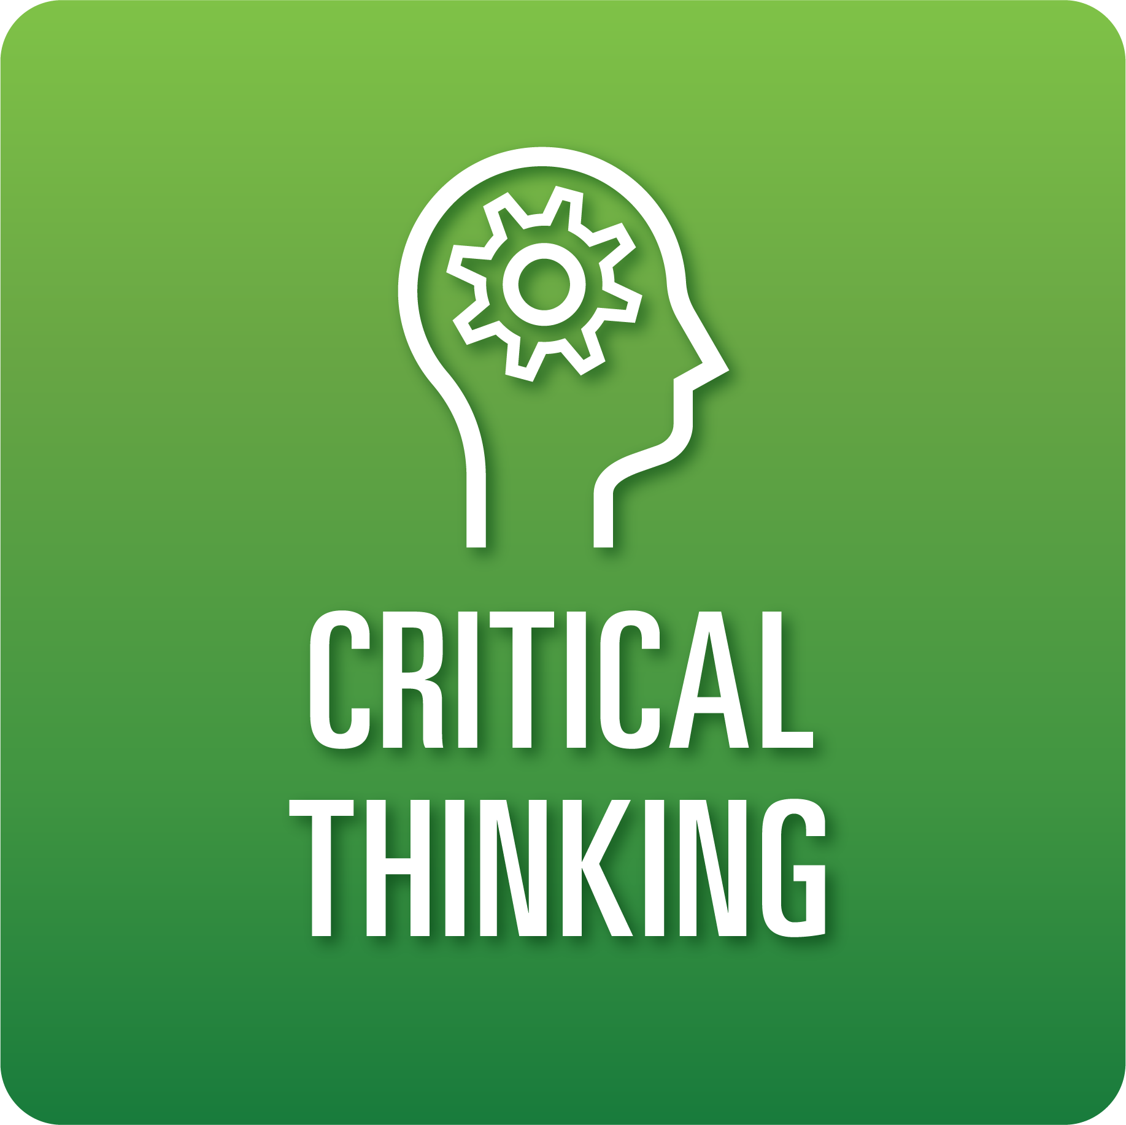

**T-Chart for Improving Critical Thinking Skills:**

**Grades 6-8**

Select one of the following Critical Thinking skills. Complete the T-Chart. Then, circle a “Look Like” and “Sound Like” behavior as your focus for improvement.

**Information, Discovery, and Research:**

* I can ask clear questions related to the topic, improve the questions, and identify a key question or set of questions to investigate.
* I can conduct research and find multiple helpful and relevant sources to answer my questions about the topic.
* I can assess the credibility of each source based on given criteria to decide which information to use.

**Reasoning, Analysis, and Interpretation:**

* I can document my learning by organizing and prioritizing notes/data.
* I can identify similarities, differences, and/or patterns in the information I’ve collected.
* I can form valid inferences from information.

**Solution Finding:**

* I can use the provided criteria to select an effective solution to test that is directly related to the problem and feasible to implement.
* I can test a solution using the provided criteria and collect clear information.
* I can analyze the effectiveness of my proposed solutions, explain what I learned, and determine the need for further work on the problem.

**Justification:**

* I can provide a clear, knowledgeable claim about the problem or issue.
* I can support my claim with logical reasoning and relevant evidence.

**When I _____________________________________________________________, it would…**

| **Look like… (Be very specific)** | **Sound like… (Be very specific)** |
| --- | --- |
|  |  |

(To be completed at the end of a unit or performance task.)

| **Reflect: How did you improve your ability to demonstrate this skill?** |
| --- |
|  |