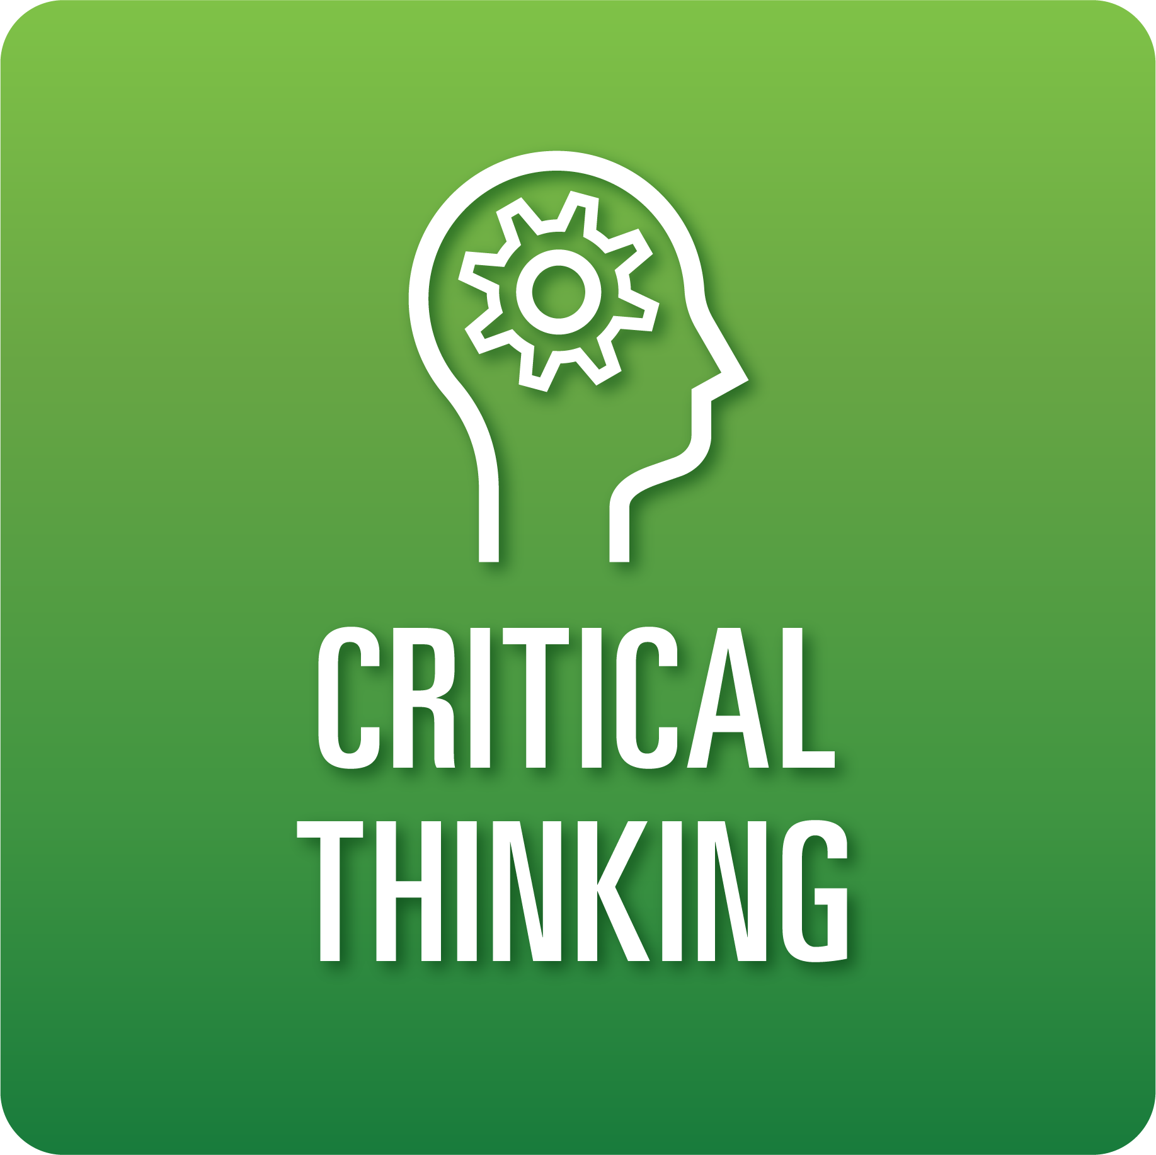

**T-Chart for Improving Critical Thinking Skills:**

**Grades 3-5**

Select one of the following Critical Thinking skills. Complete the T-Chart. Then, circle a “Look Like” and “Sound Like” behavior as your focus for improvement.

**Information, Discovery, and Research:**

* I can show that I understand (the task, challenge, topic we’re going to learn about) by explaining it in my own words.
* I can ask clear questions related to the topic to help me find information.
* I can gather helpful sources to answer my questions about the topic.
* I can evaluate whether my sources contain information about the topic and address my questions.

**Reasoning, Analysis, and Interpretation:**

* I can clearly document my learning by organizing information into provided categories, etc.
* I can share clear and logical conclusions made from a review of information/notes.

**Solution Finding:**

* I can explain my ideas about how to best solve the problem and why each idea makes sense.
* I can select a solution that meets the provided criteria.

**Justification:**

* I can share my opinion about (the problem or issue).
* I can identify reasons that are supported by relevant facts and details to support my opinion.

**When I _____________________________________________________________, it would…**

| **Look like… (Be very specific)** | **Sound like… (Be very specific)** |
| --- | --- |
|  |  |

(To be completed at the end of a unit or performance task.)

| **Reflect: How did you improve your ability to demonstrate this skill?** |
| --- |
|  |