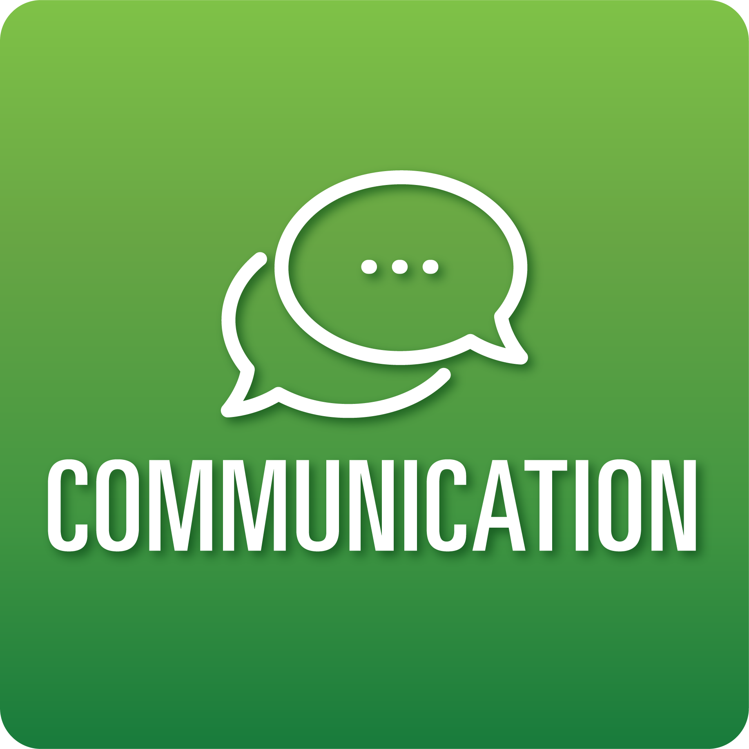

**T-Chart for Improving Communication Skills:**

**Grades 9-12**

Select one of the following Communication skills. Complete the T-Chart. Then, circle a “Look Like” and “Sound Like” behavior as your focus for improvement.

**Engaging in Conversations:**

* I can extend and deepen discussions by asking questions that invite my partners to elaborate, explain, or provide additional reasoning and evidence.
* I can respond to different perspectives shared in discussions by checking my understanding, paraphrasing, summarizing, or showing agreement with my partners’ ideas.
* I can include evidence when challenging or sharing new ideas and conclusions during discussion.
* I can share my ideas about the next steps that we need to take to deepen our understanding of the topic discussed or make progress on collaborative work.

**Giving and Receiving Feedback:**

* I can use a variety of modes (peer editing, critique protocols. etc.) to give specific, constructive, and helpful feedback to my classmates about their work based on the success criteria provided. My feedback includes a balance of commendations and suggestions for improvement.
* I can ask for specific feedback on my work in relation to my goals/the success criteria, check understanding, and document suggestions.
* I can show acceptance for feedback.
* I can use feedback to revise my work.

**Presenting Knowledge and Ideas:**

* I can present information, findings, and supporting evidence clearly and directly, addressing alternative or opposing perspectives to allow listeners to follow my line of reasoning.
* I can use adequate volume, appropriate pacing, and clear pronunciation.
* I can strategically use visual displays or digital media to enhance understanding and add interest.
* I can answer questions to show my understanding.

**When I _____________________________________________________________, it would…**

| **Look like… (Be very specific)** | **Sound like… (Be very specific)** |
| --- | --- |
|  |  |

(To be completed at the end of a unit or performance task.)

| **Reflect: How did you improve your ability to demonstrate this skill?** |
| --- |
|  |