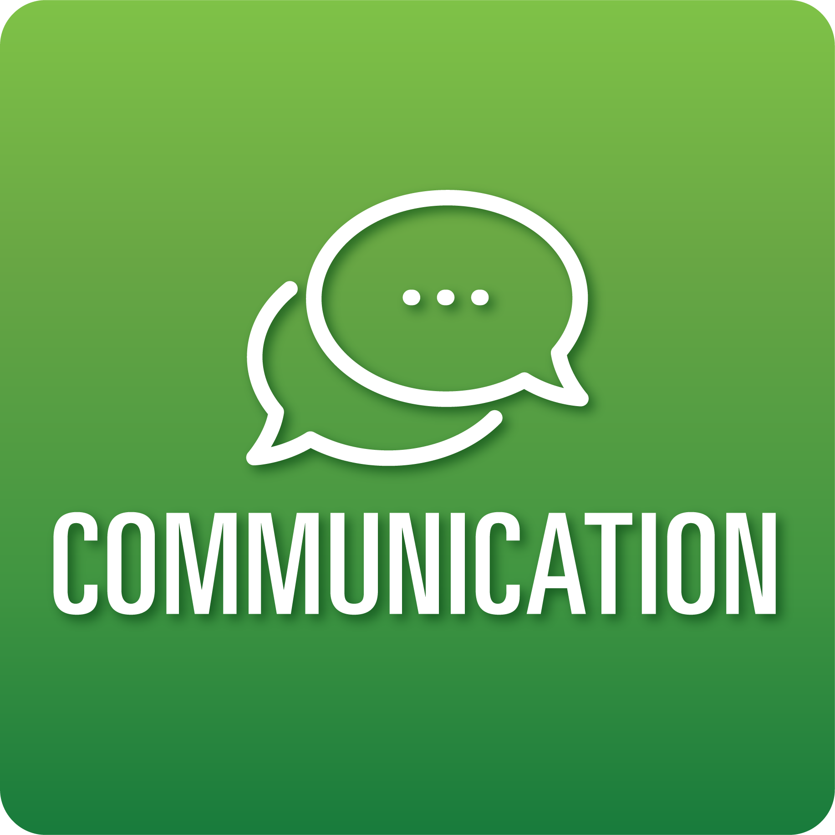

**T-Chart for Improving Communication Skills:**

**Grades 6-8**

Select one of the following Communication skills. Complete the T-Chart. Then, circle a “Look Like” and “Sound Like” behavior as your focus for improvement.

**Engaging in Conversations:**

* I can ask specific questions to check my understanding and deepen my knowledge during discussions.
* I can respond to others’ questions and comments with relevant connections and ideas.
* I can include evidence to support the views that I share during the discussion.
* I can accurately summarize information and perspectives shared during discussions.

**Giving and Receiving Feedback:**

* I can give specific, constructive feedback to my classmates about their work based on the success criteria provided.
* I can ask for specific feedback on my work.
* I can show acceptance for feedback.
* I can use feedback to improve my work.

**Presenting Knowledge and Ideas:**

* I can deliver a focused, coherent presentation using factual, relevant evidence, sound reasoning, and well-chosen details.
* I can speak clearly, at an understandable pace, using adequate volume.
* I can integrate visual displays or digital media to clarify information, strengthen claims, and add emphasis.
* I can answer questions to show my understanding.

**When I _____________________________________________________________, it would…**

| **Look like… (Be very specific)** | **Sound like… (Be very specific)** |
| --- | --- |
|  |  |

(To be completed at the end of a unit or performance task.)

| **Reflect: How did you improve your ability to demonstrate this skill?** |
| --- |
|  |