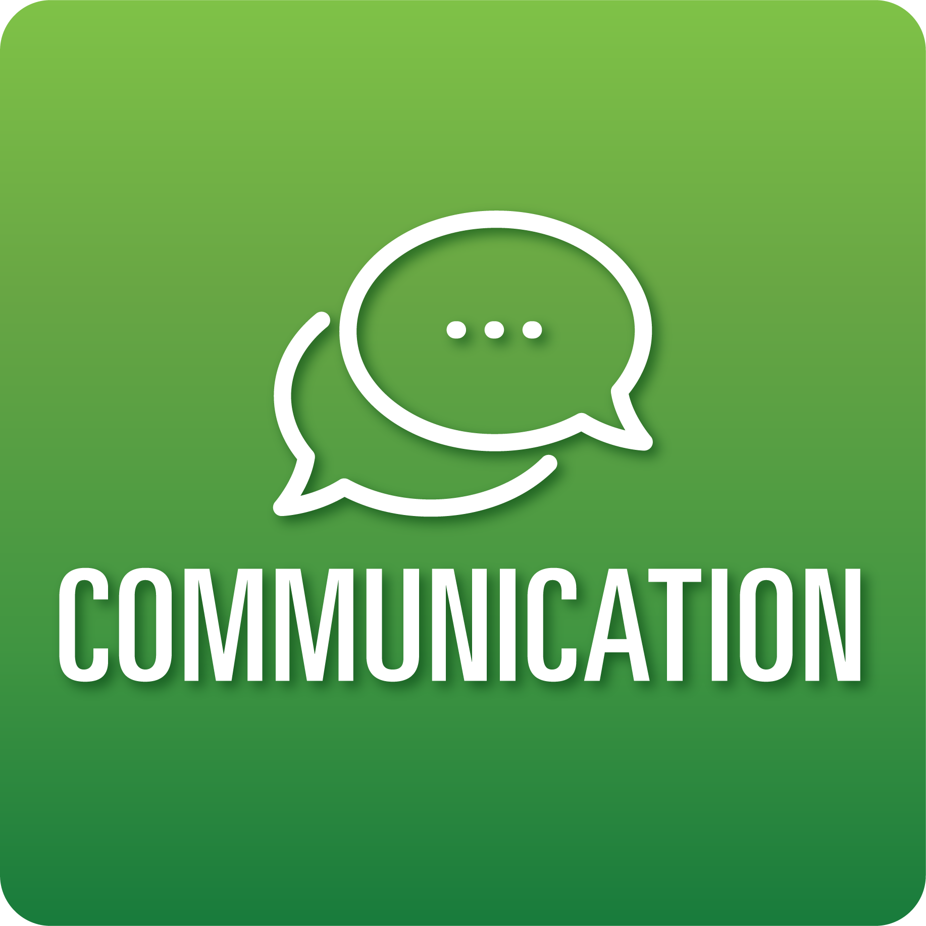

**T-Chart for Improving Communication Skills:**

**Grades 3-5**

Select one of the following Communication skills. Complete the T-Chart. Then, circle a “Look Like” and “Sound Like” behavior as your focus for improvement.

**Engaging in Conversations:**

* I can expand on others’ ideas during discussions.
* I can ask questions to better understand others’ comments.
* I can contribute to the discussion and connect my comments to what others say.
* I can summarize the main ideas made during a discussion.

**Giving and Receiving Feedback:**

* I can give constructive feedback to my classmates about their work.
* I can show acceptance for feedback.
* I can use feedback to improve my work with help from others.

**Presenting Knowledge and Ideas:**

* I can (tell a story, share my learning, etc.) using an appropriate amount of facts and details.
* I can speak clearly and at an understandable pace.
* I can use (props, drawings, visual displays, etc.) to support what I say and to emphasize important facts or ideas.
* I can answer questions to show my understanding.

**When I _____________________________________________________________, it would…**

| **Look like… (Be very specific)** | **Sound like… (Be very specific)** |
| --- | --- |
|  |  |

(To be completed at the end of a unit or performance task.)

| **Reflect: How did you improve your ability to demonstrate this skill?** |
| --- |
|  |