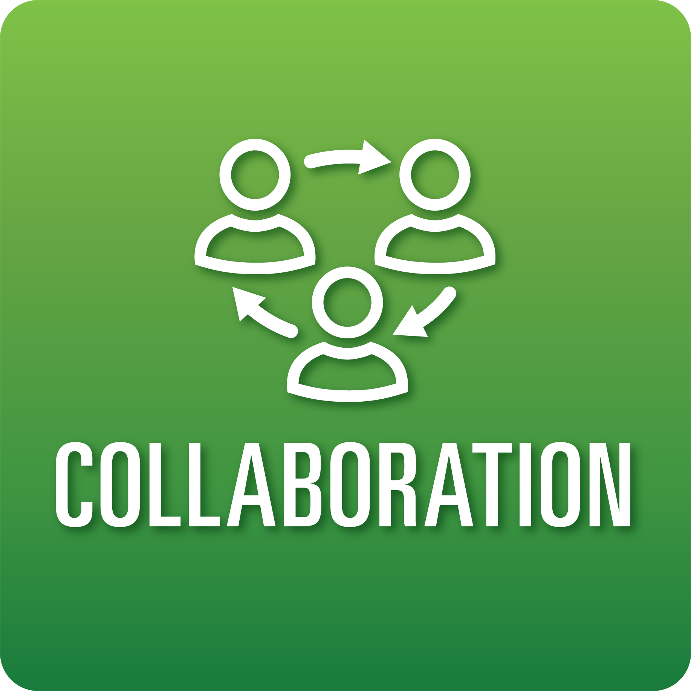

**T-Chart for Improving Collaboration Skills:**

**Grades 9-12**

Select one of the following Collaboration skills. Complete the T-Chart. Then, circle a “Look Like” and “Sound Like” behavior as your focus for improvement.

**Roles:**

* I can play a variety of roles and carry out different responsibilities that help my team meet goals.
* I can share the leadership responsibilities of my team.
* I can adjust to and respond to the needs of the group to achieve goals.

**Cooperation:**

* I can collaborate respectfully with my teammates in digital spaces.
* I can consistently follow our defined team norms and decision-making agreements.
* I can help my team solve problems or conflicts.

**Productivity and Accountability:**

* I can show that I am consistently prepared and ready to work with my team.
* I can prioritize and track individual and group progress toward established goals and deadlines.
* I can complete my tasks on time consistently.

**When I _____________________________________________________________, it would…**

| **Look like… (Be very specific)** | **Sound like… (Be very specific)** |
| --- | --- |
|  |  |

(To be completed at the end of a unit or performance task.)

| **Reflect: How did you improve your ability to demonstrate this skill?** |
| --- |
|  |