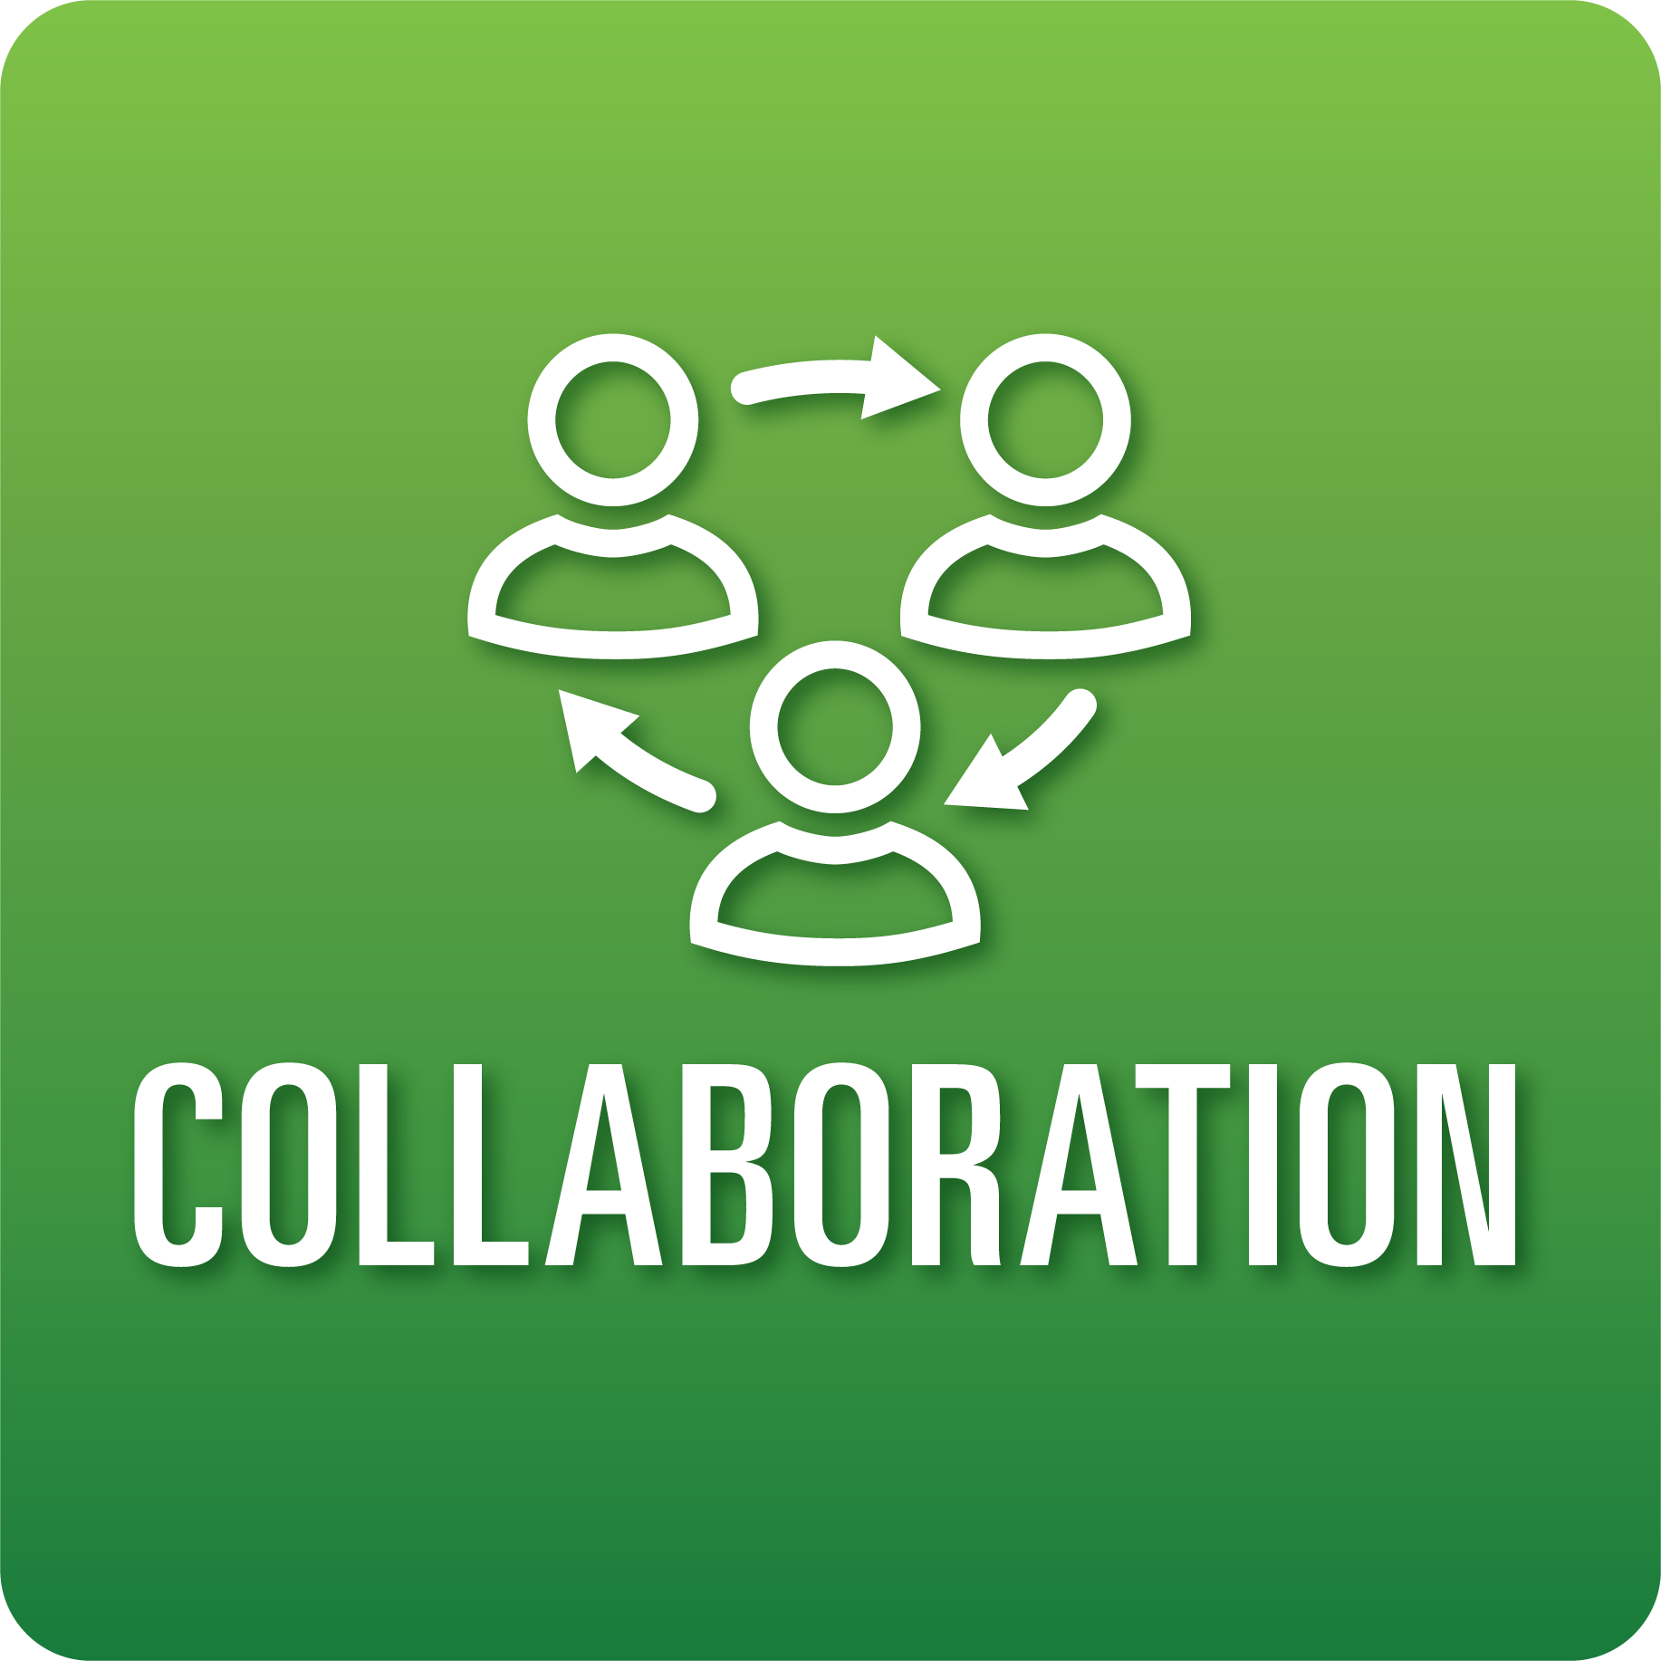
T-Chart for Improving Collaboration Skills:
Grades 3-5
Select one of the following Collaboration skills. Complete the T-Chart. Then, circle a “Look Like” and “Sound Like” behavior as your focus for improvement.

Roles:
- I can play a role that helps my team meet a goal.
Cooperation:
- I can follow our class norms when I participate in a conversation.
- I can help my team solve problems or conflicts by explaining/naming the problem or conflict and sharing ideas about how it can be solved.
Productivity and Accountability:
- I can show that I am consistently prepared and ready to work with my team.
- I can complete my tasks on time consistently.

When I _____________________________________________________________, it would…
Look like… (Be very specific) | Sound like… (Be very specific)
(To be completed at the end of a unit or performance task.)
Reflect: How did you improve your ability to demonstrate this skill?

