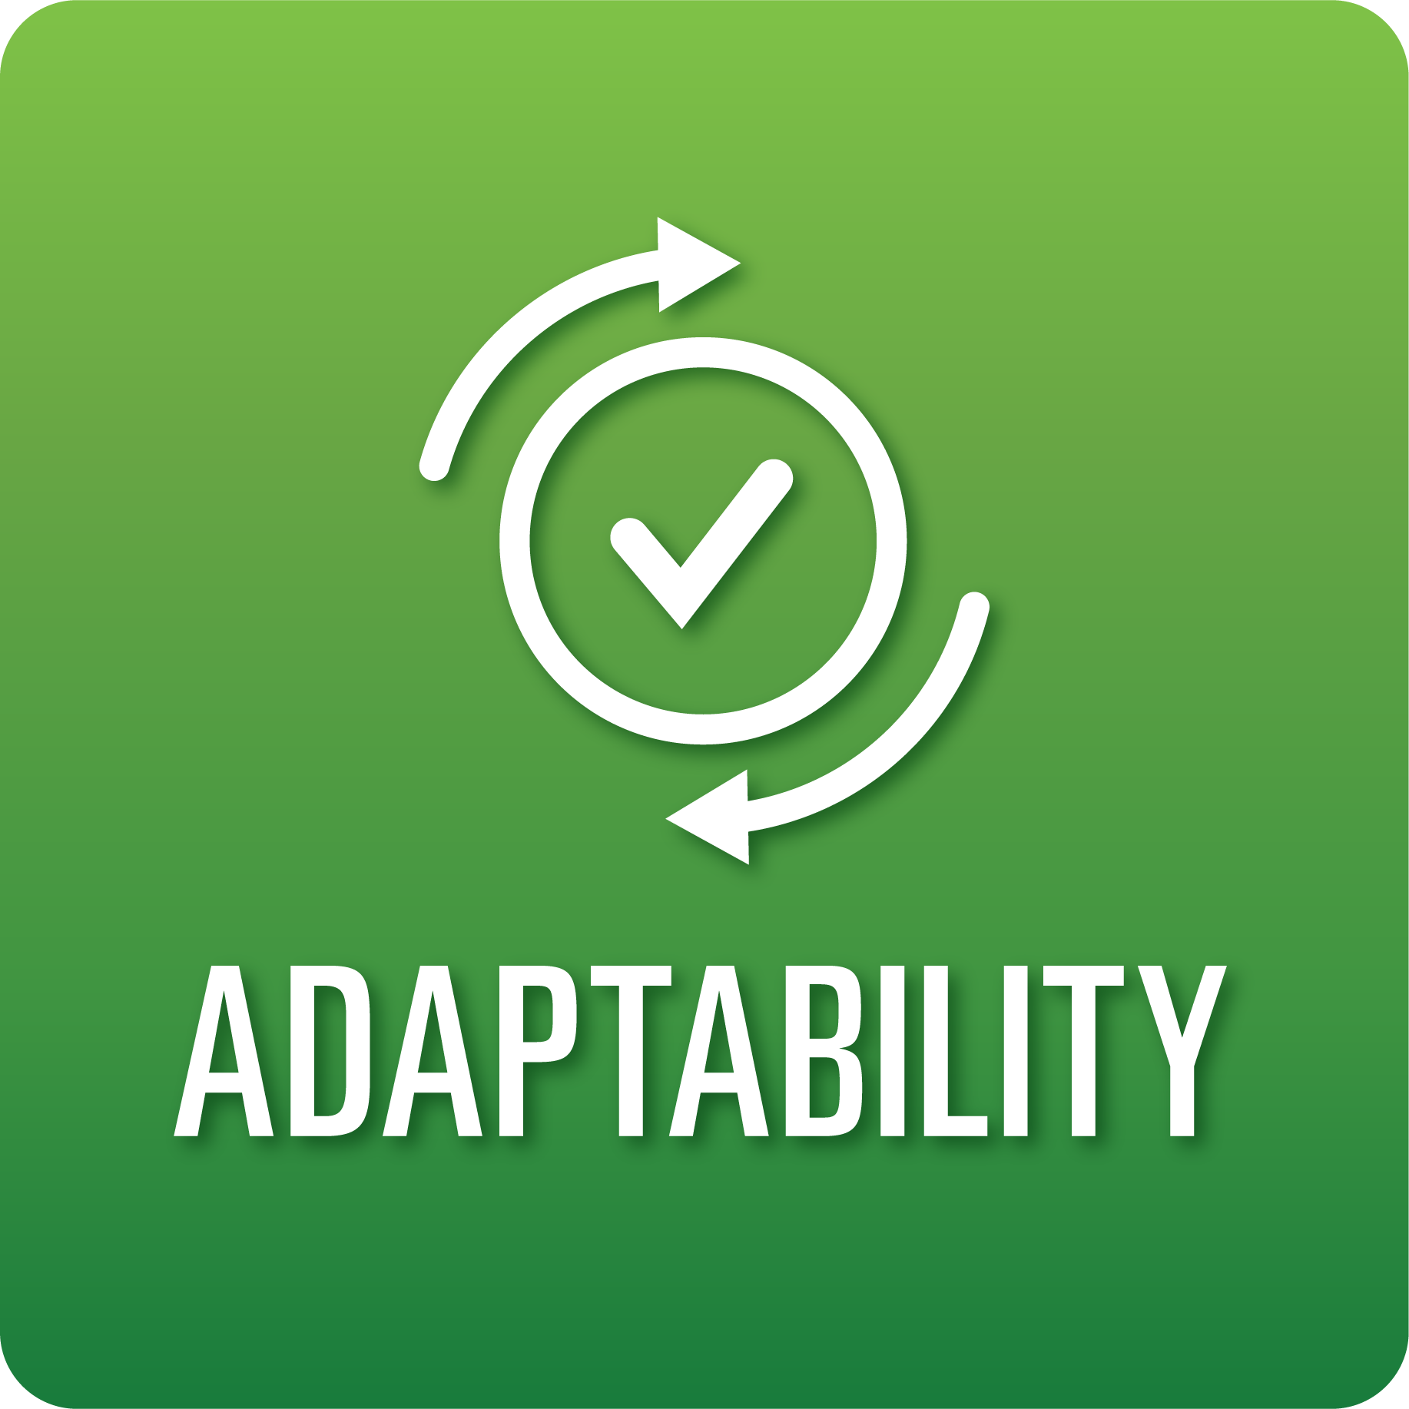
T-Chart for Improving Adaptability Skills:
Grades 9-12
Select one of the following Adaptability skills. Complete the T-Chart. Then, circle a “Look Like” and “Sound Like” behavior as your focus for improvement.

Agility:
- I can anticipate and plan for challenges and obstacles.
- I can use a variety of strategies to solve problems.
- I can learn and grow from situations that pose challenges and obstacles to success.
Responding to Feedback:
- I can explain how feedback and resources are used to revise my work.
Inclusiveness:
- I understand, respect, and value the diverse perspectives of others.

When I _____________________________________________________________, it would…
Look like… (Be very specific) | Sound like… (Be very specific)
(To be completed at the end of a unit or performance task.)
Reflect: How did you improve your ability to demonstrate this skill?

