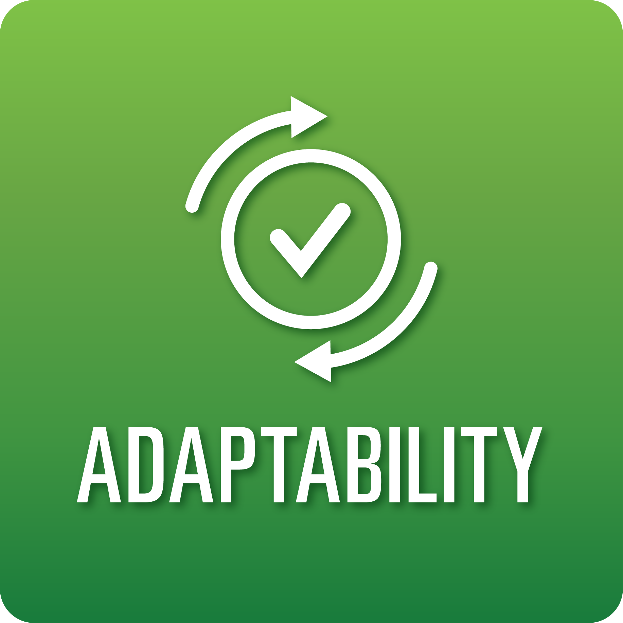
T-Chart for Improving Adaptability Skills:
Grades 6-8
Select one of the following Adaptability skills. Complete the T-Chart. Then, circle a “Look Like” and “Sound Like” behavior as your focus for improvement.

Agility:
- I can use resources to respond to challenges and obstacles.
Responding to Feedback:
- I can revise my work based on feedback from others.
- I can use success criteria to review and revise my work.
Inclusiveness:
- I understand and respect the ideas, beliefs, and practices of others that are different from my own.

When I _____________________________________________________________, it would…
Look like… (Be very specific) | Sound like… (Be very specific)
(To be completed at the end of a unit or performance task.)
Reflect: How did you improve your ability to demonstrate this skill?

