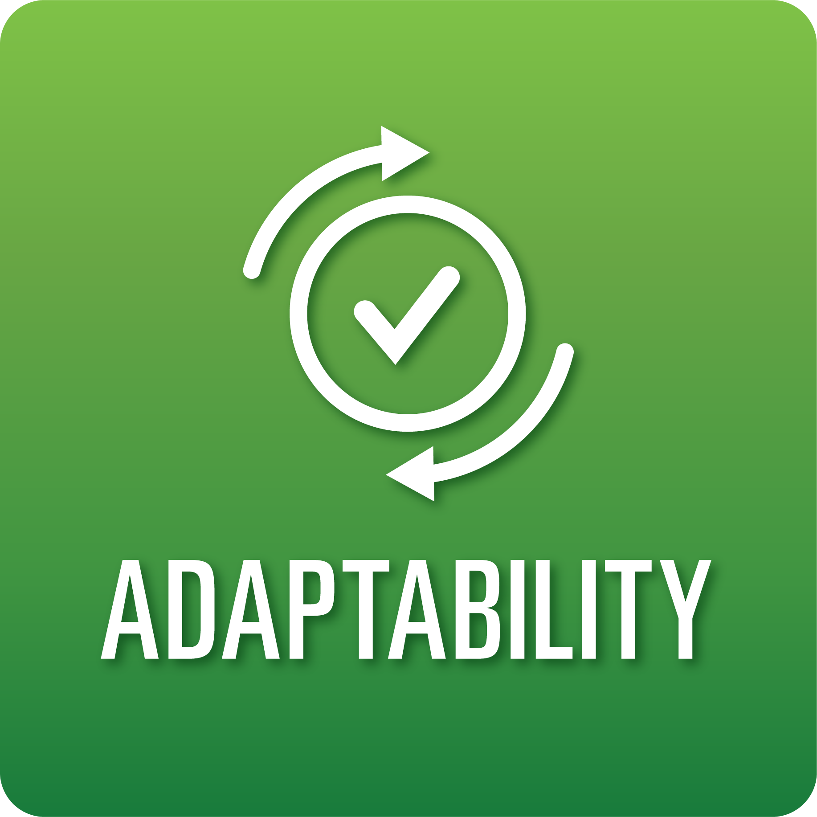
T-Chart for Improving Adaptability Skills:
Grades 3-5
Select one of the following Adaptability skills. Complete the T-Chart. Then, circle a “Look Like” and “Sound Like” behavior as your focus for improvement.

Agility:
- I can choose appropriate responses and strategies when faced with challenging situations that may require change.
Responding to Feedback:
- I can revise my work in response to specific feedback.
Inclusiveness:
- I can invite others to share their ideas, beliefs, and practices.

When I _____________________________________________________________, it would…
Look like… (Be very specific) | Sound like… (Be very specific)
(To be completed at the end of a unit or performance task.)
Reflect: How did you improve your ability to demonstrate this skill?

