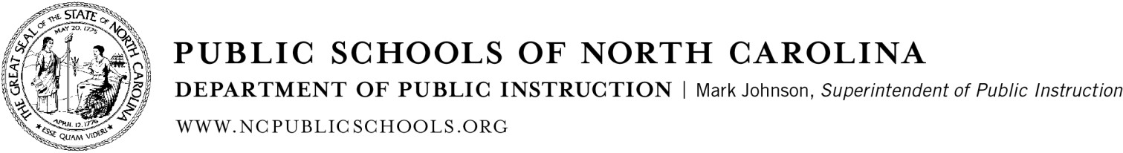

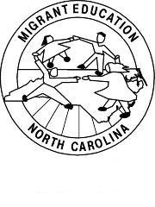
Occupational Survey

Student Name : __ Last Name First Name

School:
Grade:

The Migrant Education Program, through the North Carolina Department of Public Instruction, provides support and instructional services to children and families who have moved in the past three years and who have done agriculture or fishing work. We appreciate your help in determining if your children or relatives qualify to receive services in this program. Please answer the following questions and return the survey to the school.

1. Have you or someone in your family worked in any of the following areas below in the last three years?
No
Yes (Select all that apply and continue to question number 2)

2. Have you or your family moved to another school district or to another city or county in the last three years?
No
Yes
Work in the harvest of fruits and vegetables, tobacco, sweet potatoes, nuts, cotton, or in agricultural farms, ranches, fields, and vineyards |  |  | Working in a fruit or vegetable cannery or in a fruit or vegetable packing plant |  | Working in a dairy | Working in a fishery or on a shrimp or catfish farm
Working in a slaughter house (chicken, cow, or pig) | Working on a poultry or hog farm | Working in a plant nursery or orchard; growing or harvesting trees |  | Other similar work in agriculture, please explain:
3. How long ago did you arrive to this county? Month Year
4. Parent(s)’ Name(s)
5. What is your current address?

Address

City State Zip Code

6. Phone Number(s):

FEDERAL PROGRAM MONITORING & SUPPORT DIVISION
6351 Mail Service Center, Raleigh, North Carolina 27699-6351 | (919) 807-3957 | Fax (919) 807-3968
AN EQUAL OPPORTUNITY/AFFIRMATIVE ACTION EMPLOYER

